EFFECTIVENESS OF PLANNED HEALTH EDUCATION ON KNOWLEDGE REGARDING PREVENTION OF CERVICAL CANCER AMONG WOMEN ATTENDING MAHILA SANGHA MEETING AT SELECTED URBAN AREA, KOLAR.
By
Mrs MATTUGALLA KAVITHA
Dissertation submitted to the
Rajiv Gandhi University of Health Science, Bangalore, Karnataka


In partial fulfilment of the requirement for the degree of
Master of Science in Nursing
In
Medical surgical Nursing

Under the guidance of
Dr. G.VIJAYALAKSHMI
Professor & Principal
Medical Surgical Nursing Department
Sri DevarajUrs College of Nursing
Tamaka, Kolar-563103

2022

DECLARATION BY THE CANDIDATE

I hereby declare that this dissertation entitled “EFFECTIVENESS OF PLANNED HEALTH EDUCATION ON KNOWLEDGE REGARDING PREVENTION OF CERVICAL CANCER AMONG WOMEN ATTENDING MAHILA SANGHA MEETING AT SELECTED URBAN AREA, KOLAR”. is a bonafide and genuine research work carried out by me under the guidance ofDr.G.VijayalakshmiProfessor and Principal Sri DevarajUrs College of Nursing, Tamaka, Kolar.

Date: 26-03-2022 Signature of the candidate
Place: Kolar (Mrs.Mattugallakavitha)

CERTIFICATE BY THE GUIDE

This is to certify that the dissertation entitledis a bonafide research work done by Mrs.MattugallaKavitha, “EFFECTIVENESS OF PLANNED HEALTH EDUCATION ON KNOWLEDGE REGARDING PREVENTION OF CERVICAL CANCER AMONG WOMEN ATTENDING MAHILA SANGHA MEETING AT SELECTED URBAN AREA, KOLAR”. In partial fulfilment of the requirement for the degree of Master of Science in Medical and Surgical Nursing.

Date:26-03-2022 Signature of the Guide
Place:Tamaka, Kolar. Dr G. Vijayalakshmi
Professor and Principal
Sri DevarajUrs College of Nursing
Tamaka, Kolar

ENDORSEMENT BY THE HEAD OF THE DEPARTMENT/
PRINCIPAL /HEAD OF THE INSITITUTION

This is to certify that the dissertation entitled “EFFECTIVENESS OF PLANNED HEALTH EDUCATION ON KNOWLEDGE REGARDING PREVENTION OF CERVMONG WOMEN ATTENDING MAHILA SANGHA MEETING AT SELECTED URBAN AREA KOLAR”. Is a bonafide research work done by Mrs.Mattugallakavithaunder the guidance of Dr G. Vijayalakshmi,Professor& Principal, in partial fulfilment of the requirement for the degree of Master of Science in Medical Surgical Nursing.

Signature of HOD | Signature of the principal
Dr. ZeanathC J | Dr. G Vijayalakshmi MSc Ph.D.[N]
HOD Of MSN | Principal ofSDUCON
SDUCON | Tamaka, Kolar. 563101
Tamaka, Kolar. 563101
Date: 26-03-2022 | Date: 26-03-2022
Place:Tamaka,Kolar | Place:Tamaka, Kolar

COPYRIGHT
DECLARATION BY THE CANDIDATE
I hereby declare that the Rajiv Gandhi University of Health Sciences, Bangalore, and Karnataka shall have the right to preserve, use and disseminate this dissertation in print or electronic format for academic research purpose.

Date:26-03-2022 Signature of the candidate
Place:Tamaka, Kolar (Mrs. MattugallaKavitha)

ACKNOWLEDGEMENT
I raise my heart with profound gratitude to God Almighty for being done marvelous things throughout my study. He guided me, strengthened me and enlightened me at every step to bring it to completion.
My heartfelt gratitude and respect to Director and Secretary, Sri DevarajUrs Educational Trustfor giving me a platform to study in this college and complete my study efficiently.
It is a genuine pleasure to express my deep sense of thanks and gratitude to my philosopher and guideDr. G.VijayalakshmiPrincipalfor her invaluable advice, continuous support, and patience during my study. Her immense knowledge and plentiful experience have encouraged me in all the time of my academic research and daily life.
I take immense pleasure in thanking to DrZeanath C.J HOD of Medical Surgical Nursing Speciality for her great support, inspiration, encouragement and continuing motivational support for the study.
I express my sincere thanks to Mr.Rajesh R, Associate Professor, andIIndYr.MSc(N) class coordinator for giving support, encouragement and valuable suggestion which helped me in conducting this study.
I am thankful to all the faculties of various departments to Prof. Mary Minerva, Prof.Mrs.JairakiniAruna,Dr.LavanyaSubhashini, Mrs.PunithaAssociate professor, Mrs.GayathriAssociate professor. Dr. MalathiK.VAssistant Professor, for their valuable advice and suggestions.
I am grateful to Mr. Ravi Shankar, Associate Professor, Department of statistics, Sri DevarajUrs Medical College, Kolar for his expert guidance, valuable suggestions and assistance in the statistical analysis and interpretation of the data.
I would like to extend my gratitude to all the subject experts who have contributed in the form of constructive criticism and suggestions to formulate the tool.

I express my utmost gratitude to Director, Shree Kshethradharmasthala rural development project B.C, Trust, Kolar, for granting me Permission to conduct this study.
My special words of thanks to Mrs.Shamala and Mrs.Amruthalibrarians of Sri DevarajUrs college of Nursing, for their constant help, support and cooperation.
My special words of thanks to non-teaching staff of Sri DevarajUrs college of Nursing, for their constant help, support and cooperation.
I owe personal in-depth of gratitude to all Participants who have enthusiastically been a part of the study without their cooperation the study would not have been possible.
I extend my sincere thanks to my beloved Friends Mrs. T. UmadeviAssistant prof.
Mrs.GunasheelaTutor for helping me throughout the study and Ms.Rachana and Ms.chaithra VI BSc (N) students for helping me in Data collection.
I am greatly indebted to my family without whom my study would not have been possible. I wish to acknowledge my husband Mr. Hemagiri and my daughter Chaithra and my Son Kushalmy Father Mr.venkataramanaand my brother Mr. Kiran and other family members who had been a source of strength and support through their prayers, love, support and encouragement throughout my study and for being at my side in time of up and downs.
I owe a deep sense of sincere thanks and gratitude to all those who have contributed towards the successful completion of this Endeavour directly or indirectly.
Thank you all Date: 26-3-2022. Signature of the Candidate;
Place: Tamaka (Mrs. Mattugallakavitha)

LIST OF ABBREVIATIONS

Sl.no | Abbreviations
1. | f: Frequency
2. | % : Percentage
3. | SD : Standard Deviation
4. | df : Degree of Freedom
5. | NS : Not Significant
6. | SS : Statistically significant

ABSTRACT

Title:EFFECTIVENESS OF PLANNED HEALTH EDUCATION ON KNOWLEDGE REGARDING PREVENTION OFCERVICAL CARCINOMA AMONG WOMEN ATTENDING MAHILA SANGHA MEETING AT SELECTED URBAN AREA KOLAR.
Background: Carcinoma cervix is a major health problems the world, and Hence Women form an important pillar of society & They are the principal stewards of the environment. family. If knowledge they have regarding healthy lifestyle & all family members will be healthy. present studywas undertaken with an objective to evaluate effectiveness of health education planned regarding prevention of carcinoma cervixamong women.
Methods:APre-experimental with one group pre-test & post-test used for the reseach. First ethical clearance obtained, authorization acquired in writing from Director, Shree Kshethra dharmasthala rural development project B.C, Trust,Kolar. Through Purposive sampling technique30 women who full filled inclusion criteria were selected, after taking a written consent from the women, they were assessed through self-administered questionnaire about prevention of cervical cancer knowledge , followed by health education planned was administered to all the participants. After 30 days the same tool post test was conducted.
Results: According to a study average pretest Knowledge score was 9.63 with SD of 2.38, where as the average posttest knowledge score was14.9 with SD 4.51.The obtained paired ‘t’ value was 6.13 indicating that planned health education effective at increasing knowledge score among women which was statistically significant at 0.05 level.

Conclusion: According to results of research, health education planned was effective in improving knowledge score among women about prevention of cervical cancer.
Key words: Cervix cancer, Prevention,knowledge,women.

TABLE OF CONTENTS
SL. NO. | CONTENT | PAGE NO.
1. | INTRODUCTION | 01-03
2. | OBJECTIVES | 04-09
3. | REVIEW OF LITERATURE | 10-20
4. | METHODOLOGY | 21-28
5. | SAMPLE SIZE ESTIMATION | 29
6. | RESULTS | 30-44
7. | DISCUSSION | 45-48
8. | SUMMARY | 49-54
9. | CONCLUSION | 55
10. | REFERENCES | 56-62
11. | ANNEXURES | 63-141

LIST OF TABLES

Table No. | Titles | Page No.
1. | Distribution of women based on age group | 32
2. | Distribution of womenbased on marital status | 33
3. | Distribution of women according to their Educational qualification | 34
4. | Distribution of women based on occupation | 35
5. | Distribution of womenbased on Age of menarche | 36
6. | Distribution of Women basedon overall pretest knowledge score | 37
7. | Distribution of women based on area wise pretest knowledge score | 39
8. | Distribution of women based on area wise pretest and post-testknowledge score | 40
9. | Comparison of Pre-test and Post-test Mean Knowledge scores. | 41
10. | Knowledge scores after the posttest and selected socio-demographic characteristics | 42

LIST OF FIGURES

Sl.no | Figures | Page no
1. | Application of Theoretical frame work of Modified Conceptual framework based on Ludwig Von Bertanlanffy’s General System Theory [1968] | 09
2.. | Distribution of women based on age group | 32
3. | Distribution of womenbased on marital status | 33
4. | Distribution of women according to their Educational qualification | 34
5. | Distribution of women based on occupation | 35
6. | Distribution of women based on age of menarche | 36
7. | Distribution of overall pretest knowledge score among women | 38

LIST OF ANNEXURES
ANNEXURE NO | CONTENTS | PAGE NO.
 | Ethical committee clearance certificate | 63
 | Synopsis Approval Letter | 64
3. | Request for authorization to conduct the main study in a letter | 66
4. | Letter requesting opinion ,suggestion specialists for determining the content authenticity | 67
5. | Validation criteria rating scale research tool | 68
6. | Lists of Experts | 71
7. | Content validity certificate | 72
8. | Certificates from statistician | 78
9. | English editing certificates | 79
10. | Kannada translation certificate | 80
11. | Consent letter | 81
12. | Knowledge Questionnaire on prevention of cervical cancer in English | 83
13. | Knowledge Questionnaire on prevention cervical cancer in Kannada | 93
14. | Key Answer | 105
15. | Blue Print | 106
16. | Lesson plan on cervical cancer English | 107
17. | Lesson plan on cervical cancer in Kannada | 118
18. | Data collection photos | 132
19. | Gannt Chart | 134
20 | Master Data sheet | 135

CHAPTER 1
INTRODUCTION
Womanhood is a stage in a woman's life that occurs after she travelled through adolescence and childhood, usually around the age of 18. Pubescentusually begins at age of ten years, followed by menarche around the age of twelve to thirteen years. Women are critical to the health of their families and communities. Some women's health issues will take a little more effort to resolve than others, but practically all can be resolved if suitable natural health measures are done to address the underlying reasons. Cancer is the frequently discussed & dreaded diseases, and it can affect any region of the body.
Cancer is an uncontrolled growth of abnormal cells and when it affects to the cervix, it is called as cervical carcinoma is a disease is most common among women.⁵
Female reproductive system women includes the cervix & is located in the lower part of Uterus,creating the vaginal aperture from the uterus.Cervical cancer is a slow growing cancer and it is caused by theHPV stands for human papillomavirus, a virus that is generally transmitted through sexual contact. HPV virus can live for many years, & in some women, it can cause cells of the part to become cancerous.⁶The risk factors that affects women are, who menstruate early, marry early, with many sex partners, many children and poor antenatal care, poor genital hygiene, weakened immune system/ failure in body natural protection system/infection or taking immune-suppressing medications,using birth control pills for a long time. The intake of tobacco also increases the chances of getting this cancer by 50%.⁷

Clinical features of cervical cancerdevelop slowly over several years. In some women, there is no any symptoms, while in others it may cause abnormal vaginal bleeding or discharge. This can include bleeding between menstrual periods, bleeding after sex, or bleeding after menopause. This bleeding may be spotting or heavy bleeding. Weight loss for > 5 percent over 12 months,skin being loose and wrinkled and sunken eyes, anemia, decreased appetite, thin watery vaginal discharge and foul smell discharge. Pain is a late symptom; person will have back pain, leg pain, pelvic pain and knee pain. Other symptoms will occurs in late stage such painful and frequent maturation, incontinence of urine, pruritis, and vaginal discharge.⁵
Screening tests can find cervical cancer and pre-cancer in the initial stages when it can treated & thus may reduce cancer in addition the number number of deaths as a consequence illness.A Pap smear test is commonly a method of test for cervical cancer. Here cellsare collected from surface of vaginal canal & the cervix viewed under microscope for find out the abnormality.⁸
Prevention is better than cure. Carcinoma of cervix can be avoided if you take certain precautions as like an intake of vitamin A and C and B foliate and improving the living standard. Hence, nurse as a health care team member of responsibility to provide an awareness programme to women using print andCervical cancer can be prevented by using audio visual media.⁹

STUDY NEEDS:
Cervical malignancy is the most common cancer in people. females worldwide &it is going reason of death in women underdeveloped countries.⁵Cervical cancer forms 16.5% of total cancer cases in Indian women & is the 2nd most common type of cancer amongst women in the country. Every minute one woman is diagnosed with cervical cancer. Current data suggests that, 90 %of all cases occur due to women are does not reaching to hospital for testing & early detection.It is estimated that about between the ages of 160 million females 30 &59 yearsin India are at risk of having cervical cancer.⁶
In Karnataka alone, 5,000 there are fresh cases discovered each year and in Bengaluru, carcinoma cervix is 2nd common cancer among females with 850 cases being diagnosed every year.¹¹
A descriptive study conducted on knowledge, attitude & practices on prevention of cervical cancer among rural women revealed that, younger women had better Cervical cancer knowledge and various risk factors, signs associated with the disease. The study recommended that, efforts should be made to implement aninnovative ways to reach older and illiterate women for better information regarding prevention of cervical cancer in the community.¹²
Women form an important pillar of society & they are primary caretakers in each family in every country of world,¹³because many of them de-prioritize their own health and well-being in favor of other family members, while giving lack of time to invest in self-care.
So, the Researcher felt that, educating women is equal to educating the family. As a result, the research undertaken with an aim to knowthe intended health education's influence on cervix cancer prevention in women.¹⁴

CHAPTER 2
OBJECTIVES
This chapter covers the problem statement, study objectives, operational definitions, assumptions, hypothesis, and conceptual framework that serves as the study's frame of reference.
PROBLEM STATEMENT
“EFFECTIVENESS OF PLANNED HEALTH EDUCATION ON KNOWLEDGE REGARDING PREVENTION OF CERVICAL CANCER AMONG WOMEN ATTENDING MAHILA SANGHA MEETING AT URBAN AREA KOLAR”.

.OBJECTIVES

- Evaluate your understanding of cervical cancer control among women attending Mahilasangha meeting at selected urban area Kolar using Structured Knowledge Questionnaires
- To evaluate the effectiveness, compare before test & after test knowledge scores of planned health education among Mahila sangha meeting women.
- Determine there is link between the degree of Knowledge with socio demographic variablessuch as age, marital status, education, family income, occupation and age of menarche.

NULL HYPOTHESIS:
H₀₁: There will not be any between the mean knowledge levels before and after the test scores, there will be no statistically significant difference.
H₀₂: There will not be statistically significant association between posttest a knowledge score based on a set of socio-demographic characteristics such as age, marital status, education,family income, occupationandage of menarche,
OPERATIONAL DEFINITIONS:
1. EFFECTIVENESS: In this research, it relates to the degree to which the planned health evaluated by increase in knowledge score, education has yielded the anticipated results.
2. PLANNED HEALTH EDUCATION: Its refers to systematically in the current study planned and organized way of preparing & imparting information regarding early cervical cancer prevention.
3. KNOWLEDGE:It was discovered in this investigation that means correct response of women to the structured knowledge questionnaire.
4. PREVENTION OF CERVICAL CANCER: In current study it refers to group based intervention for detection and treatment of risk factors in order to reduce the burden of cervical cancer.
5. WOMEN: In this research, we looked into it refers to a female who is married with reproductive age group and will be attending in Mahilasangha meeting.
6. MAHILA SANGHA: It refers to a woman in the current study association which works in empowering women at selected area.

THEORETICAL FRAMEWORK
A theory is set of concepts, definitions, relationships, assumptions that project a systemic view of phenomenon.
The goal of this reseach is to see how effective organised health education is at improving women's knowledge regarding cervical cancer prevention at MahilaSangha sessions.
The current study's theoretical framework was developed by on the basis of an investigation of General System Theory which was abstracted by Ludwig Von Bertalanffy (1968). This theory takes an account interrelationship between parts whole, which have vast implication for nursing. According to this theory, a system consists of interconnected components enclosed by a boundary that controls the type and rate of interaction with the outside world.
Structural & functional components make up system. Structure relates to how parts are arranged at any particular time, whereas function refers to how system changes over time as matter, energy, and information are exchanged with the environment.
Open systems characterise biological systemsthat encourage the interchange of matter, energy, and information with other subsystems and the environment (supra- system). The exchange within an open system, as well as between an open system and its suprasystem, is ongoing. Internal stability is created and maintained through a dynamic control within and between the system, subsystems, and suprasystems. When one part of the system changes, other sections of the system alter as well. Activity can recorded in an aggregate of feedback circuits, such as input, throughput, and output, in all systems. Because of the openness of the human system, it possible for examine interaction between the things that affect a person, including influence subsystems and suprasystems.
Theory consists of 4 components such as input, throughput, output & feedback.
INPUT
Input refers to any type of energy, information, or material that enters system through its borders, according toLudwingvanBertalanffy (1968). Women are treated as a system in this study, with input from both within the system (subsystems) and from the environment (supra system). Women's background information such as age, marital status, education, family income, occupation, and menarche age are included in the input, which may influence women's understanding of cervical cancer.
The delivery of organised health education to women about carcinoma prevention is referred to as input in this study.
THROUGHPUT
Throughput is a process that occurs at a point between input & output processes that allows input to be transferred as output in way that system can easily utilise it. Throughput in this study refers to the transformation about cervical cancer knowledge, prevention that was taught in planned health education.
OUTPUT
The output is the final outcome of the system's product. Any transmission of energy, information, or material environment. It refers aimprove knowledge score of women cervical cancer prevention after planned health education programme in current study.
FEEDBACK
Feedback is process whereby output of systems is redirected to input of the same systems. It may be positive or negative or or a neutral state. In this research, we looked into the feedback is about effectiveness health education that has been planned &it can be tested through alternate hypothesis as follows;
- Comparing the difference in knowledge values on cervical cancer prevention women before and after test.
- Identify the link between knowledge and action score and a set of socio-demographic characteristics.

SUMMARY:
This chapter discussed with statement of problem, objectives of study, operational definitions, assumptions, hypotheses and theoretical frame work.

Socio demographic Data
Throughput
Input
Output
Age
Marital status
Education
Family income
Occupation
Menarcheage
Structured teaching program
P
R
E
T
E
S
T
P
O
S
T
T
E
S
T
Process of transformation of knowledge
No Gain in Knowledge score on prevention of cervical cancer
Gain in Knowledge score on prevention of cervical cancer

Feedback
Testing of hypothesis using formula

Fig-1: Modified Conceptual framework based on Ludwig Von Bertanlanffy’s General System Theory (1968)

CHAPTER- III

REVIEW OF LITERATURE

Review of the literature familiarises the researcher with current studies and gives information that aids in focusing on a specific problem & lays foundation based on which to base new knowledge. Review of Literature for present study is categorized under the following headings;
I.Studies pertaining to cervical cancer knowledge
II. Studies related to The Efficacy of a Structured Teaching Program.
I. Studies related to cervical cancer knowledge

A cross-sectional A study was undertaken on women's understanding cervical cancer in Urban Community at Tamil Nadu. For the study 1033 women were included through outreach clinics as well as via home visits.The result revealed that, with regard to cervical cancer knowledge , 84.6% of women had poor knowledge, 10.3% had moderately adequate knowledge, and only 5.1% had good knowledge. The findings suggest that a community-based education and screening campaign will be reduce cervical cancerprevalence among women.¹⁵

A cross-sectional survey was conducted on Cervical Cancer Awareness &HPV vaccine among women at Bangladesh. For the research 2037 women were included. Data was obtained by interview schedule using a structured questionnaire. Results revealed that, Cervical cancer knowledge on risk factors in urban:9.1%, rural: 8.8% and prevention in urban: 6.4%, rural: 4.4% respectively . The research came to a conclusion that, women had poor knowledge in cervical cancer information on symptoms, risk factors, and preventive methods.¹⁶

A study in terms of cervix cancer knowledge was conducted among females attending an outpatient department at Kasturba Medical College hospital, Mangalore. For the study 83 women were selected & assessed for their cervical cancerknowledge followed by a health education hand-out was distributed to all.The results showed that, majority of women had poor cervical cancerknowledge (81.9%) and it's screening (85.5%). Only 6 out of 83 women had undergone screening. Though women come into contact with doctors earlier, they were neither educated about cervical cancer nor were they told about the screening. Whatever little knowledge the women had, was obtained from mass media.¹⁷

A cross sectional survey regarding knowledge on prevention of cervical cancer was conducted among women attending Gynaecology Out-Patient Department (OPD) in a tertiary care hospital in Pondicherry. The results found that, less than half of the study population (178, 44.5%) knew about cervical cancer. Less than one-fourth of the population knew about screening services for prevention of cervical cancer, and majority (389, 97.2%) were not aware of vaccination as prevention for cervical cancer. The study concluded that there is a need for an extensive health education to the public with regard to cervical cancer and its prevention.¹⁸
A study oneffect of health education about cervical cancer and papanicolaou testing on the behavior, knowledge, and beliefs was conducted among women at Turkish. For this study 148 women were participated. The results revealed that knowledge about cervical cancer and Papanicolaou testing, was statistically significant between the control group and the study group (t = 10.122, P < 0.05). In the Health Belief Model Scale for Cervical Cancer and Pap Smear Test, there were statistically significant differences in the following measures: lower levels of susceptibility to cervical cancer score (t = -2.035, P < 0.05), lower levels of perceived benefit from a Papanicolaou test score (t = 3.278, P < 0.05) and lower levels of perceived barriers to Papanicolaou test score (t = -3.182, P < 0.05).¹⁷ The study was conducted regarding Knowledge about Human Papilloma virus and Cervical Cancer Prevention among Intern Nurses. For this study 323 intern nurses from eight schools were selected.The results found that, effective response rate was 79.8%. Some (7.0%) knew that early-stage cervical cancer is commonly asymptomatic. Only 9.7% knew that infection is generally asymptomatic and 20.5% knew that vaccination has no major side effects.¹⁹
At a tertiary health institute in Ahmadabad, cross-sectional study was done to assess nursing staff's knowledge of cervix cancer and its prevention. Data was collected using a standardised questionnaire with numerous choices. A total of 100 nurses took part in this investigation. According to the findings, one of the signs cervical cancer is vaginal discharge, which was mentioned by 65 (94.2%) of respondents. Menstrual irregularity and pain were indicated as symptoms by 86.9% and 66.6 percent of respondents, respectively. Only eight (11.5%) of those polled were aware that having several sexual partners is risk factors for cervical cancer. The 69 people who said they knew something about cervical cancer, 61 (88.4%) said they knew about Pap tests as a preventive approach.²⁰
At King Fahad Medical City (KFMC), Saudi Arabia, A cross-sectional investigation carried out for female healthcare professionals' knowledge, attitudes, and practisesof cervical cancer & screening. A predesigned, tested, and self-administered questionnaire was used to collect data. A total of 395 people took part in the survey. Only 16 (4.0 percent) among the participants an excellent understanding of cervical cancer (in terms of risk factors, vulnerability, signs and symptoms, prevention, and screening), while 58 (14.7 percent) had a decent understanding. A total of 343 (86.8%) participants thought the Pap smear test and it is a good test for detecting cervical cancer, and 103 (26.2%) participants had their Pap smear test done. ²¹
Cross-sectional research on cervical cancer screening knowledge and attitudes was conducted in female inIsiolo and TharakaNithicountries.For the study 451 women with 18 years of age were selected through multi stage cluster sampling technique. The results showed that 25.6% of them have undergone a cervix cancer screening, 44.4% had above average knowledge of cervical cancer risk factors and 89.2% of them were scary of carcinoma cervix. There was a small but substantial variation in the results overall attitude assessment score towards cervical cancer between participants from Isiolo and TharakaNithi countries; the mean score was 2.13 (SD:0.34) and 2.20(SD:0.30) respectively. The score was comparatively higher among participants residing in TharakaNithi (95%ci :0.002-0.146:p=0.043).The study concluded that, research is needed to further understand and different strategies to improve attitudes cervical cancer in order to getting the uptake of screening services, particularly among less- educated women and those in hard-to- reach areas.²²

Comprehensive Cervical cancer awareness among women in Northwest Ethiopia was the subject of a study. For this study 633 women aged 15 years and above were interviewed using semi structured questionnaire. The findings revealed that 495 (78.7%) of all respondents had heard cervix cancer and only 195 (31%) were informed with the condition, indicating that women's understanding cervix cancer is inadequate. According to the findings, cervical cancer education should include information on risk factors, signs, and symptoms.²³
Ghana did a study on the influence of health education interventions on women's knowledge and perceptions on cervical cancer and screening. 782 people in 11 to 70 years were chosen for the study (396 intervention group & 386 in control group). The findings showed statistically significant difference in cervical cancer knowledge (t=6.22,df=780,p=0.001), perceived seriousness (t=3.36, df=780,p=0.001), and perceived benefits (t=9.19,df=780,p=0.001) when pre-post test scores for intervention and control groups were compared. The findings reveals that health education interventions crucial in enhancing women's knowledge and perspectives regarding cervical cancer & screening, in addition their self-efficacy.²⁴
A study was carried out to evaluate cervical cancer prevention, knowledge, and awareness among health-care personnel, working in six hospital of Yaoundé, Cameroon. For this study 400 women were participated by using self-administered questionnaire. The findings revealed that majority of participants (58 percent) were able to identify the etiological elements and believed that screening may prevent cervical cancer (90%) & may be performed by Pap test (84%). The study identified cervical cancer awareness & knowledge are two factors that have been found & its prevention by screening showed several gaps and important misconceptions regarding screening methods. And recommendations were made about creating awareness among healthcare workers on risk factors and current cervical cancer screening methods as a necessary step towards implementing effective prevention programs.²⁵
A cross-sectional survey of 400 women in tertiary care centres in Karachi, Pakistan, was undertaken to examine their cervical cancer understanding and awareness and its prevention. According to the findings, 1.8 percent of population had never heard cervical cancer, whereas 26 percent had heard of it and 37 percent had heard of Pap smear a screening test. According to the study, ongoing medical education will help disseminate disease awareness.²⁶
A cross-sectional investigation was carried out in New Delhi, India, to measure women's knowledge, attitudes, and practises surrounding Screening for cervical cancer. Pretested self-administered A questionnaire was utilised to 220 women for this study. Only 75 of the female population in the survey (50.0 percent) had ever cancer is something you may have heard, based on the information Cervical cancer and its various domains are significantly better understood by students and single women. According to the majority of women who took part in the poll, the most prevalent early cervical cancer warning sign was a foul-smelling vaginal discharge (26, 17.3 percent ). Tobacco and smoking were the most prevalent risk factors for cervical cancer, according to the majority women in the study (19, 12.7 percent). Only 39 patients had never been screened for cervical cancer (26 percent ). Only 27 women (18%) had ever had a Pap smear, and 87 said they would be willing to participate in free cervical cancer screening.²⁷
Nurses at hospital in Tanzania were evaluated for their knowledge on cervical cancer & screening procedures in a descriptive cross-sectional study. A total of 137 nurses took part in this investigation. According to the data, less than half of nurses had adequate understanding cervix cancer. Younger nurses had superior knowledge (p = 0.027), and knowledge varied significantly by cadre. Registered nurses had more adequate knowledge than enrolled nurses (p = 0.006). Only a few knew about the HPV vaccine, and the majority were uninformed of screening intervals. The majority of nurses (84.6%) had never performed Pap smear test. The study discovered that continuing medical education, in addition the development cervical cancer prevention policies and efforts, are all needed.²⁸

In India, a study was undertaken on women's knowledge, attitudes, and practises in terms of cervical cancer & screening. Studies published between 2012 and March 2020 were searched in the health sciences electronic databases Pub Med and Google Scholar. This research involved 7688 women in total. The findings revealed that women had an overall knowledge of cervix cancer of 40.22 percent. The women had a good understanding of risk factors and indications and symptoms. Early marriage was a risk factor for Cervical Cancer for 32.68 percent of women, while early sexual activity initiation was a prevalent risk factor for 23.01 percent of women.The most prevalent sign and symptom described by 30.75 percent and 28.86 percent of women, respectively, was intermenstrual bleeding and foul-smelling discharge. Cervical cancer screening knowledge, attitude, and practise were found in 20.31 percent, 43.64 percent, and 13.22 percent of women, respectively. The findings suggested that improving women's knowledge of cervical cancer requires effective information, education, and communication initiatives.²⁹
A cross-sectional survey was conducted on Cervical cancer and HPV vaccine knowledge among women at Bangladesh. For the research 2037 women were included. The data was collected through interview schedule using a structured questionnaire. The results revealed that, Cervical cancer knowledge on risk factors in urban:9.1%, rural: 8.8% and prevention in urban: 6.4%, rural: 4.4% respectively . The research came to a conclusion that, women had poor knowledge in cervical cancer information on symptoms, risk factors, and preventive methods.³⁰
A hospital based case-control study among women was conducted in ShirdiSai Baba Cancer Hospital and Research Centre, Manipal, Udupi District. For this study total 273 participants (91 cases and 182 controls) were included by using a semi-structured questionnaire. The results revealed that, the marital status (married) is an important risk factor for cervical cancer, OR = 2.98 (1.23–7.20). People having history of alcohol use were at 4.55 (1.17–17.73) times at risk of getting cervical cancer when compared to those who did not use alcohol. Age at menarche of 13–14 years found to be a significant risk factor of cervix cancer with OR of 2.91(1.18–7.20). Age at 1st coitus of <18 years had an odds ratio of 5.44(2.73–6.38) and was significantly associated. At least one abortion is an important risk factor with odds of 2.61 (1.70–18.96). Also, adjusted odds ratio for parity of 3–5 was 3.16 (1.12–8.91) and 5.57 (1.70–18.96) for women having ≥6 parity when compared to women having parity of less than 3 and was statistically significant.this study concluded that marital status, history of alcohol use, <18 years of age at first coitus, age at menarche and parity of >3 as risk factors of cervix cancer.³¹

II. Studies related to the efficiency of structured instruction programme
A study was done to see how successful health education is at improving women's knowledge and perceptions on carcinoma cervix in rural Nigerian areas. Three hundred and fifty (350) women were chosen using a multistage random selection procedure for the study. Women had very excellent understanding about cervical cancer, and screening increased from 2% to 70.5 percent ( 2 = 503.7, p 0.0001) following health education, whereas the proportion of those with good perception increased from 5.1 percent to 95.1 percent (p 0.0001)..³²

A study was done to determine the efficacy of a planned teaching cervical cancer prevention programme in a rural community in terms knowledge and attitudes among ladies of childbearing age in Delhi. A straightforward sampling strategy was used to choose 60 females of childbearing age for this investigation. The findings revealed that Percentage of women having adequate knowledge increased from 0% to 63.34% after giving planned teaching program. Whereas 18.33% population reported inadequate Knowledge and 18.33% population have moderate knowledge in post test indicating improved awareness score of 38.46% after planned teaching program.³³

In a Gurugram hamlet, study was conducted to examine efficiency planned training programme on women's understanding of early detection , prevention of cervical cancer.A purposive sample strategy was used to choose 60 women for the study. The findings found that 35% of women had low awareness, 60% had moderate knowledge, and only 5% had strong understanding about cervical cancer early detection and prevention. In terms of posttest knowledge, 0% had low knowledge, 25% had average knowledge, and 75% had strong knowledge.³⁴

In Karad, Western Maharashtra, India, a study was undertaken on the the impact of organised health education on knowledge of nurses working at tertiary care hospitals regarding early identification of cancer. Simple random sampling strategy was used to choose 168 samples for this research. The findings revealed that planned health education was successful in raising knowledge at a P0.001 level.³⁵
In M.V.Ps Arts, Commerce and Science College, Ozar, a study was undertaken on the efficiency of a planned health programme of instruction on adolescent girls' knowledge of cervical cancer prevention. A suitable sample strategy was used to choose 60 adolescent girls ages between of 16 and 18 for this investigation. The findings revealed that the mean knowledge score before exam was 7.84 and average knowledge score after the test was 12.67. The reseach found that the planned health education programme was helpful in enhancing adolescent females' understanding.³⁶
The study conducted to know the The impact of an organised teaching programme on women's awareness about cervical cancer in sanganerdistrict,Jaipur. For the study 60 women aged between 25 to 45 were participated. The findings revealed that 36.66% have satisfactory knowledge about cervical cancer in pre test where as in post test raised to 85%. ³⁷
The goal of this research the efficacy as part of public health education programme in getting cervical cancer knowledge and attitudes and Pap smear in Malaysia. Self-administered questionnaires were used to choose 210 women for the research. Findings demonstrated that at Evaluation 1, control and intervention groups saw considerable improvements in their understanding cervical cancer and Pap smears, in addition their attitudes about them. At the evaluation, however, there were no further improvements in the intervention group. The intervention group's Pap smear uptake increased significantly from 48.0 percent at baseline to 68.0 percent at Evaluation 1 (P0.001), and then from 68.0 percent to 79.0 percent at Evaluation (P0.001). The control group saw a substantial increase in Pap smear uptake from 63.0 percent at baseline to 76.0 percent at Evaluation stage 1 (P=0.003)^{.38}

The goal of this research to see if an organised training programme could improve women's understanding about cervical cancer in rural areas of the district of Jalandhar. The convenience sampling strategy was used to pick 100 women for this investigation. According to the findings, the control and experimental groups' pre-test mean knowledge scores were 7.78 and 8.08, respectively, whereas their post-test mean knowledge scores were 9.94 and 14.94, respectively. In the experimental group, variation between before and after test mean knowledge scores was statistically significant, whereas in the control group, it was not. According to the findings, a systematic teaching programme had a considerable impact on women's understanding about cervical cancer. ³⁹

CHAPTER – IV
METHODOLOGY
All of the study's components are organised in such a way that they are most likely to lead to a right answer to the subproblems that the research technique has posed.
The methodology of the current research is covered in this chapter, which comprises research approach, research design, setting, sample and sampling process, instrument development and description, data collecting, and data analysis plan.
Aim of the study
The present study aimed to prepare and administer planned health education on prevention ofcervicalcancerto a group of women attending MahilaSangameeting.

RESEARCH APPROACH
Research approach is the basic procedure for the research enquiry. The research approach helps the researcher to determine what data to collect and how to analyse it. It also suggests possible conclusions to be drawn from the data.³
For the present study the researcher used a quantitative research approach.

RESEARCH DESIGN
An investigator's entire plan for acquiring answers to the study questions is referred to as a research design.¹
For present studypre-experimental with one group pre-test and post-test design was used.
THE STUDY'S CONTEXT
Setting refers to the area where the study was conducted.²
In Kolar district, different women associations are existing, for the present study,ShreeKshethraDarmasthalaGramabinavrudhiYojanamahilasangawasselected because around30-40 women were attending meeting in eachSangha, hence researcher felt it is feasible.
POPULATION
The target population refers to the entire group or all of the elements, such as humans or objects, that meet particular requirements must be considered for the study.²
In thepresentstudy, population consists of women attendingMahilasanghameeting.

SAMPLE AND SAMPLE SIZE
Sample refers to a portion of population which represent the entire population.²
In this study, sample consists of women attending Shree KshethraDarmasthalaGramabivrudhiYojanaSanghameetingatKadhripuraVillage,Kolartaluk was selected.
For the purpose of this research 30 women who fulfilled inclusion criteria were included.
SAMPLING TECHNIQUE
The process of selecting group of individuals or other items to perform a research is known as sampling. ²
The sample for this reseach was chosen using a purposive sampling strategy.
CRITERIA FOR SELECTING THE SAMPLE
INCLUSION CRITERIA
Women who were;
- Willing to take part in the study
- Aged between 20 to 60 years
- Reading ability & understand Kannada or English language.

EXCLUSION CRITERIA
Women who were;
- Cervical cancer has been diagnosed.

SELECTION AND DEVELOPMENT OF TOOL AND LESSON PLAN
The following steps were used to develop a tool andplanned health education program;
DESCRIPTION OF TOOL
Based on the research problem, objectives of study stated, the researcher referred text books, journals, internet and discussed with subject and research experts and prepared the tool(AnnexureXII) under the following sections:
SECTION-A: Socio-Demographic Variables.
This section consists of 6 items, which includes age, marital status, education, family income,occupationandage of menarche.

SECTION-B: A structured interview schedule for cervical cancer preventive knowledge.
This section consists of 28 items under the following headings;
SL NO. | AREA | QUESTION NO.
1. | General information on cervical cancer | 1,2,3,4,5
2. | Cervical carcinoma risk factors | 6,7,8,9,10,11,12
3. | Symptoms and signs of cervical cancer | 13,14,15,16,17,18
4. | Treatment on carcinoma of the cervix | 19,20
5. | Preventable measure of cervical cancer | 21,22,23
6. | Cervical cancer screening | 24,25,
7. | cervical cancer health education | 26,27,28

Scoring system: For the knowledge questionnaire, the scoring given as, the correct answer gets one mark, and the wrong answer gets zero mark. So, the total allotted score was 28. Then the scoring interpretation was given as follows:

- Less than 50%= Inadequate Knowledge
- 50 -75% =Moderately adequate Knowledge
- More than 75%= Adequate Knowledge

DEVELOPMENT OF LESSON PLAN

The content on planned health education in terms of cervical cancer preventive knowledge was prepared(Annexure- 16)after referring text books, journals, Internet and discussing with subject experts and prepared under the following headings.
- General information on cervical cancer
- Risk factors of cervical cancer
- Cervical cancer signs and symptoms
- Treatment on cervical cancer
- Preventable measure of cervical cancer
- Screening of cervical cancer
- Health education on cervical cancer

TRANSLATION OF THE TOOL AND PLANNED HEALTH EDUCATION
First the tool and lesson plan on health education was prepared in English and then it is translated to Kannada by the Kannada Language expert and then it was re-translated to English by English expert to determine its content validity.

CONTENT VALIDITY OF THE TOOL AND PLANNED HEALTH EDUCATION
The prepared tool and lesson plan along with objectives , study was submitted to seven experts (4 nursing experts,3medical expertsand 01 statistician)for establishing content validity.

ITEM ANALYSIS
According to Gilbert (1991) a question with difficulty index between 30% to 70% is acceptable,the question with a discriminating value more than 0.25-0.35 is considered as good question. For the present study, the tool was analyzed for difficulty index and discriminating value. The items having difficulty index between 30%-70% and the discriminating value above 0.25-3.5 were retained. For items whose difficulty index was above 30% and discriminating value above 0.25 were selected.

THE TOOL'S RELIABILITY
To establish reliability, the tool was administered to 10 women attending Shree KshethradarmasthalagramabivrudhiyojanaSangha meeting atDoddpet,Kolar. In order to establish reliability of the tool, Split half method was used & the reliability was found 0.78.Hence the tool found to be reliable to proceed for the data collection.
After reliability, validity and item analysis, 3 questions were deleted from socio-demographic variables and 2 questions were modified and 2 questions were deleted fromknowledge questionnaire. The final draft of the tool had 6 Socio-demographic variables and 28 knowledge questionnaires for prevention cervical cancer , same was selected for data collection.

ETHICAL CLEARANCE
Before conducting the study, the ethical clearance was received from the institutional ethical committee of Sri DevarajUrs college of Nursing, Tamaka, Kolar which is(Annexure- I).

PILOT STUDY
Pilot study is a small scale version of trail run of major study (Polit and Hungler1999).The purpose of pilot study, to find out feasibility for conducting final study when it comes to time, sample availability and co-operation from the study participants and also in terms of statistical analysis.
From 03-01-2022 to 02-02-2022, a pilot study was done at Shree KshethraDarmasthalaGramabivrudhiYojanaSanghaa women association in Naganayakanahalli village, KolarThaluk. The findings showed that women's mean knowledge score (14.2) increased significantly in the post-test compared to the pre-test (10.6). As a result, health education has been demonstrated to be beneficial in raising women's knowledge scores. The pilot reseach concluded that the major study could be carried out.

DATA COLLECTION PROCEDURE
Data collected from 07-02-2022 to 09-03-2022in the following steps:
1. Preparatory phase: The Sri DevarajUrs College of Nursing's institutional ethical committee gave their approval. The DistrictDirector of Shree Kshethra Darmasthala Gramina abivrudhi Yojane, Kolar, gave his formal authorization. Then, during a monthly women's meeting, formal approval was secured from local supervisors to conduct a study. Thirty women were chosen from Kadripura, Kolar Taluk, based on inclusion criteria and purposive sampling technique. After discussing the study and its goals to these ladies, a signed consent (included in annexure-XI) was obtained. The information was gathered using a self-administered structured knowledge questionnaire on cervical cancer prevention that took each person 35 to 40 minutes to complete
2.Intervention phase: After the pretest, on the same day, a Cervical cancer preventive education is being administered in Kannada by using charts, PPT and pamphletsto all women who attended meeting. For this session around 30minutes was taken followed by 15 minutes of discussion was carried out.During this time,women raised few questions and the same was clarified.
3. Closing phase:After 30 days health education that been scheduled , a post-test was conducted using same questionnaire.Then the researcher thanked all women who participated this study and supervisors of the women Sangha as well as Director of Shree KshethraDarmasthalaGramabivrudhiYojane, Kolar for their permission and co-operation in completing study smoothly.
A DATA ANALYSIS PLAN
Data obtained from women was analyzed using descriptive & inferential statistics as follows:
- Socio-demographic datawas analyzed by using frequency and percentage
- Mean, mean percentageand standard deviation were used to analyze knowledge score.
- A paired t test was used to examine effectiveness of planned health education campaign for cervical cancer prevention.
- The association between posttest knowledge score and selected-demographic characteristics was investigated using the Chi-square and Fisher exact tests.
SUMMARY:
The methodology, research approach, study design, setting, population, sample and sampling technique, development & description of tool and lesson plan on health education, in addition the data analysis plan, were all covered in this chapter. The fifth chapter will cover data analysis using non-statistical methods.

CHAPTER –V
SAMPLE SIZE ESTIMATION

PROBLEM STATEMENT
“EFFECTIVENESS OF PLANNED HEALTH EDUCATION ON KNOWLEDGE REGARDING PREVENTION OF CERVICAL CANCER AMONG WOMEN ATTENDING MAHILA SANGHA MEETING AT URBAN KOLAR”.

Research approach: Quantitative research approach.

Research design: Pre experimental with one group Pre-test and Post-test design.

Sampling technique:Purposive sampling technique.

Sampling size:30 women attending mahilasangha meetings at selected urban area kolar.
Sample size estimation: Sample size was estimated based on a research to determine the efficacy of health education-based conventional intervention method to reduce cervical cancer risk factors among rural population.
For the goal of this research 30 women attending mahilasangha meetings at selected urban area kolar.

CHAPTER –VI
DATA ANALYSIS AND INTERPRETATION
Data analysis is the schematic organization of research data and the testing of research hypothesis using that data.⁴
This chapter is about analysing and interpreting of data gathered from women through structured interview schedule and presented based on the following objectives;
OBJECTIVES:
- Assess level of the knowledge of women in attendance about cervical cancer prevention Mahilasangha meeting at selected urban area Kolar using Structured Knowledge Questionnaires
- Evaluate the Effectiveness Health Education plan for women attending Mahila Sangha meeting by comparing pretest and posttest Knowledge scores
- To see if there is a link between knowledge level and socioeconomic status. Variables such as age, marital status, education, family income, occupation and age of menarche.
NULL HYPOTHESIS:
H₀₁: There will not be any statistically substantial deviation from the mean pretest & knowledge scores of posttest.
H₀₂: There will not be any statistically significant there's a link between post-test knowledge and certain socioeconomic factors demographic characteristics such as Age, Marital status, education,occupation and age of menarche,Basedontheobjectives and hypothesis of study, the data collected were tabulated, organized and presented under the following sections;
Section I:Distribution of women according to their Socio- demographic variables.
SectionII: Distribution of women based on pretest knowledge on cervical cancer
Prevention .
Section III: The impact of planned health education on knowledge of cervical cancer prevention.
Section IV: Association between knowledge score based on selected socio demographic characteristics.

SECTION-I
DISTRIBUTION OF WOMEN ACCORDING TO THEIR SELECTED SOCIO- DEMOGRAPHIC VARIABLES.
Before assessing women knowledge regarding prevention of cervix cancer, they were assessed for socio- demographic variables and it is presented from table 1 to 5.
Table-1: Distribution of Women according to their age group

n= 30
Sl.No | Age | Frequency | Percentage
1 | 20-29 | 8 | 27
2 | 30-39 | 12 | 40
3 | 40-49 | 6 | 20
4 | 50-60 | 4 | 13
Total |  | 30 | 100

Fig- 2:Cone diagram showing distribution of women based on age
According to the above table and cone diagram, the majority of women (40%) were in age category 30 to 39 years, while 27% were in age group of 20 to 29 years, and just 13% were in the age group of 50 to 60 years. The remaining 20% them were in the 40-49 year old age bracket.
Table-2: Distribution of Women based on their marital status
n=30
Sl.No. | Marital status | Frequency | Percentage
1 | Married | 28 | 93%
2 | Unmarried | 2 | 7%
Total |  | 30 | 100

Fig -3:Bar diagram showing distribution of women based on marital status
Above table and bar diagram shows that, majority(93%) of women were married & 7% of them were unmarried.

Table - 3: Distribution of Women according to their Educational qualification
n=30
Sl.No | Educational qualification | Frequency | Percentage
1 | Illiterate | 11 | 37
2 | Primary and High school | 11 | 37
3 | Higher secondary | 3 | 10
4 | Graduate | 5 | 16
Total |  | 30 | 100

Fig-4: Bar diagram showing distribution of Women based on educational qualification
Above table &Bar diagram shows that, majority (37% each) of women were illiterateand primary and higher school educational respectively, only 10% of them were with Higher secondary school. Remaining 16% of them were Graduates.

Table-4: Distribution of Women based on their Occupation

n=30
Sl.No. | Occupation | Frequency | Percentage
1 | Unemployed | 23 | 76%
2 | Self employed | 5 | 17%
3 | Private employed | 2 | 7%
 | Total | 30 | 100%

Fig -5: Pyramid showing distribution of Women based on occupation
The above table and Pyramid shows that, majority (76%) of women were unemployed, 17% of them were self employed and only7% of them were private employed.

Table-5: Distribution of Women based on their Age of Menarche

n=30
Sl.No | Age of Menarche | Frequency | Percentage
1 | 10-12 | 10 | 33%
2 | 13-15 | 12 | 40%
3 | Above 16 | 8 | 27%
 | Total | 30 | 100%

Fig -6: Bar diagram showing distribution of women based on their age of menarche
The above table and bar diagram shows that, majority( 40%) of women were attained menarche at the age of 13 to 15 years, 33% of themwere attained menarche at the age of 10 to 12 years and only 27% of them were attained menarche at the age above 16 years.

SECTION-II
DISTRIBUTION OF WOMEN BASED ON KNOWLEDGE ON PREVENTION OF CERVICAL CANCER
This section deals with distribution of women based on their existing prevention of cervical cancer knowledge . The first objective of the study was to “Assess the knowledge regarding prevention of cervical carcinoma among women attending MahilaSanga meeting at selected Urban area, Kolar using Structured Knowledge questionnaires” and presented from table-6&7.
Based on level of knowledge obtained by women, they were grouped as inadequate Knowledge (who scored less than 50%), moderately adequate Knowledge (who scored 50-75 %) and adequate Knowledge (who scored above 75 %) and presented in table-6.

Table-6: Distribution of Women based on overall pretest knowledge score.
n=30

Knowledge score | Frequency | Percentage
Inadequate knowledge | 27 | 90%
Moderately adequate knowledge | 3 | 10%
Adequate knowledge | 0 | 0%

Fig-7:Bar diagram showing distribution over all pretest knowledge score
The above table and bardiagramshowsthatoverall pre-test knowledge score on women regardingprevention of cervical cancer. Majority (90%) of the women had inadequate knowledge, 10% of them had moderately knowledge and none of them had adequate knowledge.

Table-7:Distribution of women based on area wise pretest knowledge score

n=30

Sl. NO | Area of knowledge | NO. of Item | Mean | SD
1 | Information on cervical cancer | 05 | 1.90 | 0.88
2 | Risk factors of cervical cancer | 07 | 1.83 | 0.91
3 | Signs and symptoms of cervical cancer | 06 | 1.30 | 1.02
4 | Treatment of cervical cancer | 02 | 0.5 | 0.57
5 | Cervical cancer Prevention | 03 | 1.50 | 0.90
6 | Cervical cancer screening methods | 02 | 1.03 | 1.61
7 | Cervical cancer health education | 03 | 1.56 | 0.85

The table above shows the distribution of women based on their pre-test knowledge score by area. There were seven sections in the knowledge questionnaire. The highest mean value of 1.90 with SD of 0.88 was found in the area of Cervical Cancer Information, while the lowest mean value of 1.03 with SD of 1.61 was found in the area of Cervical Cancer Screening. The remaining areas included risk factors for cervical cancer, which had a mean value of 1.83 with a standard deviation of 0.94, signs and symptoms of cervical cancer, which had a mean value of 1.30 with a standard deviation of 1.02, cervical cancer treatment, which had a mean value of 1.50 with a standard deviation of 0.90, cervical cancer prevention, which had a mean value of 1.50 with a standard deviation of 0.90, and cervical cancer treatment, which had a mean value of 1.50 with Cervical cancer prevention education

SECTION-III
Section IIISection III
EFFECTIVENESS OF PLANNED HEALTH EDUCATION ON KNOWLEDGE REGARDING PREVENTION OF CERVICAL CANCER AMONG WOMEN
This section deals with second objective that wastoEvaluate the effectiveness of Planned Heath education on Knowledge regarding prevention of cervical cancer among women attending MahilaSanga meeting by comparing pretest & post test knowledge scores , it is showed in table 8& 9.

Table-8: Distribution of women based on area wise pretest and posttestknowledge score
n=30
Sl. NO | Area of knowledge | Pre test |  | Post test |  | Paired t value | P-value | Inference
Sl. NO | Area of knowledge | Mean | SD | Mean | SD | Paired t value | P-value | Inference
1 | Information on cervix cancer | 1.90 | 3.23 | 0.88 | 1.22 | 4.84 | 0.00 | SS
2 | Risk factors of cervical cancer | 1.83 | 2.8 | 0.91 | 1.29 | 3.35 | 0.00 | SS
3 | Signs and symptoms of cervical cancer | 1.30 | 2.7 | 1.02 | 2.00 | 3.41 | 0.00 | SS
4 | Treatment of cervical carcinoma | 0.5 | 1.03 | 0.57 | 0.66 | 3.30 | 0.00 | SS
5 | Prevention of cervical cancer | 1.50 | 2 | 0.90 | 0.74 | 2.34 | 0.02 | SS
6 | Screening of cervical cancer | 1.03 | 1.1 | 1.61 | 0.71 | 0.40 | 0.68 | NS
7 | Health education on cervical cancer | 1.56 | 2.1 | 0.85 | 0.75 | 2.58 | 0.01 | SS

The comparison of before and after test mean area wise knowledge score of women on cervical cancer prevention is shown in table above. The derived paired 't' value indicates that there was significant difference in knowledge scores between pretest & posttest. This suggests that the planned health education programme was successful in enhancing women's knowledge.
TABLE-9: Comparison of Pre-test& Post-test Mean Knowledge scores.
n= 30
Variables | Mean | SD | Df | Paired “ t ” Value | P value
Pretest knowledge | 9.63 | 2.38 | 29 | 6.13  SS* |  | 0.00
Posttest knowledge | 14.9 | 4.51 | 29 |  |  | 0.00

SS=Statistically Significant.

The comparison of pre- and post-test mean knowledge scores of women on cervical cancer prevention is shown in the table above. The mean pretest knowledge score was 9.63, with a standard deviation of 2.38, while mean posttest knowledge score was 14.9, with a standard deviation 4.51. Derived paired't' value was 6.13, which was higher than the table value (1.98), showing that the pretest and posttest knowledge scores differed significantly. This suggests that planned health education programme was successful in enhancing women's knowledge. As a result, the study's first Null hypothesis was rejected.

SECTION-IV

ASSOCIATION BETWEEN POST TEST KNOWLEDGE SCORE WITH SELECTED SOCIO DEMOGRAPHIC VARIABLES
This section deals with third objective that was to find out the association between level of knowledge with selected socio-demographic variable and it is presented in table-10.

Table-10:Associationbetween posttest knowledge score withsocio demographic variables.
N = 30
SL.No | Variables | Posttest knowledge |  | x2 | df | P-value | Inference
SL.No | Variables | Below Median  ≤14 | Above Median  >14
1 | Age  ≤40  >40 | 15  4 | 6  5 | 1.975 | 1 | 0.16 | NS
2 | Marital status  Married  Single | 15  1 | 14  0 | - | 1 | *1.00 | NS
3 | Education  Illiterate  Literate | 6  12 | 6  6 | 0.833 | 1 | 0.36 | NS
5 | Occupation  Unemployed  Employed | 16  2 | 9  3 |  | 1 | *0.36 | NS
6 | Age of menarche  ≤12  >13 | 5  12 | 5  8 | 0.01 | 1 | 0.89 | NS
NS: Not significant at 0.05 level, *: Fisher Exact test p value.
The above table shows that association of after test knowledge score among women with selected socio-demographic variables.
- With regard to age, there were 2 age groups, below or equal to 40 years and above 40 years. The obtained𝜒²value was 1.97 and P value was 0.16 indicating there was no statistically significant association between knowledge score of women with age at 0.05 level.

- With regard to Marital status, there were 2 groups, unmarried and married. The obtained Fisher exact P value was 1.00 indicating there was no statisticallysignificant association between knowledge score of women with marital status at 0.05 level.

- With regard to Education, there were 2 groups, literate and illiterate. The obtained 𝜒²value was 0.83 and P value was 0.36 indicating there was no statistically significant association between knowledge score of women with educationat 0.05 level.

- With regard to Occupation, there were 2 groups, employed and unemployed. The obtainedFisher's exact P value was 0.36 indicating there was no association statistical between knowledge score of women with occupationat 0.05 level.

- With regard to Age of menarche, there were 2 age groups, ≤ 12 and > 13. The obtained 𝜒²value was 0.01 and P value 0.89 indicating there was no statistical association between knowledge score of women with age of menarcheat 0.05 level.

The above discussion concludes that, there no relation between post-test knowledge score with socio demographic selected variables with chi square and fisher exact value such as Age, Marital status, Education, Occupation .Age of menarche, Previous Knowledge and Source of information. Hence the second Null hypothesis stated in the present reseach was accepted.

CHAPTER- VII
DISCUSSION
Women form an important pillar of the society & they are primary caretakers in each family in every country of world. Hence present study was intended to evaluate efficacy of planned health education on knowledge of cervical cancer prevention among women women attending MahilaSangameeting at Kolar. The data collected from 30 women was analyzed and presented in chapter V. The findings obtained were discussed as follows:

- SOCIO- DEMOGRAPHIC VARIABLES
Age
With regard to age, highly (40%) women were in the age group of 30 to 39 years and 13% them between 50 to 60 years. This supported by the study on Planned Teaching Program (PTP) Effectiveness on Cervical Cancer Early Detection and Prevention Knowledge in Women:Pre-experimental Study.⁵
Marital status

With regard to marital status the majority (93%) of women were married and 7% of them were single.This supported by the study on the efficacy a planned teaching programme (PTP) on Women's Awareness of Cervix Cancer Early Detection and Prevention women:Pre-experimental Study.

Education
With regard to education, majority (37% each) of women were illiterate and primary and higher school educational respectively and 10% of them were with Higher secondary school. This was controversial by the study on the efficacy of a planned teaching programme (PTP) on Women's Awareness of Cervical Cancer Early Detection and Prevention Women: Pre-experimental Study. ⁵
Occupation
With regard to occupation,majority (76%) of women were unemployed and only 7% of them were private employed andremaining 17% of them were self employed . This was supported by the study onEffectiveness Planned Teaching Program (PTP) on Knowledge of Cervical Cancer Early Detection and Prevention among Women:Pre-experimental Study. ⁵
Age of menarche
With regard to age of menarche, majority (40% each) of women were attained menarche age of 13 to 15 years and 33% of them were attained menarche at the age of 10 to 12 years and only 27% of them were attained menarche at the age above 16 years. There was no studies to support this findings.

- LEVEL OF KNOWLEDGE REGARDING PREVENTION OF CERVICAL CANCER AMONG WOMEN
Area wise mean knowledge score
In terms of mean knowledge score by area, the highest mean value of 1.90 with SD of 0.88 was found in the area of cervical cancer information, while the lowest mean value of 1.03 with SD of 1.61 was found in the field of cervical cancer screening. The remaining areas included risk factors for cervical cancer, which had a average value of 1.83 with a standard deviation of 0.94, signs and symptoms of cervical cancer, which had a mean value of 1.30 with a standard deviation of 1.02, and treatment for cervical cancer, which had a mean value of 1.30 with a standard deviation of 1.02. The mean value was 1.50, with a standard deviation of 0.90. Cervical cancer prevention The mean value was 1.50, with a standard deviation of 0.90, and cervical cancer education was provided. In the remaining locations, the mean value was 1.56 with a standard deviation of 0.85 such as respectively. To support these findings there were no studies.
Overall knowledge score
With regard to overall knowledge score of women regarding prevention of cervical cancer revealed that majority (90%) women had inadequate knowledge, 10% of them had moderate knowledge and none of them had adequate knowledge. This was supported by the study on Effectiveness of a Planned Teaching Program (PTP) on Early Detection and Cervical Cancer Prevention Knowledge among Women Women:Pre-experimental Study. ⁵

III.EVALUATE THE EFFECTIVENESS OF PLANNED HEALTH EDUCATION ON KNOWLEDGE REGARDING PREVENTION OF CERVICAL CANCER

Comparison of knowledge between pre and post test

In terms of the effectiveness of planned health education for cervical cancer prevention, the average pretest knowledge score was 9.63 with a standard deviation of 2.38, whereas the mean posttest knowledge score was 14.9 with a standard deviation of 4.51. The paired't' value was 6.13, which was higher than the table value (1.98), showing that the pretest and posttest knowledge scores differed significantly.

ASSOCIATION BETWEEN POST TEST KNOWLEDGE SCORE WITH SELECTED SOCIO DEMOGRAPHIC VARIABLES.
With regard to association of post-test knowledge score among women selected socio demographic variables, no selected variables were found to be significant at 0.05 level. To support this finding there were no studies.

SUMMARY:
This chapter dealt with the discussion of major findings of the research such as selected socio- demographic variables, area wise mean knowledge, overall knowledge, Comparison of pre- and post-test knowledge scores, as well as the relationship between post-test knowledge scores and selected socio-demographic characteristics in women.

CHAPTER-VIII
SUMMARY

This chapter discusses on a brief summary of the study, limitations, Nursing implications and recommendations for future study.
The present study aimed to assess effectiveness of planned health education knowledge regarding prevention of cervical cercinoma among women in urban area, Kolar.
The Objectives of the study:
- Assess the knowledge women in attendance about cervical cancer prevention Mahilasangha meeting at selected urban area Kolar using Structured Knowledge Questionnaires
- Evaluate Effectiveness of Planned Health Education among women attending MahilaSangha meeting by comparing pretest &posttest Knowledge scores
- To find out the association between level of Knowledge with socio demographic variablessuch as age, marital status, education, occupation and age of menarche.

NULL HYPOTHESIS:
H₀₁: There will be no significant difference between pretest and posttest knowledge score.
H₀₂: There will be no significant association between posttest knowledge score with selected socio demographic variables such as age,marital status, education, occupation, age of menarche
MAJOR FINDINGS OF THE STUDY:
Socio demographic variables
With regard to Socio demographic variables majority (40%) of women belonged to this age bracket. of 30 to 39 ,majority (73%) of women were married ,majority (37% each) of women were illiterate,majority (76%) of women were unemployed,majority (40%) of women were attained menarche at the age of 13 to 15 years,
Area wise mean knowledge score
With regard to area wise mean knowledge score, the highest mean value of 1.90 with the SD of 0.88 was seen in area of Information of cervical cancer and the lowest mean value of 1.03 with SD 1.61 seen in area of screening for cervical cancer. Remaining areas such as risk factors on cervical cancer mean value was1.83 with SD 0.94, Signs and symptoms of cervical carcinoma mean value was 1.30 with SD of 1.02, treatment for cervical cancer mean value 1.50 with SD of 0.90,prevention of cervical cancer the mean value was 1.50 with SD of 0.90 &health education on cervical cancer the average value was 1.56 with SD of 0.85 was seen in remaining areas such as respectively. To support these findings there were no studies.
With regard to women's overall knowledge score about prevention cervical cancer revealed that majority (90%) of the women had inadequate knowledge, 10% of them had moderate knowledge and none of them had adequate knowledge
EFFECTIVENESS OF PLANNED HEALTH EDUCATION
Comparison of knowledge between pre and post test
In terms of the the efficacy of pre-planned health education in terms of cervical cancer prevention. The mean knowledge score before the exam was 11.1 with a standard deviation of 1.6, while mean knowledge score after the test was 13.8 with a standard deviation of 2.0. The derived paired't' value was 9.53, which was higher than table value (1.98), showing that the pretest & posttest knowledge scores differed significantly.

Here's a link between posttest knowledge and a few socioeconomic factors.
Related to association of posttest knowledge score among women with selected socio demographic variable like age,marital status, education, occupation,and age of menarche none of variables were found significant at 0.05 levels.

NURSING IMPLICATION
The study's findings have wide range of consequences in nursing administration, practice, education, and research.
NURSING ADMINISTRATION
Nursing administrators should involve in formulating policies to support in both hospital and community level. With the advancement and ever-growing challenges of health care need, the administrators have the responsibility to provide patients need based health education.
- The Nursing Administrator should encourage social support networking to organize awareness program on prevention of cervix cancer in both rural and urban areas.
- The Nursing Administrator should arrangeeducationalprogramme on prevention of cervical cancer through nurses to patient care givers and all the health care teamof hospital and community setting.
- The Nursing Administrator should plan to conduct clinic for screening, risk assessment and awareness programmeon cervical cancer once in a month in the OPD block, because a large proportion of cervical cancer are preventable if correct information is provided by a nurse at right time in order to practice a healthy lifestyle which in turn to reduce the risk of cervical cancer.
- The Nursing Administrator should make an institutional health policy to screen all its employees for cervix cancer in the rural and urban community setting.
NURSING PRACTICE
- The professional nurse must be aware of all aspects of cervical cancerincluding skills in early identification, management and prevention.Nurses should plan and conduct awareness programme and the preventive measures of cervical cancer patients & their care givers.
NURSING EDUCATION
It is an essential tool for development ofnursing profession. From the study findings the nurse educator can plan as follows;
- Nursing educator should prepare nurses to impart quality education to Peopleby using various teaching methods.
- Undergraduate post graduate students can be imparted specialized knowledge on cervical cancer.
- Nurse educator should organize extension activities in the hospital, industrial and community settings using Undergraduate and post graduate students to provide the awareness programme on prevention ofcervical cancer.
.
NURSING RESEARCH
- Nursing research is an integral part of nursing profession. Nurse’s role is not only limited to administering medications as prescribed by physicians. This role can be expanded by conducting research on various roles of a nurse. The resuls of the study serve as a basis for the nursing body of knowledge and the students to conduct further studies in different areas of cervical cancer.
- The present study helped the nurse researcher to develop insight in to the research areas of cervical cancer.
- There were lack of research studies among women, nurse researchers should focus on the women to conduct screening activities and awareness programmes on prevention of cervical cancer.
- There were only few studies related to the efficiency of a planned teaching programme cervical cancer prevention. Hence nurse researchers must involve in conducting more studies in this area.

LIMITATIONS
- The study was limited to Kadripura of Shree Kshethra darmasthala gramabivrudhi yojane at Kolar.
- The women group was limited to only 30.
RECOMMENDATIONS
- A Similar study can be replicated using larger populations.
- A True Experimental study can be conducted by using educational interventions to assess the efficacy of a planned health-education programme
- A research study can be conducted by using educational interventions for each modifiable risk factors of cervical cancer separately.
- Studies on knowledge attitude and practice of women on prevention cervix carcinoma to be conducted.

CHAPTER – IX
CONCLUSION

The aim of present study was to see how effective health education on cervical cancer prevention was among women who attended a mahilasangha meeting in Kolar. A pre-experimental research design with one group pretest and posttest was used for investigation. Using a simple sample procedure, 30 women were chosen based on inclusion criteria. Then, using a standardised knowledge questionnaire, existing knowledge on cervical cancer prevention was analysed. After that, a planned health education was given. The women were examined again after 30 days using the same questionnaire. The study's findings revealed that the pretest knowledge score was 9.63 with a standard deviation of 2.38, whereas the average posttest knowledge score was 14.9 with a standard deviation 4.51. Paired't' value obtained was 6.13, which was higher than the table value.

REFERENCES

Polit, D. and Hungler, B,: Nursing Reseach: Principle and Method, 6^{th ed,;} Philadelphia: Lippincott Company; 1999: Pg : 416-417.

Burns and Grove’s The Practice of Nursing Research 5th Edition, saunders publishers ;2002, pg: 768-788.

Kothari, CR.:Reseach methodology, methods and techniques, Wisha Prakashan;2003; pg-346.

K. Park; Textbook of Preventive and social medicine 15th edition; JabalPur; Banarsides Bhanot;1998,Page No.7-8.

Kusumlata, AkoijamMamata Devi, To assess the Effectiveness of Planned Teaching Program (PTP) on Knowledge Regarding Early Detection and Prevention of Cervical Cancer among Women:Pre-experimental Study. International Journal of Nursing Education,2019 June: 11(2).
- https://www.medanta.org/patient-education-blog/cervical-cancer-in-india-what-women-need-to-know/
- https://www.mayoclinic.org/diseases-conditions/cervical-cancer/symptoms-causes/syc-20352501
- https://www.testing.com/tests/pap-smear/
- Ono A, Koshiyama M, Nakagawa M, Watanabe Y, Ikuta E, Seki K, OowakiM.Medicina (Kaunas).The Preventive Effect of Dietary Antioxidants on Cervical Cancer Development.
PMCarticle2020Nov10;56(11):604.doi:10.3390/medicina56110604.PMID: 33182663 .
- Sung H, Ferlay J, Siegel RL, Laversanne M, Soerjomataram I, Jemal A, et al. Global cancer statistics 2020: GLOBOCAN estimates of incidence and mortality worldwide for 36 cancers in 185 countries. CA Cancer J Clin. 2021:71:209–49.
doi:10.3322/caac.21660.
- https://www.deccanherald.com/city/kidwai-hospital-observe-cancer-701430.html
- Mengesha, A., Messele, A. &Beletew, B. Knowledge and attitude towards cervical cancer among reproductive age group women in Gondar town, North West Ethiopia. BMC Public Health 20, 209 (2020). https://doi.org/10.1186/s12889-020-8229-4
- Dr .G. Vijayalakshmi, Priyanka Joseph, RincyRaju,RinjuRaju RGUHS Journal of Nursing Sciences,December 2018;vol-8;issue-2.
- http://www.dailyo.in/variety/women-s-health-public-healthcare-system-international-day-of-action-for-womens-health-gender-equality/story/1/32974.
- AlyseReichheld, BA,¹ Pavan Kumar Mukherjee, MSW,² Sajitha MF Rahman on Prevalence of Cervical Cancer Screening and Awareness among Women in an Urban Community in South India—A Cross Sectional Study.Ann Glob Health. 2020 Mar 16; 86(1): 30. doi: 10.5334/aogh.2735. annals of global health.
- Islam JY, Khatun F, Alam A, Sultana F, Bhuiyan A, Alam N, Reichenbach L, Marions L, Rahman M, Nahar Q. Knowledge of cervical cancer and HPV vaccine in Bangladeshi women: a population based, cross-sectional study. BMC Womens Health. 2018 Jan 11;18(1):15. doi: 10.1186/s12905-018-0510-7. PMID: 29325530; PMCID: PMC5765714.
- HN Harsha Kumar, ShubhamTanya .A Study on Knowledge and Screening for Cervical Cancer among Women in Mangalore City. Ann Med Health Sci Res. 2014 Sep-Oct; 4(5): 751–756. doi: 10.4103/2141-9248.141547.
- Siddharthar J, Rajkumar B, Deivasigamani K. Knowledge, Awareness and Prevention of Cervical Cancer among Women Attending a Tertiary Care Hospital in Puducherry, India. J ClinDiagn Res. 2014;8(6):OC01–OC3. doi:10.7860/JCDR/2014/8115.4422.
- Bebis H, Reis N, Yavan T, Bayrak D, Unal A, Bodur S. Effect of health education about cervical cancer and papanicolaou testing on the behavior, knowledge, and beliefs of Turkish women. Int J Gynecol Cancer. 2012 Oct;22(8):1407-12. doi: 10.1097/IGC.0b013e318263f04c. PMID: 22932261.
- Shah V, Vyas S, Singh A, Shrivastava M. Awareness and knowledge of cervical cancer and its prevention among the nursing staff of a tertiary health institute in Ahmedabad, Gujarat, India. Ecancermedicalscience. 2012;6:270. doi: 10.3332/ecancer.2012.270. Epub 2012 Sep 25. PMID: 23008746; PMCID: PMC3437739.
- HumariyaHeena, Sajid Khan Durrani, IsammeAlfayyad. Knowledge, Attitudes, and Practices towards Cervical Cancer and Screening amongst Female Healthcare Professionals: A Cross-Sectional Study. Journal of Oncology October 2019, (1):1-9 :DOI:10.1155/2019/5423130
- Gatumo M, Gacheri S, Sayed AR, Scheibe A. Women's knowledge and attitudes related to cervical cancer and cervical cancer screening in Isiolo and TharakaNithi counties, Kenya: a cross-sectional study. BMC Cancer. 2018 Jul 18;18(1):745. doi: 10.1186/s12885-018-4642-9. PMID: 30021564; PMCID: PMC6052645.
- Getahun F, Mazengia F, Abuhay M, Birhanu Z. Comprehensive knowledge about cervical cancer is low among women in Northwest Ethiopia. BMC Cancer. 2013 Jan 2;13:2. doi: 10.1186/1471-2407-13-2. PMID: 23282173; PMCID: PMC3559275.
- .Ebu,N.I., Amissah-Essel,Asiedu,C.etal.Impact of health education intervention on knowledge and perception of cervical cancer and screening for women in Ghana.Bmc public Health 19,1505 (2019).http://doi.org?10.1186/s12889-019-7867-x.
- Knowledge on cervical cancer and screening tests among women at two reference hospitals in Yaounde, Cameroon Bernard WABO1 , Dickson Shey NSAGHA2 , Theophile NANA3 , Benjamin David Thumamo POKAM1* , GaitanFabrice NJIOMENIE1,4 , WaboPrisca GUEMDJOM 2 and Jules Clément Nguedia ASSOB1
- Syed Faizan Ali, SamiaAyub, Knowledge and Awareness about Cervical Cancer and Its Prevention amongst Interns and Nursing Staff in Tertiary Care Hospitals in Karachi, Pakistan, Research Article. 2010 June. Available from: http://www.plosone.org/article/info.doi/10.1371/journal/pone.001159.
- Dahiya N, Aggarwal K, Singh MC, Garg S, Kumar R. Knowledge, attitude, and practice regarding the screening of cervical cancer among women in New Delhi, India. CiJi Yi XueZaZhi. 2019 Sep 16;31(4):240-243. doi: 10.4103/tcmj.tcmj_145_18. PMID: 31867252; PMCID: PMC6905229.
- Urasa, M, and E Darj. “Knowledge of cervical cancer and screening practices of nurses at a regional hospital in Tanzania.” African health sciences vol. 11,1 (2011): 48-57.
- Taneja N, Chawla B, Awasthi AA, Shrivastav KD, Jaggi VK, Janardhanan R. Knowledge, Attitude, and Practice on Cervical Cancer and Screening Among Women in India: A Review. Cancer Control. 2021 Jan-Dec;28:10732748211010799. doi: 10.1177/10732748211010799. PMID: 33926235; PMCID: PMC8204637.
- Islam, J.Y., Khatun, F., Alam, A. et al. Knowledge of cervical cancer and HPV vaccine in Bangladeshi women: a population based, cross-sectional study. BMC Women's Health 18, 15 (2018). https://doi.org/10.1186/s12905-018-0510-7.
- Pragatisharma,sanjay M. Pattanshetty. A study on risk factors of cervical cancer among patients attending a tertiary care hospital : A case-control study. Clinical Epidemiology and Global Health.2018.June;6(2):83-87.doi:http;//doi.org/10.1016/j.cegh.2017.10.001
- Abiodun, O.A., Olu-Abiodun, O.O., Sotunsa, J.O. et al. Impact of health education intervention on knowledge and perception of cervical cancer and cervical screeninguptake among adult women in rural communities in Nigeria. BMC Public Health 14, 814 (2014). https://doi.org/10.1186/1471-2458-14-814.
- MsNidhiDagar A Study to Assess the Effectiveness of Planned Teaching Programme Regarding Prevention of Cervical Cancer in Terms of Knowledge and Attitude among Women of Reproductive Age Group in Selected Rural Community of Delhi. International Journal of Health Sciences and Research; 2018 , August ; 8 ( 8 ): 196-204.
- Kusumlata1 , AkoijamMamata Devi2, To assess the Effectiveness of Planned Teaching Program (PTP) on Knowledge Regarding Early Detection and Prevention of Cervical Cancer among Women: Pre-experimental Study . International Journal of Nursing Education, April-June 2019, Vol.11, No. 2
DOI Number: 10.5958/0974-9357.2019.00029.1
- S.Tata,RadhikaJoshi,s.Kakade on Effectiveness of planned health education on knowledge of nurses working at tertiary care hospital regarding early detection of cancer cervix karad,WesternMaharastra,India.International journal of reproduction,contraception,obstetrics and gynecology.2017 ,December. DOI:10.18203/2320-1770.ijrcog20175841
- Rahul Pardeshi, Jacinth Dhaya, "Effectiveness of Planned Health Teaching Programme on Knowledge Regarding Prevention of Cervical Cancer among Adolescent Girls in M.V.P's Arts, Commerce and Science College, Ozar", International Journal of Science and Research (IJSR).June 2019;8(6), 2401 - 2404, https://www.ijsr.net/get_abstract.php?paper_id=25061902
- Kumarinutan to study the effectiveness of structured teaching programme on knowledge regarding cervical cancer among women in sanganer district, jaipur. International journal of advanced research.2017,march; 2347-2350] (issn 2320-5407).Doiurl: http://dx.doi.org/10.21474/ijar01/3762.
- TY - JOUR,AU - Romli, RodziahAU - Shahabudin, Saadiah,AU - Saddki, Norkhafizah,AU - Mokhtar, Effectiveness of a Health Education Program to Improve Knowledge and Attitude Towards Cervical Cancer and Pap Smear: A Controlled Community Trial in Malaysia, Asian Pacific Journal of Cancer Prevention. 2020 March; 21(3): 853–859. doi: 10.31557/APJCP.2020.21.3.853.

- .MandeepKaur,Nilavansa S Begum,RamandeepKaur, Effectiveness of the Structured Teaching Programme on Knowledge Regarding Cervical Cancer among Women: a Quasi Experimental Study; January 2015International Journal of Nursing Education 7(3):252 ;DOI:10.5958/0974-9357.2015.00175.0

ANNEXURE-I
Ethical committee clearance certificate
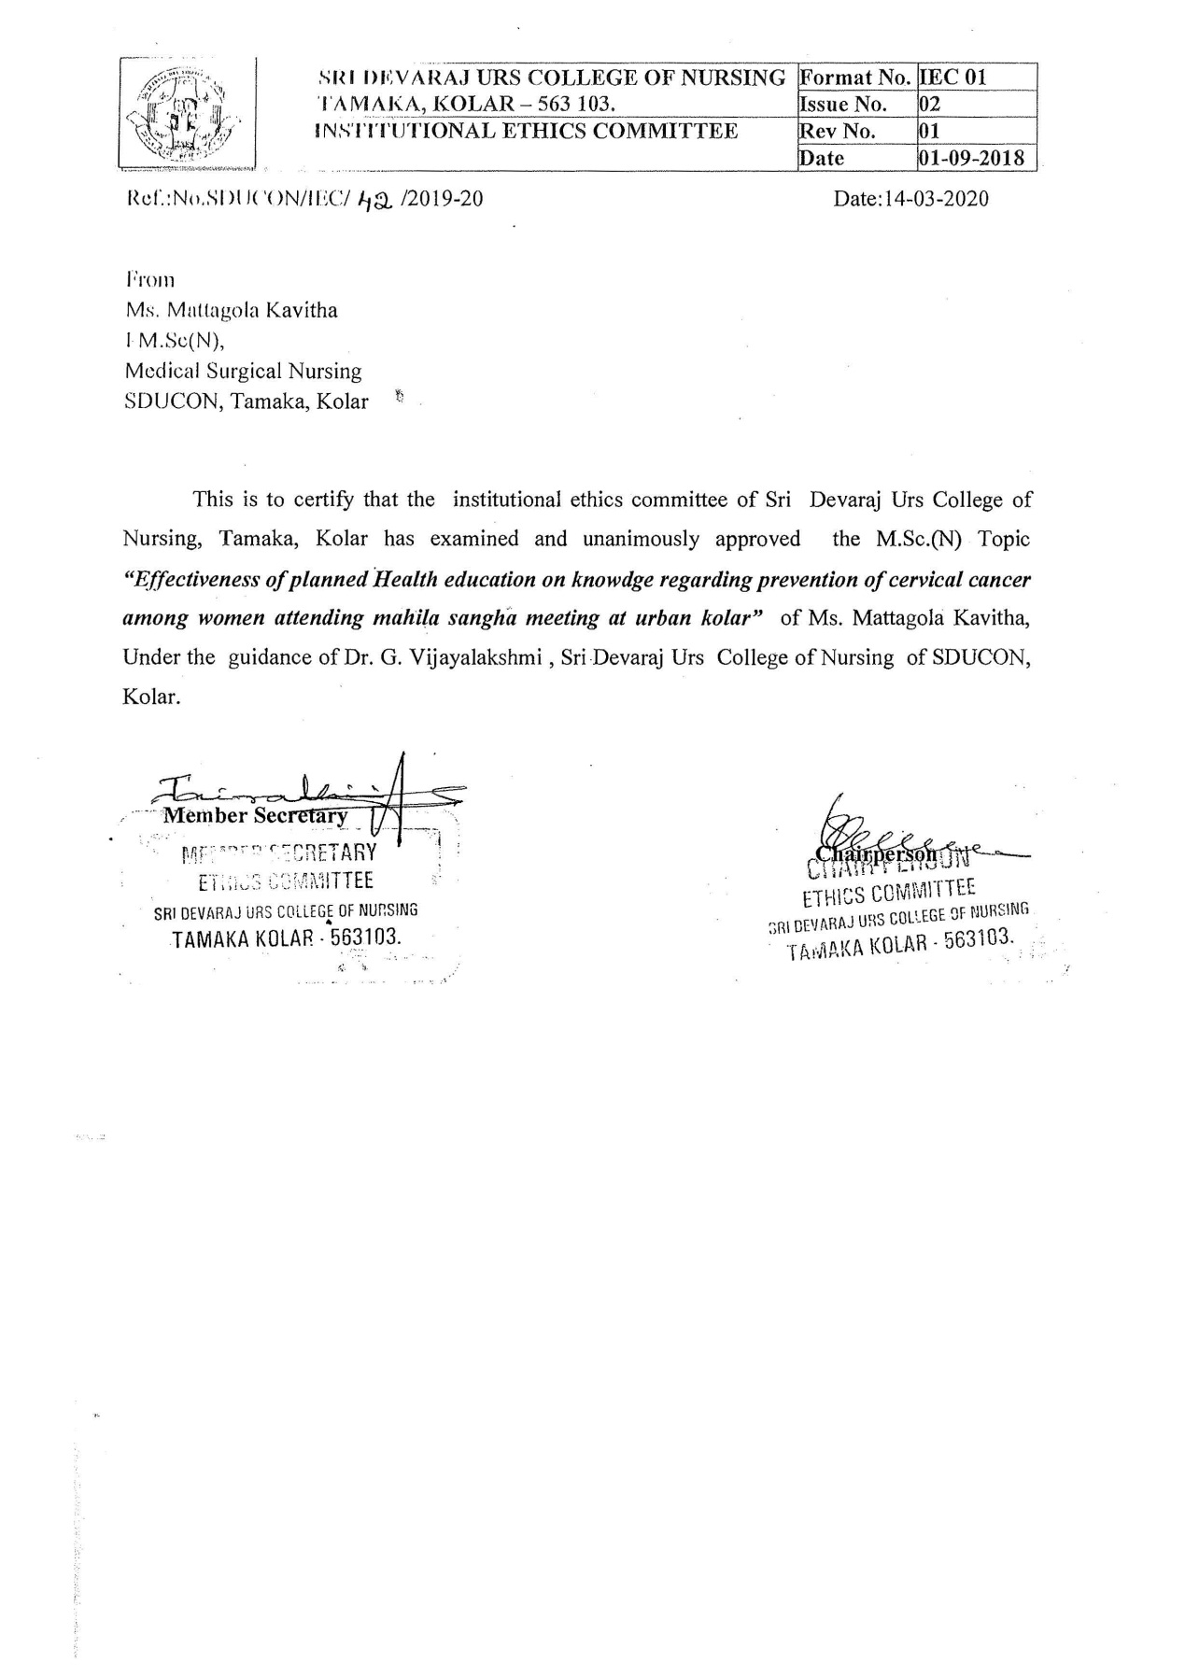
ANNEXURE-II
Synopsis Approval Letter
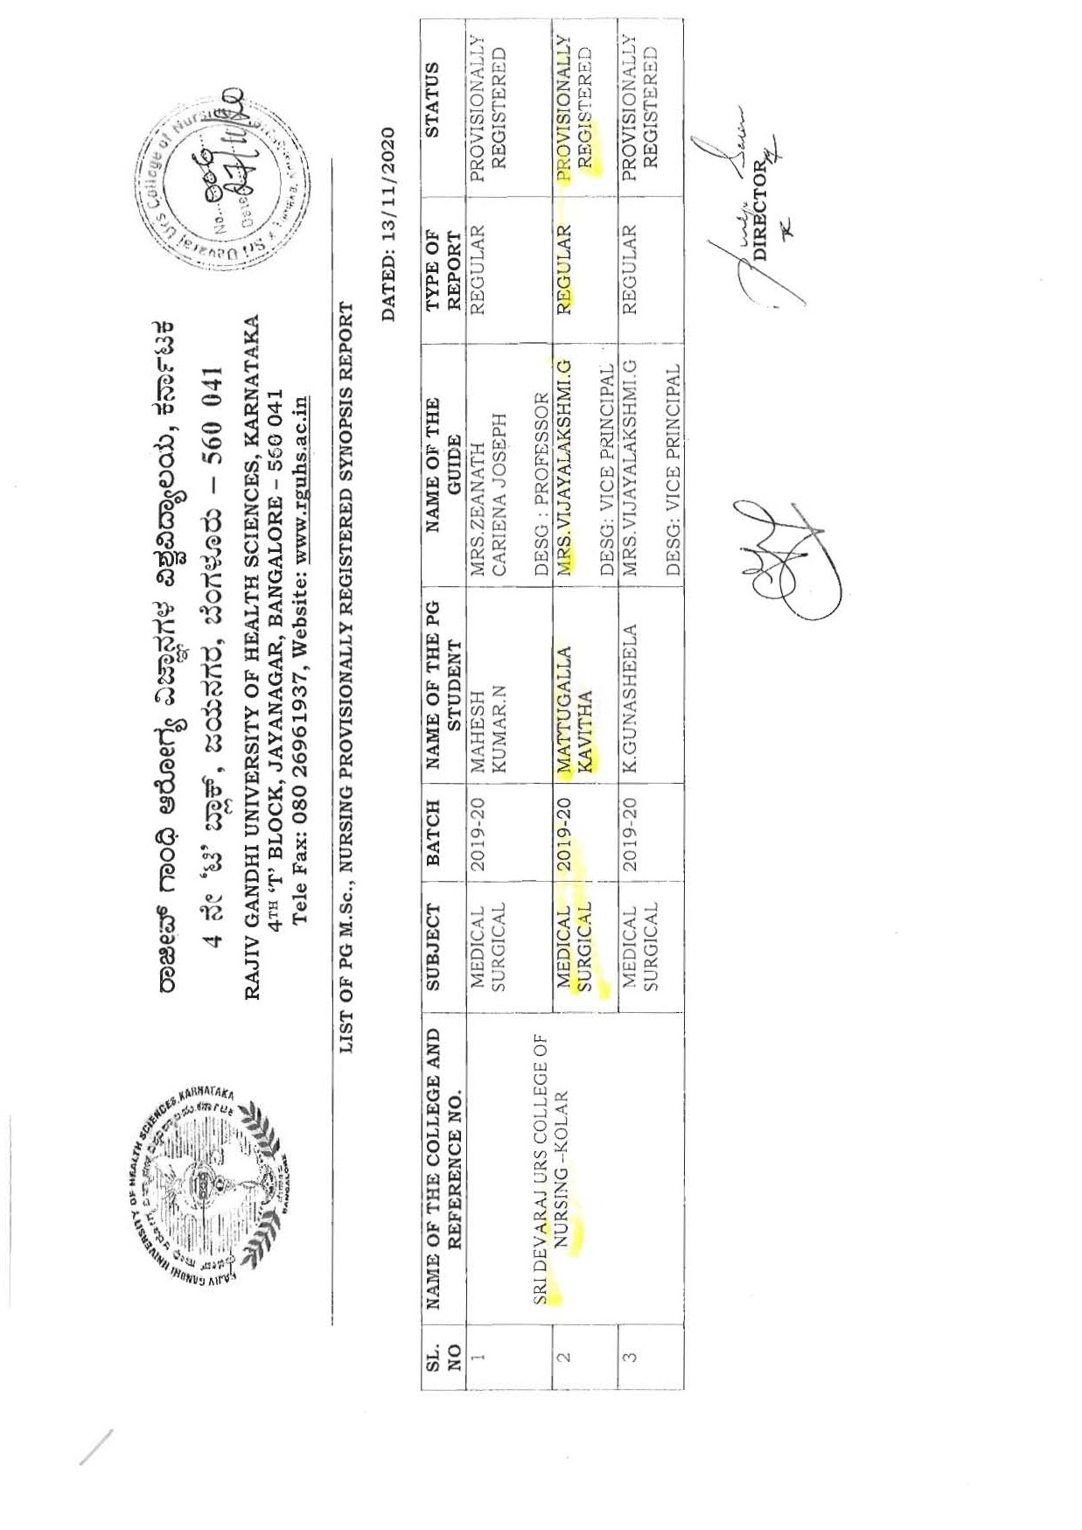

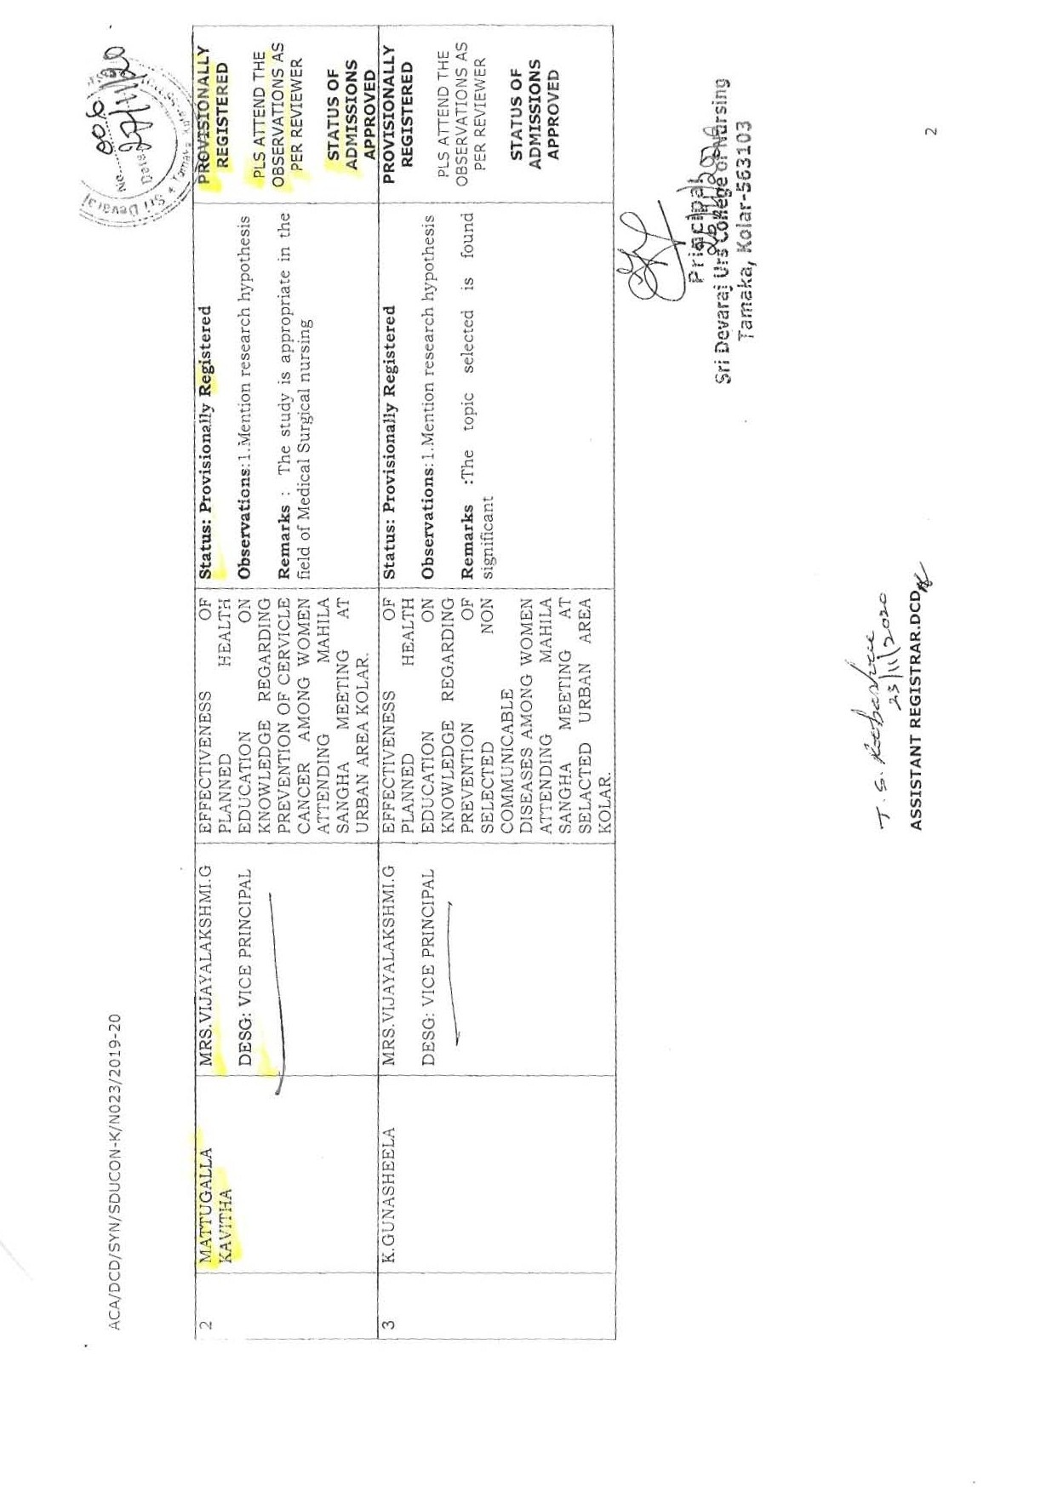

ANNEXURE-III
Letter requesting permission to conduct main study
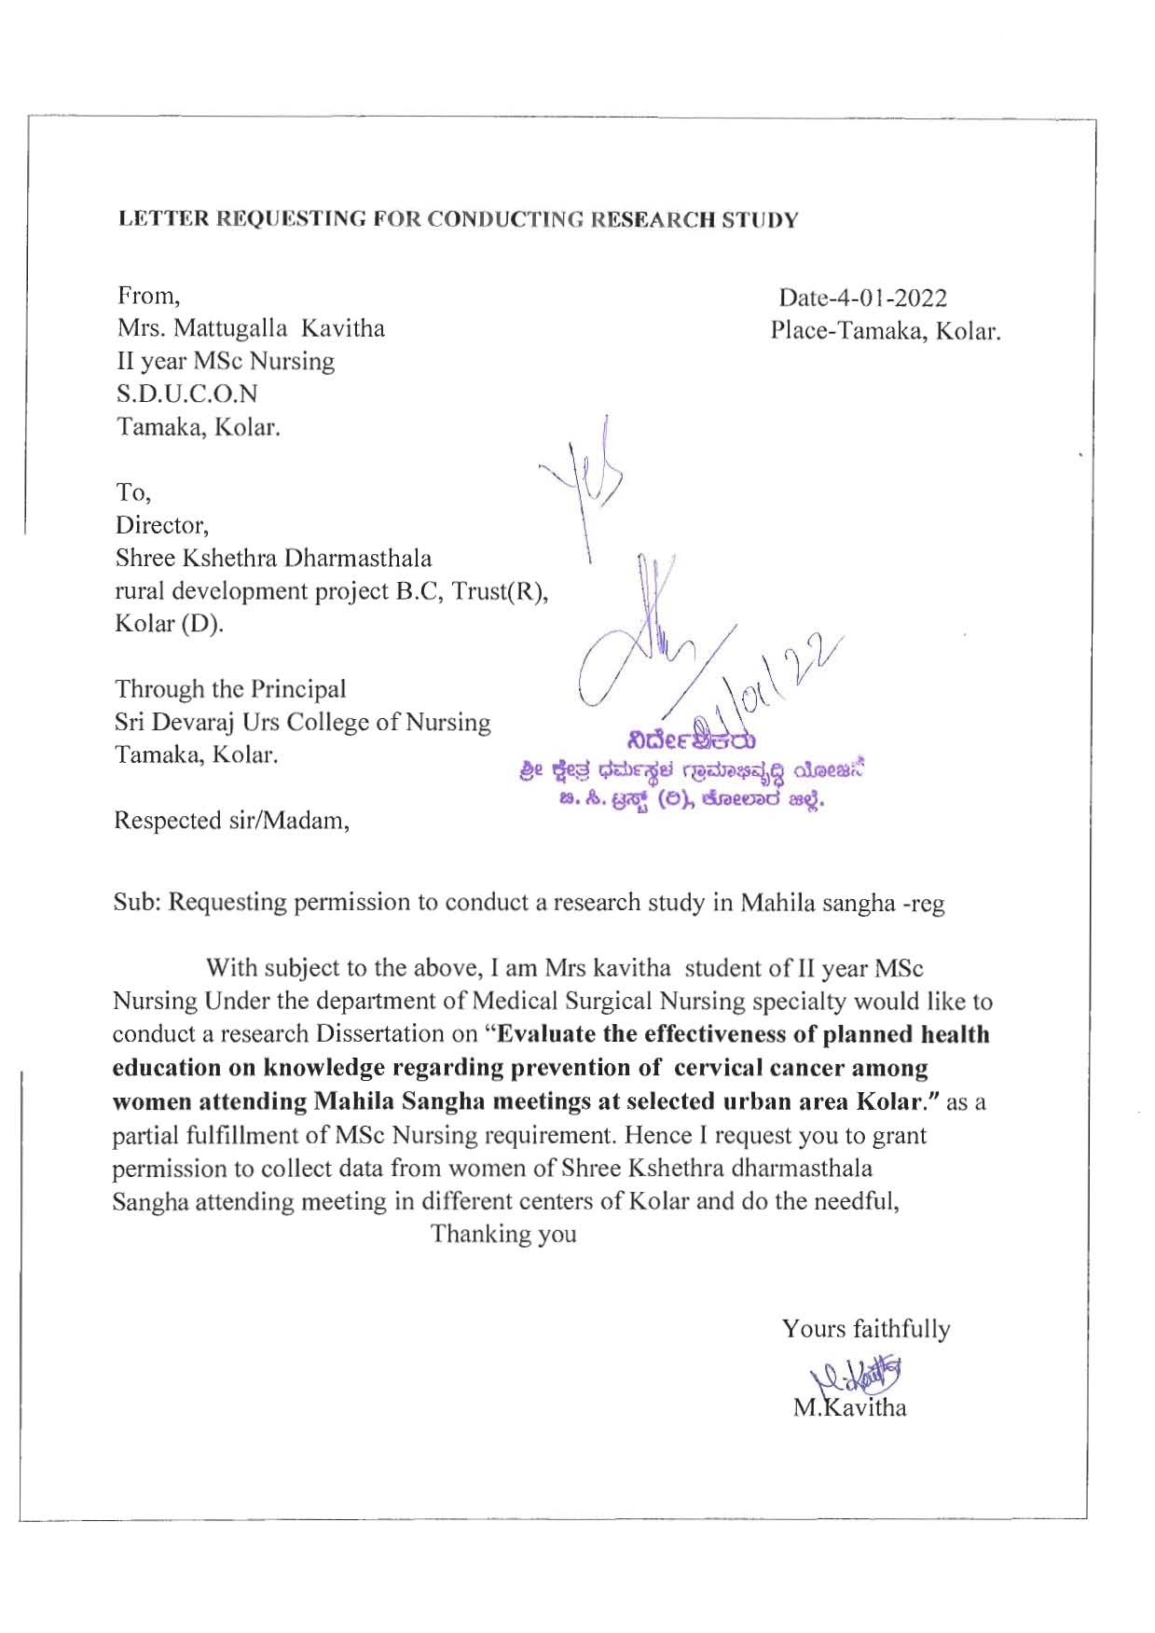
ANNEXURE-IV
LETTER REQUESTING OPINION AND SUGGESTION OF EXPERTS FOR ESTABLISHING CONTENT VALIDITY OF RESEARCH TOOL
From,
Mrs.MattugallaKavitha
II YEAR M.Sc. (N) Student
Sri DevarajUrs college of Nursing
Tamaka, Kolar-563101
To,
Respected madam/sir,
Sub: Request for opinion and suggestions of experts for establishing content validity of research tool.
I, Mrs.MattugallaKavithapost graduate student (Medical Surgical Nursing Speciality) of Sri DevarajUrs college of Nursing, Tamaka, Kolar has selected the below mentioned topic for my Dissertation, as a requirement of Masters of Nursing Degree.
Title of the topic:
“EFFECTIVENESS OF PLANNED HEALTH EDUCATION ON KNOWLEDGE REGARDING PREVENTION OF CERVICAL CANCER AMONG WOMEN ATTENDING MAHILA SANGHA MEETING AT SELECTED URBAN AREA, KOLAR”.
With regards to above May I kindly request you to validate the tool and Health Education content at the earlist. Here with I am enclosing the objectives of the study. I would be highly obliged and remain thankful for your great help.
Thanking you yours sincerely,
MattugalaKavitha.

ANNEXURE-V
Criteria rating scale for validating the content on knowledge questionnaire regarding Cervical Cancer among Women.
Respected Sir/Madam,
Kindly go through the content and rate the content in the appropriate columns given below:
Section-A
Sl.no | Item | Very  Relevant | Relevant | Needs modification | Not Relevant
 | Socio-demographic data
1
2
3
4
5

Section-B: knowledge on prevention of cervical cancer
Sl. No. | Item | Very  Relevant | Relevant | Needs modification | Not Relevant
I | Questions related to general information
1
2
3
4
5
II | Questions related to risk factors
6
7
8
9
10
11
12
III | Questions related to signs and symptoms
13
14
15
16
17
18
IV | Questions related to treatment
19
20
V | Questions related to prevention of cervical cancer
21
22
23
VI | Questions related to screening
24
25
VII | Questions related to health education
26
27
28

ANNEXURE-VI
LIST OF EXPERTS
- Dr.AbayKattepur
Associate Professor
Dept. of Surgical Oncology
SDUMC, Kolar-563130.
- Dr. Manjunath
Radio oncologist
Dept. of Radiotherapy
SDUMC, Kolar-563130
- Dr. Sadana Reddy
Senior Resident
Dept. of OBG
SDUMC, Kolar-563130
- Dr. Zeanath C J
HOD of MSN Dept
CNO, RLJH&RC
Tamaka , Kolar.
- Mrs. Punitha
HOD of OBG Dept.
SDUCON
Tamaka, Kolar.
- Mrs. Gayathri
Prof. of OBG
SDUCON
Tamaka, Kolar.
- Mr.Sasikumar
Prof. of MSN
Banglore

ANNEXURE-VII
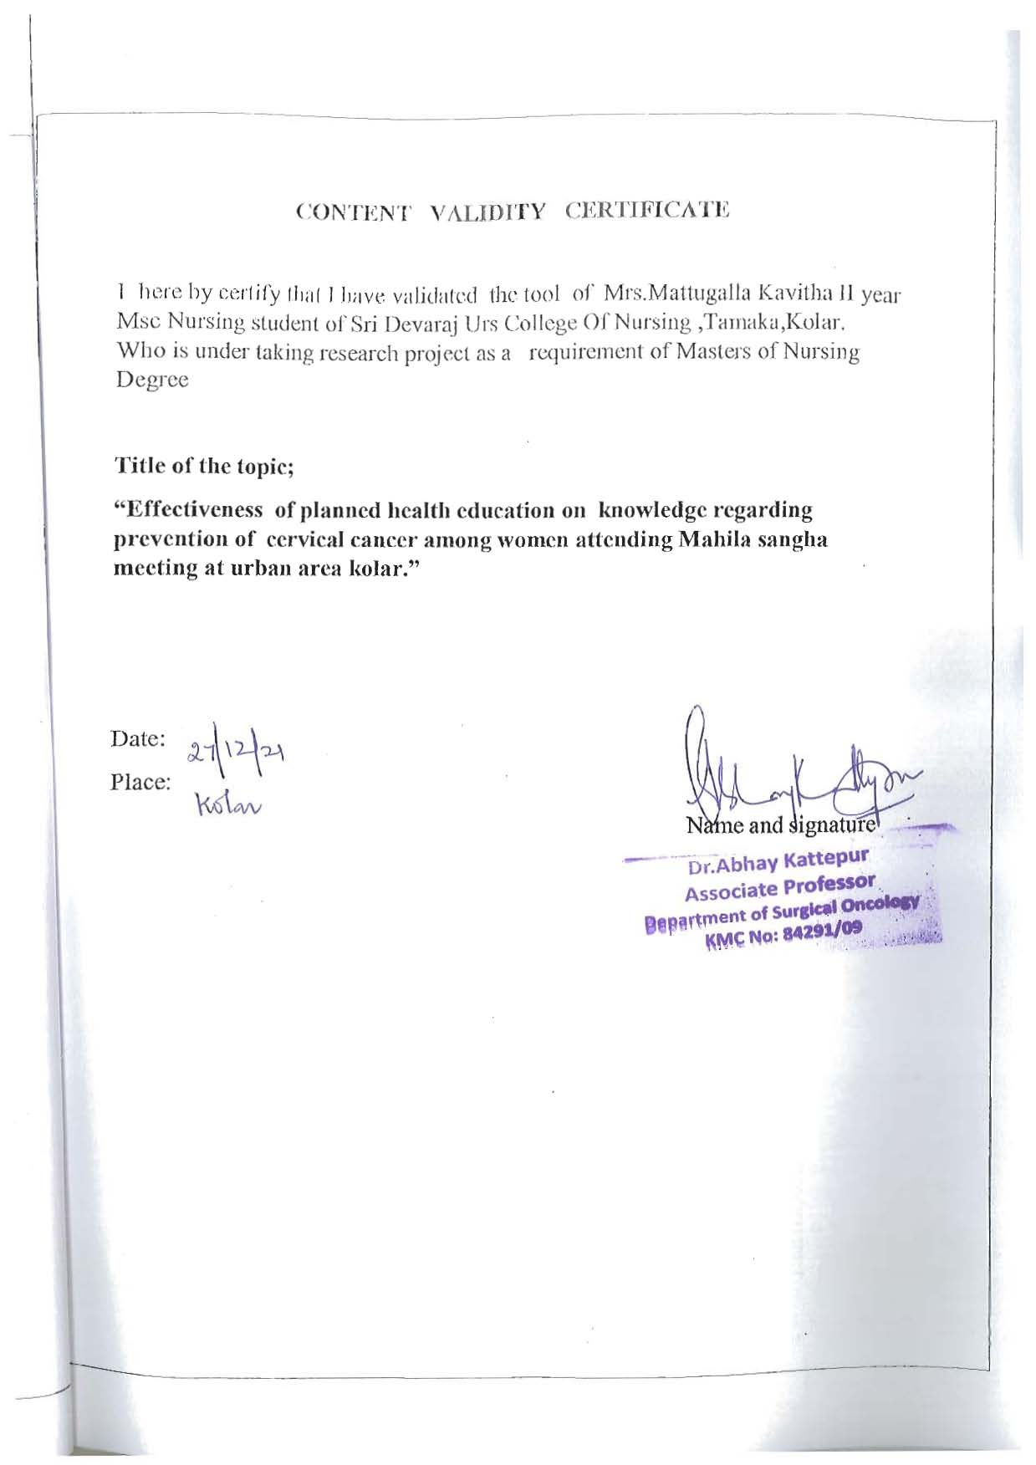

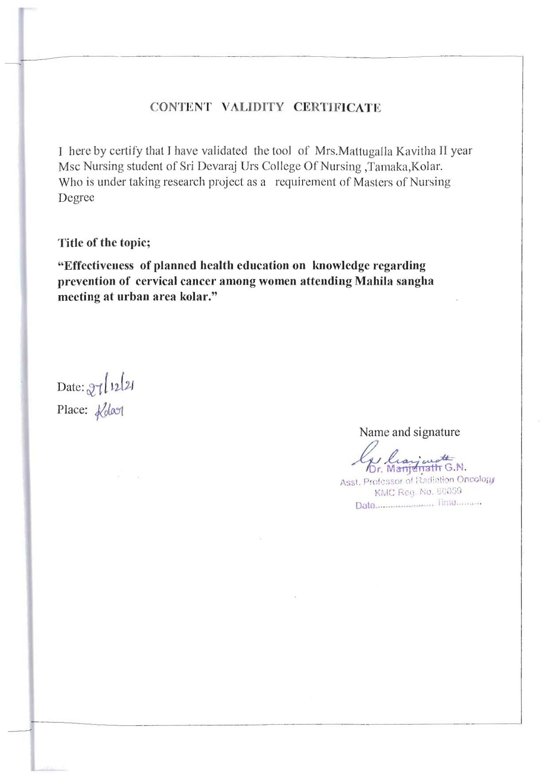

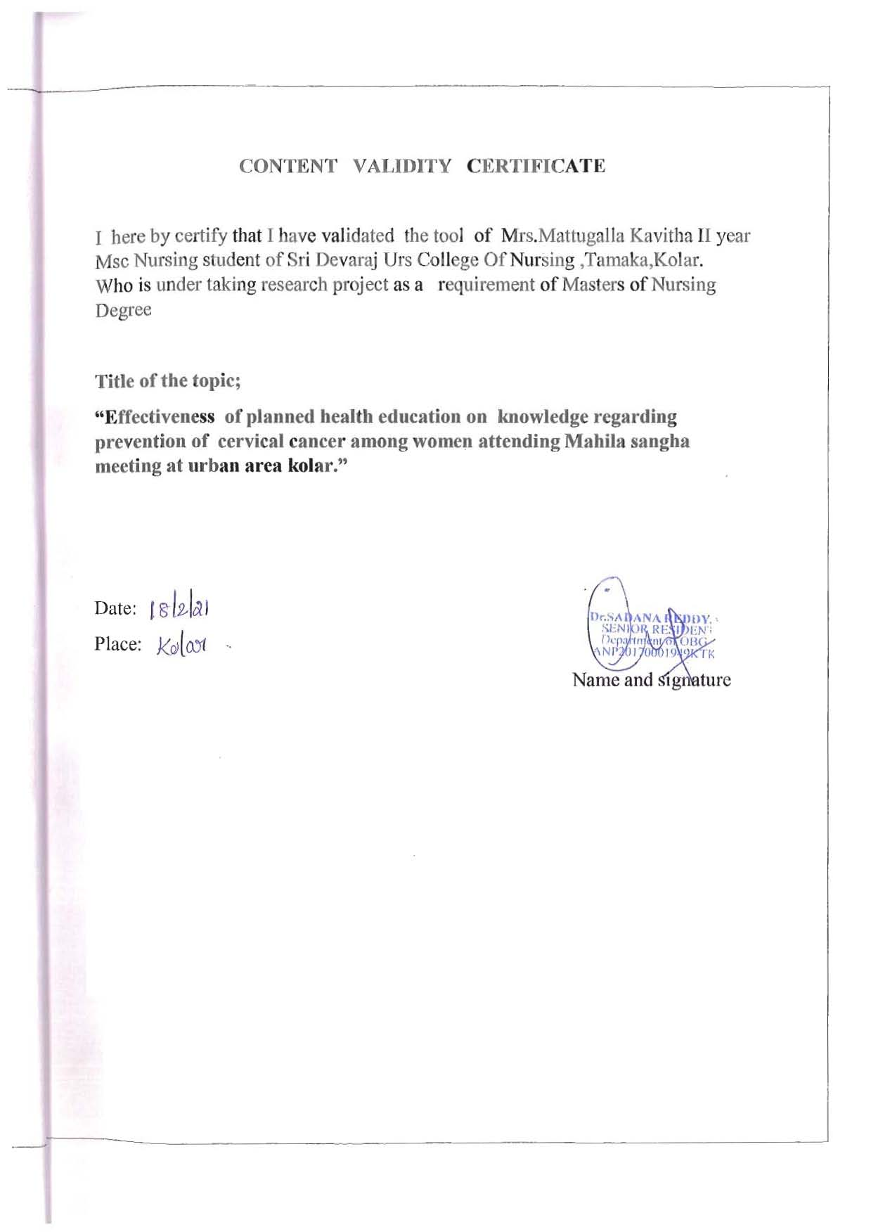

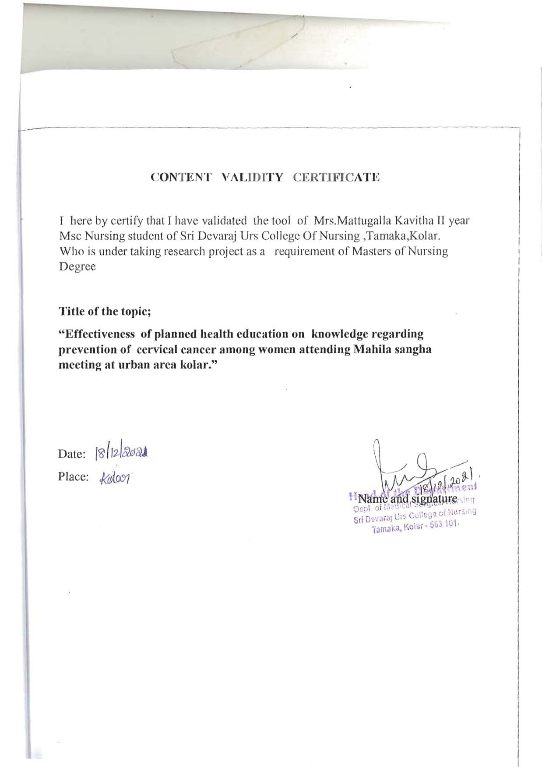

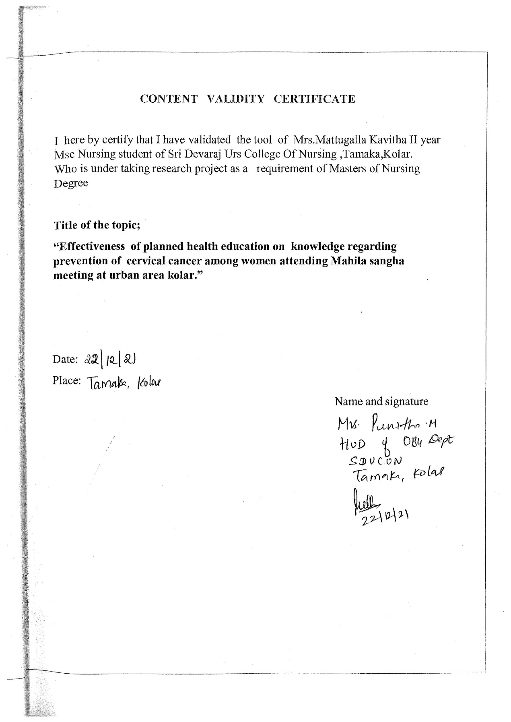

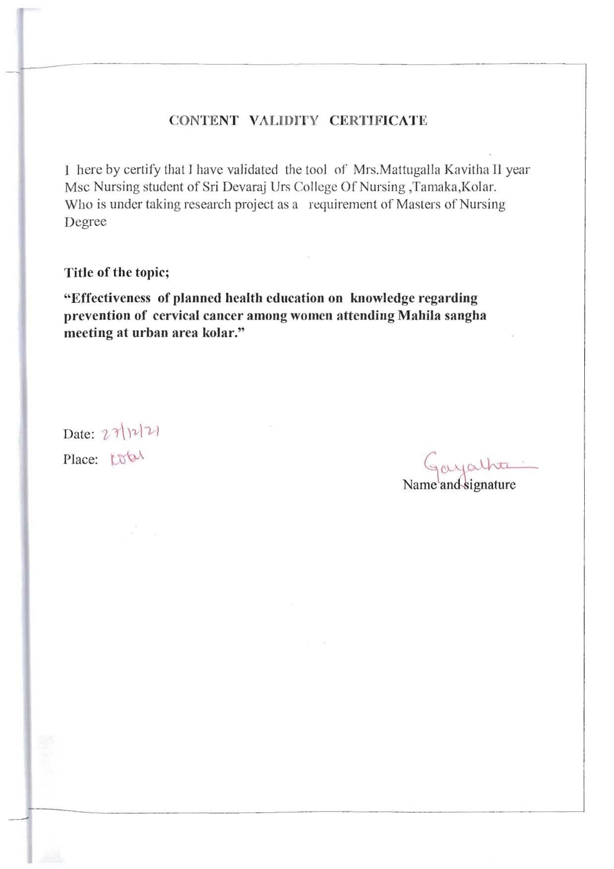

ANNEXURE-VIII
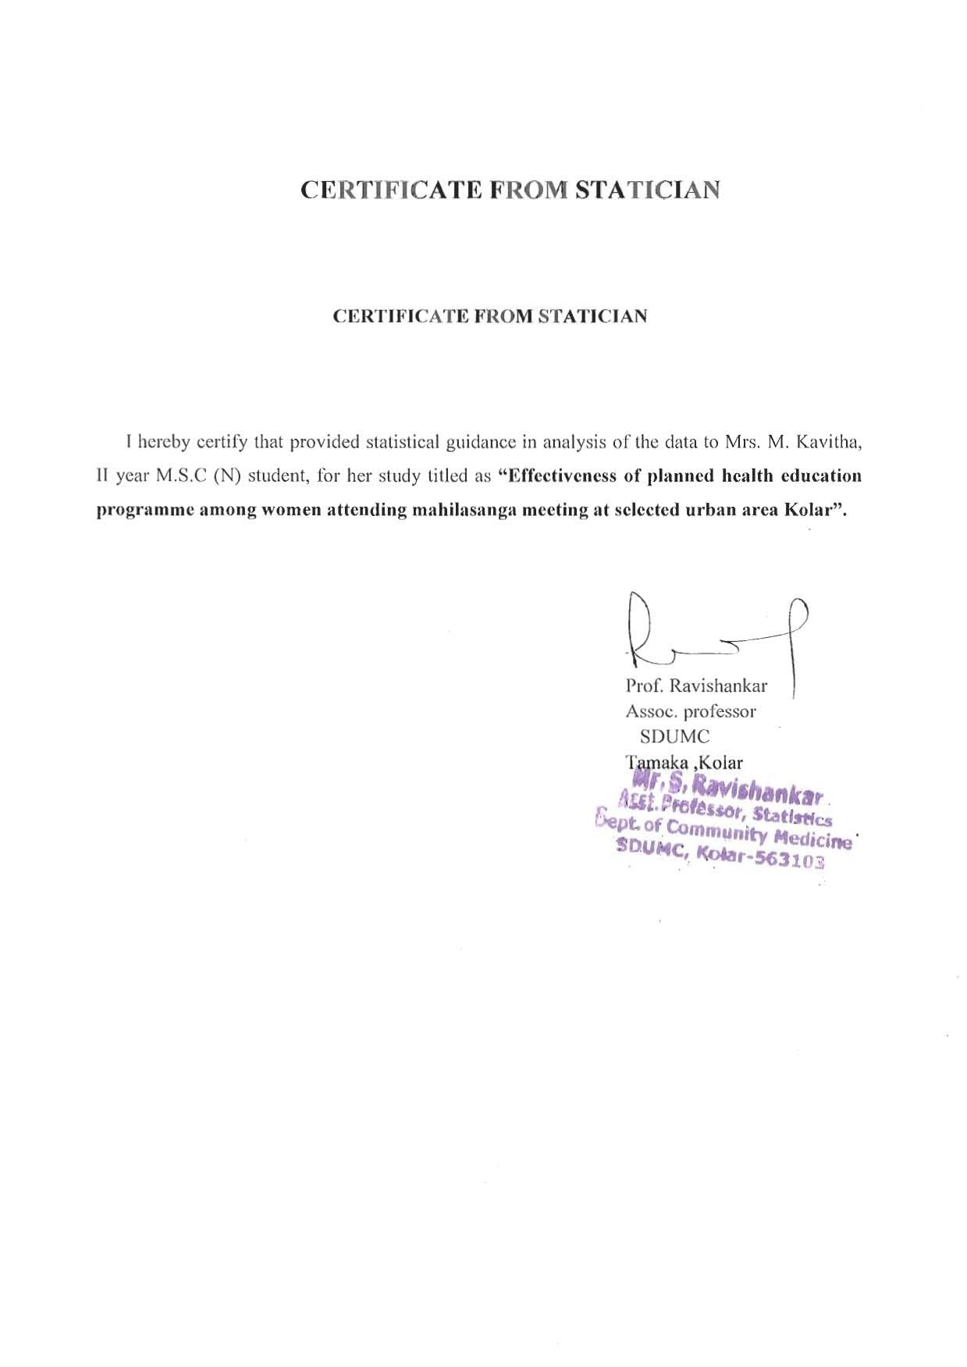

ANNEXURE-IX
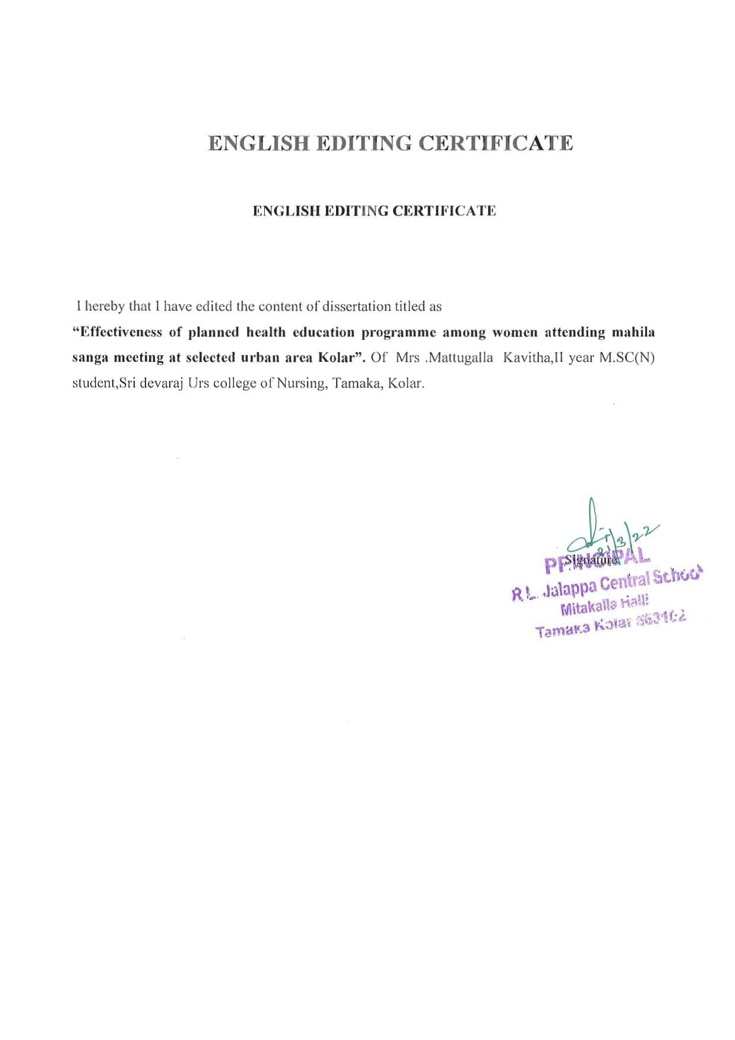

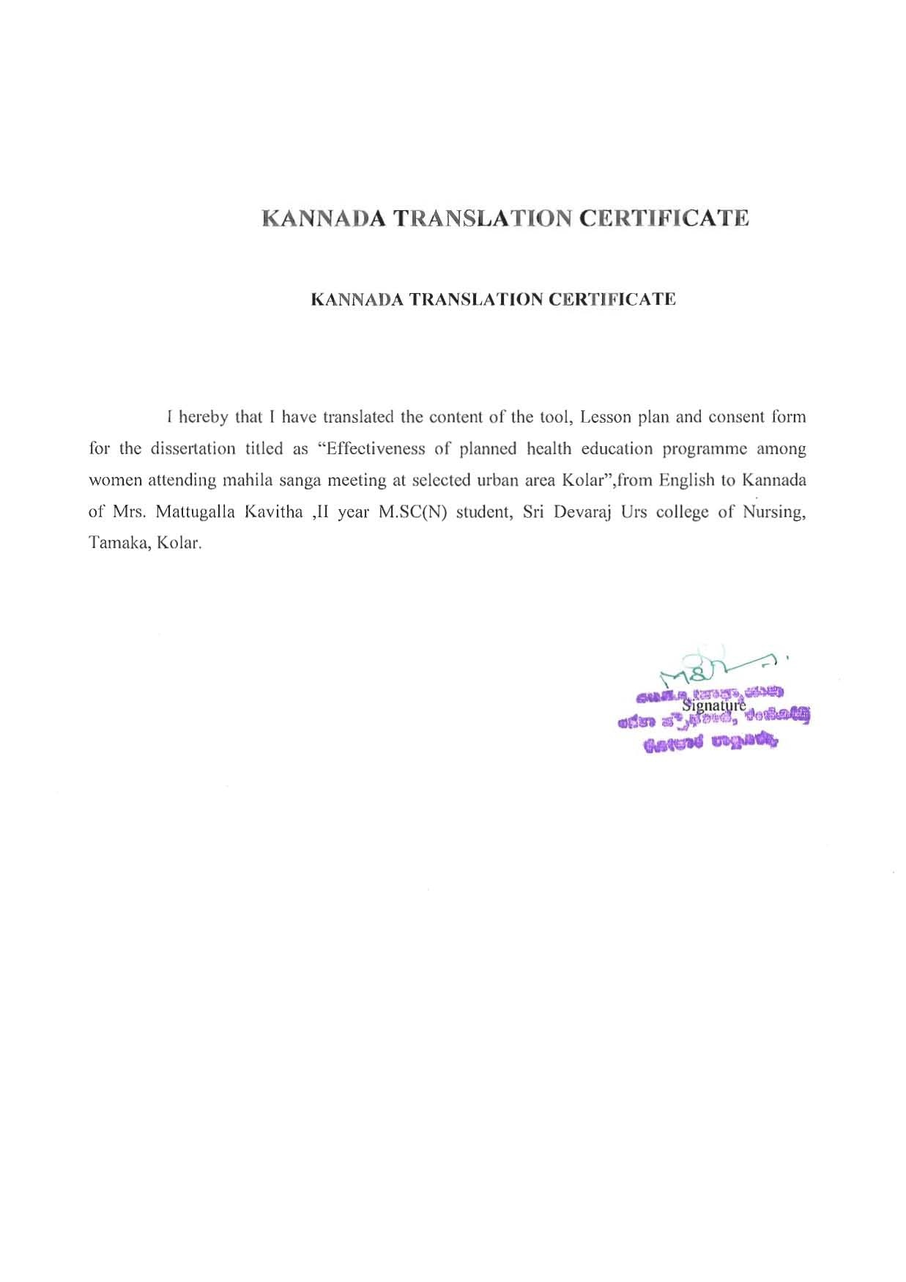
ANNEXURE-X

ANNEXURE-XI
INFORMED CONSENT FORM

Name of the investigator: Mattugallakavitha
Name of the Organization: Sri DevarajUrs College of Nursing,Tamaka,Kolar.
Title of the study:Effectiveness of planned health education on knowledge regarding prevention of cervicle cancer among women attending Mahilasangha meeting at urban area kolar.

If you agree to participate in the study I will collect information (as per proforma) from you or a person responsible for you or both. We will collect relevant details.
You are invited to part in this research study. You are being asked to participate in this study because you satisfy our eligibility criteria. The information in the given document is meant to help you decidewhether or not to take part.Please feel free to ask any queries.
I have read or it has been read and explained to me in my own language. I have understood the purpose of this study, the nature of information that will be collected and disclosed during the study. I had the opportunity to ask questions and the same has been answered to my satisfaction. I understand that I remain free to withdraw from this study at any time and this will not change my future care. I give my consent to collect the information & also can be used for medical research, test validation, or education as long as my privacy is maintained.
Patient’s signature/ Thumb impression
Person obtaining consent and his/her signature:
Principal investigator signature

M¦àUÉ ¥ÀvÀæ
C£ÀÄPÀæªÀÄ ¸ÀASÉå:
CzsÀåAiÀÄ£ÀzÀ²Ã¶ðPÉ:ಕೋಲಾರನಗರದಆಯ್ದಪ್ರದೇಶಗಳಲ್ಲಿಮಹಿಳಾಸಂಘಗಳಸಭೆಗಳಲ್ಲಿಪಾಲ್ಗೊಳ್ಳುವಮಹಿಳೆಯರಲ್ಲಿಗರ್ಭಕಂಠದ ಕ್ಯಾನ್ಸರ್ತಡೆಗಟ್ಟುವಜ್ಞಾನದಬಗ್ಗೆಆರೋಗ್ಯಶಿಕ್ಷಣದಪರಿಣಾಮಗಳನ್ನುಮೌಲ್ಯಮಾಪನಮಾಡಿ.

ªÀÄÄRå¸ÀA±ÉÆÃzsÀPÀgÀ ºÉ¸ÀgÀÄ:

¨sÁUÀªÀ»¸ÀÄªÀgÀ ºÉ¸ÀgÀÄ:ಕವಿತ

F CzsÀåAiÀÄ£ÀzÀ ¥Àæw «ªÀgÀUÀ¼À£ÀÄß ºÁUÀÆ CzÀgÀGzÉÞÃ±ÀªÀ£ÀÄß £À£ÀUÉ DxÀðªÁUÀÄªÀAvÉ w½¹PÉÆnÖgÀÄvÁÛgÉ.F CzsÀåAiÀÄ£ÀzÀ §UÉÎ ºÀ®ªÁgÀÄ ¥Àæ±Éß PÉÃ¼À®Ä CªÀPÁ±À zÉÆgÉwzÉ ºÁUÀÆ £À£Àß ¥Àæ±ÉßUÀ½UÉ vÀÈ¦ÛPÀgÀªÁzÀ GvÀÛgÀUÀ¼ÀÄ zÉÆgÉwzÉ.
£À¤ßAzÀNzÀ®àlÖCxÀªÁ £À£ÀUÉ N¢ w½¹zÀ CzsÀåAiÀÄ£ÀzÀGzÉÝÃ±À £À£ÀUÉ CxÀðªÁVzÀÄÝ, £À¤ßAzÀ ¸ÀAUÀæ»¸À®àlÖ ªÀiÁ»wAiÀÄ£ÀÄß PÉÃªÀ® CzsÀåAiÀÄ£ÀPÁÌV §¼À¸À¯ÁUÀÄªÀÅzÀÄ.ºÁUÀÄ F ªÀiÁ»wAiÀÄ£ÀÄßUË¥ÀåªÁVqÀ¯ÁUÀÄªÀÅzÀÄ.£À£ÀßUÀÄgÀÄvÀ£ÀÄß §»gÀAUÀ ¥Àr¸ÀÄªÀÅ¢®èJAzÀÄ w½¸À¯ÁVzÉ.F CzsÀåAiÀÄ£ÀzÀ°è ¨sÁUÀªÀ»¸À®Ä C¢üPÀÈvÀªÁV ªÀiÁ»w ¸ÀAUÀæ»¸À®Ä, ¥ÀjÃQë¸À®Ä ªÀÄvÀÄÛ ªÉÊAiÀÄÄQÛPÀ ªÀiÁ»wAiÀÄ£ÀÄßUË¥ÀåªÁVj¸À®Ä £À£Àß ¸ÀéEZÉÑ¬ÄAzÀM¦à ¸À» ºÁQgÀÄvÉÛÃ£É.

¨sÁUÀªÀ»¸ÀÄªÀªÀgÀ ¸À»
¢£ÁAPÀ

¸ÀAzÀ±ÀðPÀgÀ ºÉ¸ÀgÀÄ ªÀÄvÀÄÛ ¸À»:
¢£ÁAPÀ:
ªÀÄÄRå¸ÀA±ÉÆÃzÀPÀgÀ ¸À»: ------------

ANNEXURE-XII
Dear participants,
Here I have prepared a tool to assess knowledge regarding prevention of cervical cancer, so kindly a tick mark () against each item which you find more suitable by you in the checklist. Your answer will be kept confidential ,so feel free to answer.
Section-A
Socio demographic data
1. Age
a). 20-29 years
b). 30-39 years
c). 40-49 years
d). 50-60 years

2. Marital status
a). Married
b).Un marriage

3. Education status
a). Illiterate
b). Primary &Higher primary education
c) .Higher Secondary education d). Graduate and above

4. Occupation
a). Unemployed
b). Self-employee
c). Private employee

5. Age of menarche
a).10-12 years
b).13-15 years
c).Above 16 years

Section –B
Structured knowledge questionnaire
1. Where is the cervix located in the body
a). In the ovaries
b). At the lower part of the uterus
c). At the upper part of the uterus
d). In the side part of the uterus

2. Cancer means
a). Viral disease
b). Controlled growth of cells
c). Uncontrolled growth of cells
d).Sexually transmited disease

3. Cervical cancer means
a) .The uncontrolled growth of abnormal cells in the cervix
b). Swelling in the uterus
c). Numbness in the uterus
d). Lesion in cervix

4. Cervical cancer mostly develop at
a). External lining of cervix
b). Internal lining of cervix
c). Lymp nodes of cervix
d). Muscle of cervix
5. In Karnataka incidence of cervical cancer yearly are
a). 2,500
b). 3,000
c). 4,000
d).5,000
II.Riskfactors related questions
6. The major risk factors for cervical cancer is
a).Smoking
b). HPV (human papilloma virus) infection
c). Infection with the virus that causes AIDS
d). All of the above
7. The risk factors for developing cervical cancer is
a). Smoking
b). Weakened immune system
c). Family history of cervical cancer
d).All of the above
8. Cervical cancer is common among
a). No sexual activity women
b). Having more than one sexual partners
c). Late sexual activity women
d). None of the above
9.The more susptible risk factor to get cervical cancer are
a) . Women who eat more fatty food
b). Women who have family history of cervical cancer
c). Women who has history of loss of weight
d). Women who are Obese.
10.The effect of early menarche on cervical cancer
a). Increase the risk of cervical cancer
b). Decreases the risk of cervical cancer
c). Does not have any effect
d). Depends on weight of the person
11. The major cause of cervical cancer is
a).Sexually transmitted infection
b).Respiratory tract infection
c) Urinary tract infection
d) Nosocomial infection
12.Cervical cancer is more common in woman age
group between
a) 15 – 25 yrs
b). 25 – 35 yrs
c).35 – 45 yrs
d). 45 yrs and above
III.Sings and symptoms related questions
13. In the early stage symptoms of cervical cancer is
a). Usually there are none
b). Abdominal cramps and diarrhea
c). Nausea
d). Anemia and extreme tiredness
14. One of the warning signs of cervical cancer is
a). Chest pain
b). Giddiness
c). Abnormal menstruation
d). Leg pain
15 .If cervical cancer is identified early and treated,the prognosis rate is
a). Almost all of them
b). 4 out of 5
c) 1 out of 2
d). 3 out of 4
16.Early detection of cervical cancer is by
a). Education of all women
b). Physical Examination
c). Pap smear test
d). Blood test
17. Pap smear means
a). It is a blood test
b). Cells are scaped from the cervix for identify the disease
c). Urine test
d). Sputum test
18. cervical cancer will spread in
a). Days
b). Weeks
c). Months
d). Years
IV.Treatment related questions
19.The treatment for cervical cancer is
a). Surgery
b). Chemotherapy
c).Radiation
d).All of the above
20. The drugs use to destroy cancer cells is called
a). Physiotherapy
b). Chemotherapy
c). Psycotherapy
d). Audiotherapy

V.Cervical cancer prevention related questions
21. Cervical cancer can be prevented by
a). Exercise
b). Losing weight
c). HPV vaccine
d). Healthy diet
22. Can cervical cancer be cured
a). Never
b). Sometimes
c). Frequently
d). Always
23. One of the following is the primary prevention of cervical cancer
a).Regular exercise
b). Avoid early intercourse
c). Previous injuries
d). Avoid spicy food
VI.Cervical cancer screening related questions
24. Screened for cervical cancer should be start at the age group
a). all girls and teenagers
b). young women under age 21
c). Adult women age 21-65
d). Older women age 65 and older
25.Cervical cancer screening to be performed at least
a). Once in a year
b). Two years interval
c).Three years interval
d). Four years interval
VII.Health education related Question

26. The health practices during menstruation to be followed is
a). Cleaning of perineum with soap and water
b).Changing of pads or cloth at least thrice daily
c). Washing of undergarments
d). Drying undergarments in sunlight

27. The foods to be taken to prevent the cancer cervix is
a). Bland diet
b). Green leafy vegetables and fruits
c). Fiber foods
d). Fatty foods
28. The Vitamin has got a protective effect against cancer cervix is
a). Vitamin A & C
b). Vitamin K & D
c).Vitamin B & E
d). Vitamin B6 & B12

ANNEXURE-XIII
ಭಾಗವಾಹಿಸುವಆತ್ಮೀಯರೇ,
ಇಲ್ಲಿನಾನುಗರ್ಭಕಂಠದಕ್ಯಾನ್ಸರ್‌ರ್ತಡೆಗಟ್ಟುವಿಕೆಗೆಸಂಬಂಧಿಸಿದಜ್ಞಾನವನ್ನುಮೌಲ್ಯಮಾಪನಮಾಡಲುಒಂದುಸಾಧನವನ್ನುಸಿದ್ಧಪಡಿಸಿದ್ದೇನೆ,ಆದ್ದರಿಂದಚೆಕ್ಲಿಸ್ಟ್ನಲ್ಲಿನಿಮಗೆಹೆಚ್ಚುಸೂಕ್ತವಾದಪ್ರತಿಯೊಂದುಐಟಂವಿರುದ್ಧಟಿಕ್ಮಾರ್ಕ್ಮಾಡು).
ನಿಮ್ಮಉತ್ತರವನ್ನುಗೌಪ್ಯವಾಗಿಡಲಾಗುವುದು,ಆದ್ದರಿಂದಉತ್ತರಿಸಲುಹಿಂಜರಿಯಬೇಡಿ.

ವಿಭಾಗ-ಎ
ಸಾಮಾಜಿಕಜನಸಂಖ್ಯಾಸಂಗ್ರಹ
1.ವಯಸ್ಸು
a).20-29 ವರ್ಷಗಳು
b).30-39 ವರ್ಷಗಳು
c).40-49 ವರ್ಷಗಳು
d).50-60 ವರ್ಷಗಳು
2. ವೈವಾಹಿಕಸ್ಥಿತಿ
a).ವಿವಾಹಿತ
b).ವಿವಾಹ

3. ಶಿಕ್ಷಣಸ್ಥಿತಿ
a).ಅನಕ್ಷರಸ್ಥ
b).ಪ್ರಾಥಮಿಕಮತ್ತುಉನ್ನತಪ್ರಾಥಮಿಕಶಿಕ್ಷಣ
c).ಉನ್ನತ ಮಾಧ್ಯಮಿಕ ಶಿಕ್ಷಣ
d).ಪದವಿ ಮತ್ತು ಮೇಲ್ಪಟ್ಟವರು
4. ಉದ್ಯೋಗ
a).ನಿರುದ್ಯೋಗಿ
b).ವ್ಯಾಪಾರ
c).ಖಾಸಗಿಉದ್ಯೋಗಿ
5. ಮೊದಲ ಮುಟ್ಟಿನ ವಯಸ್ಸು
a).10-12 ವರ್ಷಗಳು
b).13-15 ವರ್ಷಗಳು
c).16 ವರ್ಷಕ್ಕಿಂತಮೇಲ್ಪಟ್ಟವರು

ವಿಭಾಗ –ಬಿ
ರಚನಾತ್ಮಕಜ್ಞಾನಪ್ರಶ್ನಾವಳಿ
1.ದೇಹದಲ್ಲಿಗರ್ಭಕಂಠಎಲ್ಲಿದೆ
a).ಅಂಡಾಶಯದಲ್ಲಿ
b).ಗರ್ಭಾಶಯದಕೆಳಗಿನಭಾಗದಲ್ಲಿ
c).ಗರ್ಭಾಶಯದಮೇಲಿನಭಾಗದಲ್ಲಿ
d).ಗರ್ಭಾಶಯದಬದಿಯಭಾಗದಲ್ಲಿ

2. ಕ್ಯಾನ್ಸರ್ರ್ಎಂದರೆ
a).ವೈರಲ್ರೋಗ
b).ಜೀವಕೋಶಗಳನಿಯಂತ್ರಿತಬೆಳವಣಿಗೆ
c).ಜೀವಕೋಶಗಳಅನಿಯಂತ್ರಿತಬೆಳವಣಿಗೆ
d).ಲೈಂಗಿಕವಾಗಿಹರಡುವರೋಗ

3. ಗರ್ಭಕಂಠದ ಕ್ಯಾನ್ಸರ್ರ್ಎಂದರೆ
a).ಗರ್ಭಕಂಠದಅಸಹಜಕೋಶಗಳಅನಿಯಂತ್ರಿತಬೆಳವಣಿಗೆ
b).ಗರ್ಭಾಶಯದಲ್ಲಿಊತ
c).ಗರ್ಭಾಶಯದಲ್ಲಿಮರಗಟ್ಟುವಿಕೆ
d).ಗರ್ಭಕಂಠದಗಾಯ
4.ಗರ್ಭಕಂಠದ ಕ್ಯಾನ್ಸರ್ರ್ಹೆಚ್ಚಾಗಿಬೆಳೆಯುತ್ತದೆ
a).ಗರ್ಭಕಂಠದಬಾಹ್ಯಪದರ
b).ಗರ್ಭಕಂಠದಒಳಪದರ
c).ಗರ್ಭಕಂಠದ ದುಗ್ಧರಸಗ್ರಂಥಿಗಳು
d).ಗರ್ಭಕಂಠದಸ್ನಾಯು
5.ಕರ್ನಾಟಕದಲ್ಲಿ ವಾರ್ಷಿಕವಾಗಿ ಗರ್ಭಕಂಠದ ಕ್ಯಾನ್ಸರ್‌ನ ಪ್ರಮಾಣ ಹೀಗಿದೆ
a).2,500
b).3,000
c).4,000
d).5,000

II. ಅಪಾಯಕಾರಿಅಂಶಗಳುಸಂಬಂಧಿಸಿದಪ್ರಶ್ನೆಗಳು
6. ಗರ್ಭಕಂಠದ ಕ್ಯಾನ್ಸರ್ಗೆಪ್ರಮುಖಅಪಾಯಕಾರಿಅಂಶಗಳು
a).ಧೂಮಪಾನ
b).HPV (ಮಾನವಪ್ಯಾಪಿಲೋಮವೈರಸ್) ಸೋಂಕು
c).ಏಡ್ಸ್ಗೆಕಾರಣವಾಗುವವೈರಸ್ಸೋಂಕು
d).ಮೇಲಿನಎಲ್ಲವೂ
7.ಗರ್ಭಕಂಠದ ಕ್ಯಾನ್ಸರ್ಬೆಳವಣಿಗೆಗೆಅಪಾಯಕಾರಿಅಂಶಗಳು
a).ಧೂಮಪಾನ
b).ದುರ್ಬಲಗೊಂಡಪ್ರತಿರಕ್ಷಣಾವ್ಯವಸ್ಥೆ
c).ಗರ್ಭಕಂಠದಕ್ಯಾನ್ಸರ್ನಕುಟುಂಬದಇತಿಹಾಸ
d).ಮೇಲಿನಎಲ್ಲಾ
8. ಈ ಜನರಲ್ಲಿ ಗರ್ಭಕಂಠದ ಕ್ಯಾನ್ಸರ್ ಸಾಮಾನ್ಯವಾಗಿದೆ
a).ಲೈಂಗಿಕಚಟುವಟಿಕೆಇಲ್ಲದಮಹಿಳೆಯರಿಗೆ
b).ಒಂದಕ್ಕಿಂತಹೆಚ್ಚುಲೈಂಗಿಕಪಾಲುದಾರರನ್ನುಹೊಂದಿರುವುದು
c).ತಡವಾದಲೈಂಗಿಕಚಟುವಟಿಕೆ
d).ಮೇಲಿನಯಾವುದೂಅಲ್ಲ
9. ಗರ್ಭಕಂಠದ ಕ್ಯಾನ್ಸರ್ಪಡೆಯಲುಹೆಚ್ಚುಸಂಶಯಾಸ್ಪದಅಪಾಯಕಾರಿಅಂಶಗಳೆಂದರೆ
a).ಹೆಚ್ಚುಕೊಬ್ಬಿನಆಹಾರವನ್ನುಸೇವಿಸುವಮಹಿಳೆಯರು
b).ಗರ್ಭಕಂಠದ ಕ್ಯಾನ್ಸರ್ನಕುಟುಂಬದಇತಿಹಾಸಹೊಂದಿರುವಮಹಿಳೆಯರು
c).ತೂಕನಷ್ಟದಇತಿಹಾಸಹೊಂದಿರುವಮಹಿಳೆಯರು
d).ಬೊಜ್ಜುಇರುವಮಹಿಳೆಯರು.

10. ಗರ್ಭಕಂಠದಕ್ಯಾನ್ಸರ್ಮೇಲೆಆರಂಭಿಕಮುಟ್ಟಿನಪರಿಣಾಮ
a).ಗರ್ಭಕಂಠದ ಕ್ಯಾನ್ಸರ್ಅಪಾಯವನ್ನುಹೆಚ್ಚಿಸಿ
b).ಗರ್ಭಕಂಠದ ಕ್ಯಾನ್ಸರ್ಅಪಾಯವನ್ನುಕಡಿಮೆಮಾಡುತ್ತದೆ
c).ಯಾವುದೇಪರಿಣಾಮಬೀರುವುದಿಲ್ಲ
d).ವ್ಯಕ್ತಿಯತೂಕವನ್ನುಅವಲಂಬಿಸಿರುತ್ತದೆ

11. ಗರ್ಭಕಂಠದ ಕ್ಯಾನ್ಸರ್ಗೆಮುಖ್ಯಕಾರಣ
a).ಲೈಂಗಿಕವಾಗಿಹರಡುವಸೋಂಕು
b).ಉಸಿರಾಟದಪ್ರದೇಶದಸೋಂಕು
c).ಮೂತ್ರದಸೋಂಕು
d).ನೊಸೊಕೊಮಿಯಲ್ಸೋಂಕು
12. ಈ ವಯಸ್ಸಿನ ಮಹಿಳೆಯರಲ್ಲಿ ಗರ್ಭಕಂಠದ ಕ್ಯಾನ್ಸರ್ ಹೆಚ್ಚು ಸಾಮಾನ್ಯವಾಗಿದೆ
a). 15 - 25 ವರ್ಷ
b).25-35 ವರ್ಷಗಳು
c).35 - 45 ವರ್ಷ
d).45 ವರ್ಷ 22jjಮತ್ತುಮೇಲ್ಪಟ್ಟವರು
III ರೋಗಲಕ್ಷಣಗಳಿಗೆಸಂಬಂಧಿಸಿದಪ್ರಶ್ನೆಗಳು
13.ಆರಂಭಿಕ ಹಂತದಲ್ಲಿ, ಗರ್ಭಕಂಠದ ಕ್ಯಾನ್ಸರ್ನ ಲಕ್ಷಣಗಳು
a).ಸಾಮಾನ್ಯವಾಗಿಯಾವುದೂಇಲ್ಲ
b).ಕಿಬ್ಬೊಟ್ಟೆಯಸೆಳೆತಮತ್ತುಅತಿಸಾರ
c).ವಾಕರಿಕೆ
d).ರಕ್ತಹೀನತೆಮತ್ತುತೀವ್ರಆಯಾಸ

14.ಗರ್ಭಕಂಠದ ಕ್ಯಾನ್ಸರ್ನ ಚಿಹ್ನೆ
a).ಎದೆನೋವು
b).ಹುಚ್ಚುತನ
c).ಅಸಹಜಮುಟ್ಟು
d).ಕಾಲುನೋವು
15. ಗರ್ಭಕಂಠದ ಕ್ಯಾನ್ಸರ್ಅನ್ನುಮೊದಲೇಗುರುತಿಸಿಚಿಕಿತ್ಸೆನೀಡಿದರೆ, ಮುನ್ನರಿವಿನಪ್ರಮಾಣ
a).ಬಹುತೇಕಎಲ್ಲರೂ
b).5 ರಲ್ಲಿ 4
c).2 ರಲ್ಲಿ 1
d).4 ರಲ್ಲಿ 3
16. ಗರ್ಭಕಂಠದಕ್ಯಾನ್ಸರ್ಅನ್ನುಹೇಗೆಪತ್ತೆªÀiÁqÀ§ºÀÄzÀÄ
a).ಎಲ್ಲಮಹಿಳೆಯರಶಿಕ್ಷಣ
b).ದೈಹಿಕಪರೀಕ್ಷೆ
c).ಪ್ಯಾಪ್ಸ್ಮೀಯರ್ಪರೀಕ್ಷೆ
d).ರಕ್ತಪರೀಕ್ಷೆ
17. ಪ್ಯಾಪ್ಸ್ಮೀಯರ್ಎಂದರೆ
a).ಇದುರಕ್ತಪರೀಕ್ಷೆ
b).ರೋಗವನ್ನುಗುರುತಿಸಲುಕೋಶಗಳನ್ನುಗರ್ಭಕಂಠದಿಂದತೆಗೆಯಲಾಗುತ್ತದೆ
c).ಮೂತ್ರಪರೀಕ್ಷೆ
d).ಕಫಪರೀಕ್ಷೆ

18. ಗರ್ಭಕಂಠದ ಕ್ಯಾನ್ಸರ್ ಹರಡುತ್ತದೆ
a).ದಿನಗಳು
b).ವಾರಗಳು
c).ತಿಂಗಳುಗಳು
d).ವರ್ಷಗಳು
IV.ಚಿಕಿತ್ಸೆಗೆಸಂಬಂಧಿಸಿದಪ್ರಶ್ನೆಗಳು
19. ಗರ್ಭಕಂಠದಕ್ಯಾನ್ಸರ್ಗೆಚಿಕಿತ್ಸೆUÀ¼ÀÄ
a).ಶಸ್ತ್ರಚಿಕಿತ್ಸೆ
b).ಕೀಮೋಥೆರಪಿ
c).ವಿಕಿರಣ
d).ಮೇಲಿನಎಲ್ಲಾ
20. ಕ್ಯಾನ್ಸರ್ಕೋಶಗಳನ್ನುನಾಶಮಾಡಲುಬಳಸುವಔಷಧಗಳನ್ನುK£ÉAzÀÄಕರೆಯಲಾಗುತ್ತದೆ
a).ಭೌತಚಿಕಿತ್ಸೆ
b).ಕೀಮೋಥೆರಪಿ
c).ಸೈಕೋಥೆರಪಿ
d).ಆಡಿಯೋಥೆರಪಿ
V.ಗರ್ಭಕಂಠದಕ್ಯಾನ್ಸರ್ತಡೆಗಟ್ಟುವಿಕೆಸಂಬಂಧಿತಪ್ರಶ್ನೆಗಳು
21. ಗರ್ಭಕಂಠದಕ್ಯಾನ್ಸgÀ£ÀÄß ºÉÃUÉ ತಡೆಯಬಹುದು
a).ವ್ಯಾಯಾಮ
b).ತೂಕಕಳೆದುಕೊಳ್ಳುವ
c).HPV ಲಸಿಕೆ
d).ಆರೋಗ್ಯಕರಆಹಾರಕ್ರಮ

22.ಗರ್ಭಕಂಠದ ಕ್ಯಾನ್ಸರ್ ಅನ್ನು ಗುಣಪಡಿಸಬಹುದು
a).ಎಂದಿಗೂ
b).ಕೆಲವೊಮ್ಮೆ
c).ಆಗಾಗ್ಗೆ
d).ಯಾವಾಗಲೂ
23. ಗರ್ಭಕಂಠದಕ್ಯಾನ್ಸರ್ನಪ್ರಾಥಮಿಕತಡೆಗಟ್ಟುವಿಕೆಈಕೆಳಗಿನವುಗಳಲ್ಲಿಒಂದಾಗಿದೆ
a).ನಿಯಮಿತ ವ್ಯಾಯಾಮಗಳು
b).ಆರಂಭಿಕ ಸಂಭೋಗವನ್ನು ತಪ್ಪಿಸಿ
c).ಹಿಂದಿನ ಗಾಯಗಳು
d).ಮಸಾಲೆಯುಕ್ತ ಆಹಾರವನ್ನು ತಪ್ಪಿಸಿ
VIಗರ್ಭಕಂಠದಕ್ಯಾನ್ಸರ್ಸ್ಕ್ರೀನಿಂಗ್ಸಂಬಂಧಿತಪ್ರಶ್ನೆಗಳು
24. ಗರ್ಭಕಂಠದಕ್ಯಾನ್ಸರ್‌ಗಾಗಿಸ್ಕ್ರೀನಿಂಗ್ಅನ್ನುಯಾವವಯಸ್ಸಿನಲ್ಲಿಯೇಆರಂಭಿಸಬೇಕು
a).ಎಲ್ಲಾಹುಡುಗಿಯರುಮತ್ತುಹದಿಹರೆಯದವರು
b).21 ವರ್ಷದೊಳಗಿನಯುವತಿಯರು
c).ವಯಸ್ಕಮಹಿಳೆಯರವಯಸ್ಸು 21-65
d).65 ಮತ್ತುಅದಕ್ಕಿಂತಹೆಚ್ಚಿನವಯಸ್ಸಿನಮಹಿಳೆಯರು

25. ಗರ್ಭಕಂಠದಕ್ಯಾನ್ಸರ್ಸ್ಕ್ರೀನಿಂಗ್ಅನ್ನುಕನಿಷ್ಠನಡೆಸಬೇಕು
a).ವರ್ಷಕ್ಕೊಮ್ಮೆ
b).ಎರಡುವರ್ಷಗಳಮಧ್ಯಂತರ
c).ಮೂರುವರ್ಷಗಳಮಧ್ಯಂತರ
d).ನಾಲ್ಕುವರ್ಷಗಳಮಧ್ಯಂತರ

VII.ಆರೋಗ್ಯಶಿಕ್ಷಣಕ್ಕೆಸಂಬಂಧಿಸಿದಪ್ರಶ್ನೆ
26. ಮುಟ್ಟಿನಸಮಯದಲ್ಲಿಅನುಸರಿಸಬೇಕಾದಆರೋಗ್ಯಪದ್ಧತಿಗಳು
a) ಪೆರಿನಿಯಂಅನ್ನುಸೋಪ್ಮತ್ತುನೀರಿನಿಂದಸ್ವಚ್ಛಗೊಳಿಸುವುದು
b)ಪ್ಯಾಡ್ಅಥವಾಬಟ್ಟೆಯನ್ನುದಿನಕ್ಕೆಕನಿಷ್ಠಮೂರುಬಾರಿಬದಲಾಯಿಸುವುದು
c) ಒಳಉಡುಪುಗಳನ್ನುತೊಳೆಯುವುದು
d) ಸೂರ್ಯನಬೆಳಕಿನಲ್ಲಿಒಳಉಡುಪುಗಳನ್ನುಒಣಗಿಸುವುದು

27. ಕ್ಯಾನ್ಸರ್ಗರ್ಭಕಂಠವನ್ನುತಡೆಗಟ್ಟಲುತೆಗೆದುಕೊಳ್ಳಬೇಕಾದಆಹಾರಗಳು
a)ಸೌಮ್ಯಆಹಾರ
b)ಹಸಿರುಎಲೆಗಳುಳ್ಳತರಕಾರಿಗಳುಮತ್ತುಹಣ್ಣುಗಳು
c) ಫೈಬರ್ಆಹಾರಗಳು
d) ಕೊಬ್ಬಿನಆಹಾರಗಳು
28. ಈವಿಟಮಿನ್ ಗರ್ಭಕಂಠದ ಕ್ಯಾನ್ಸರ್ ವಿರುದ್ಧರಕ್ಷಣಾತ್ಮಕಪರಿಣಾಮವನ್ನುಹೊಂದಿದೆ
a) ವಿಟಮಿನ್ಎಮತ್ತುಸಿ
b) ವಿಟಮಿನ್ಕೆ&ಡಿ
c) ವಿಟಮಿನ್ಬಿ&ಇ
d) ವಿಟಮಿನ್ಬಿ6ಮತ್ತುಬಿ 12

ANNEXURE-XIV
Key answer
1 | b
2 | c
3 | a
4 | b
5 | d
6 | d
7 | d
8 | b
9 | b
10 | c
11 | a
12 | d
13 | a
14 | c
15 | a
16 | c
17 | b
18 | d
19 | d
20 | b
21 | c
22 | b
23 | b
24 | c
25 | c
26 | b
27 | b
28 | a

ANNEXURE-XV
Blueprint
Area | Questions | Total | Knowledge |  |  | Comprehensive |  | Application
Area | Questions | Total | Item no
General information on cervical cancer | 1-5 | 5 | 1,2,3,4,5
Risk factors of cervical cancer | 6-12 | 7 | 11 |  |  | 6,8, 12 |  | 7,9,10
Signs and symptoms of cervical cancer | 13-18 | 6 | 14,17 |  |  | 16,18 |  | 13,15,
Treatment on cervical cancer | 19-20 | 2 |  |  |  |  |  | 19,20
Preventable measure of cervical cancer | 21-23 | 3 | 21 |  |  | 22 |  | 23
Screening of cervical cancer | 24-25 | 2 |  |  |  |  |  | 24, 25
Health education on cervical cancer | 26-28 | 3 |  |  |  | 26 |  | 27,28
Total 28 |  |  | 9 32% |  |  | 7 25% |  | 12 43%

ANNEXURE-XVI
LESSON PLAN
Planned health education on knowledge regarding prevention of cervical cancer

Guided by: Prepared by:
Dr G. VijayalakshmiMattugallaKavitha
Principal IInd year Msc Nursing
SDUCON SDUCON
Tamaka,kolar. Tamaka,kolar.

Name of the student teacher : Mattugallakavitha
Subject : Medical Surgical Nursing
Batch : IInd year Msc (N)
Place : Women meeting hall kolar
Date :
Time : 60 min
Number of group : 30
Previous Knowledge of group: women will have some knowledge on prevention of cervical cancer
A.V. Aids Used: PPT, Charts and Hand out.
General Objectives: On completion of health education, women able to acquire knowledge on prevention of cervical cancer and identify risk factors of cervical cancer as well as adopt healthy life style practices.
Specific Objectives:
By the end of the class, students will be able to,
- Define cervical cancer
- Enlist the clinical features and risk factors of cervical cancer
- Enumerate signs and symptoms of cervical cancer
- Enlist theDiagnostic findings of cervical cancer
- Explain the management of cervical cancer
- Discuss the prevention of cervical cancer
- Health education on cervical cancer

TIME | SPECIFIC OBJECTIVES | CONTENT | TEACHER ACTIVITY | STUDENT ACTIVITY | AV AIDS | EVALUATION
2 min  1 min  2min  5 min  5 min  10 min  5 min  5 min | Introduces the topic  Definescervical cancer  Explains the incidence of cervical cancer  List out the risk factors of Cervical cancer  List out the clinical features of Cervical cancer  Explains the screening facilities  Explain management of cervical cancer  Explain the prevention of cervical cancer | INTRODUCTION  Non-communicable diseases including cancer are emerging as major public health problems in India. These diseases are lifestyle related, have a long latent period and needs specialised infrastructure and human resource for treatment.  Cancer is group of diseases with similar characteristics. In cancer, the cells in the body grow out of control. Cancer can occur in all living cells in the body and different cancer types have different natural history. Now we learn more on cervical cancer and its prevention.  Cervical cancer  Cervical cancer is the uncontrolled growth of abnormal cells in the internal lining of the cervix.  The cervix is part of the female reproductive system and is located in the lower part of the Uterus,forming the opening from the Uterus to the vagina.  Incidence  - Cervical cancer forms 16.5% of the total cancer cases in Indian women and is the second most common type of cancer amongst women in the country.  - Every minute one women is diagnosed with cervical cancer  - Current data suggests that 90 %of all cases occur due to women are not reaching to the hospital for screening and early detection.  - It is estimated that about 160 million women between the ages of 30 and 59 years are at risk of developing cervical cancer in India.  - In Karnataka alone, 5,000 new cases are identified each year. In Bengaluru, cervical cancer is the second most common cancer among females with 850 cases being diagnosed every year.  Risk factors of cervical cancer  - Almost all cervical cancer cases (99%) are linked to infection with high-risk human papillomaviruses (HPV), an extremely common virus transmitted through sexual contact.  - Women who have many sexual partners can easily get cervical cancer  - Having sex/ getting married at an early age  - Having sexually transmitted infections (STIs)such as gonorrhea, syphilis and HIV/AIDS  - Family history/ heredity /genetics  - Smoking cigarettes  - Weakened immune system/ failure inbody natural defense system/ infection or taking drugs that suppress the immune system  - Using birth control pills for a long time  - Multiparty with poor birth spacing between pregnancies and giving™ birth to many children [5 or more]  - Low socio economic status causes imbalanced diet which leads to inadequacy of nutrition.  - Nutritional deficiency such as Vitamin A and C deficiency.  - Poor genital  Above all situation causes risk of cervical cancer.  Clinical features  - Cervical cancer develops slowly over several years.  - In some women, the cancer does not cause any symptoms, while in others it causes abnormal vaginal bleeding or discharge.  - This can include bleeding between menstrual periods,  - bleeding after sex, or bleeding after menopause.  - This bleeding may be spotting or heavy bleeding.  - Loss of body weight for more than 5 percent over 12 months. The patient skin being loose and wrinkled and sunken eyes, anemia, decresed appetite  - Thin watery vaginal discharge and fowl smell discharge.  - Pain: it is a late symptom; person will have back pain, leg pain, pelvic pain and knee pain.  - Other symptoms will occurs in late stage such painful and frequent micturation, incontinence of urine, pruritis, vaginal discharge.  Screening facilities  Screening tests can find cervical cancer and precancer in the early stages when it can be treated, and thus may reduce the number of people who develop cervical cancer as well as the number of deaths due to the disease.  - Pap test: A Pap test is commonly used to screen for cervical cancer.  A Pap test is a procedure to collect cells from the surface of the cervix and vagina. Then the cells are viewed under a microscope to find out the abnormality. This procedure is also called a Pap smear.  - An HPV test: this test helps to find out if there is an infection caused by human papillomavirus that is linked to cervical cancer.  MANEGEMENT  Any cancer will be treated with the following  three measures.  Surgical management  Hysterectomy it is a surgical removal of the uterus including the cervix. It will be done when the cervical cancer or precancer ("dysplasia") or history of an abnormal Pap or HPV test .  Chemotherapy  Chemotherapy is the use of chemicals [medications] to destroy cancer cell. Cytotoxic medication prevents cancer cells from dividing and growing.  Cisplatin,a chemotherapy drug ,is frequently used in combination with radiotherapy  Radiotherapy  Radiotherapy/radiation therapyworksby damaging the DNA inside the tumor cells and destroying their ability to reproduce .  Prevention  Primary prevention;  Cervical cancer can be prevented by early detection of precancerous cells. Precancerous cells are 100% curable so the following measures to be taken;  - Women under 21-29, a Pap smear should be conducted once every 3 years.  - Women 30-65, cervical cancer screening should include a Pap smear and HPV test once every 5 years.  - For older women, Pap and HPV testing should only be performed if there is a history two or three abnormal test results in the last 5 or 10 years.  - A vaccine is available to prevent infection against the two types of HPV responsible for most cases of cervical cancer. The vaccine is approved for females ages 9-26 years old.  - cervical cancer can be prevented by not engaging in sexual acts with people who have HPV or genital warts.  - Condoms do not protect against HPV, but should be used to prevent other types of sexually transmitted diseases.  - Limit your number of sexual partners and avoid partners that participate in high risk sexual activities.  - Quit smoking may reduce risk of developing cervical cancer.  - Avoid early marriage: Marriage before 18 years and sexual intercourse before 18 years should be discouraged  - Take vitamin A such as green leafy vegetables specially dromastic leaves all yellow colour fruits like mango,papayaetc and vitamin C rich fruits such as all sore fruits orange,lemon ,pine apple etc.  - Maintain good hygienic practices such as Genital hygiene, Menstrual hygiene,, wash the perineal area after each voiding, wear cotton under garments, daily washing of under garments  - Barrier methods of contraceptives | Researcher introduces the topic  Researcher defines the topic on cervical cancer  Researcher explains the incidence of cervical cancer  Researcher list out the clinical features of Cervical cancer  Researcher explains the screening facilities available  Researcher explains the  management of cervical cancer  Explaining  Explaining | Women listens carefully  Women observes and listens carefully  Women listens carefully  Women listens carefully  Women  Listens carefully and discusses  Women  Listens carefully  Women  Listens carefully  listening | Black board  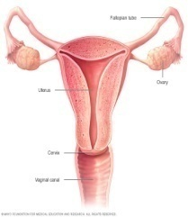  ppt  Hand out  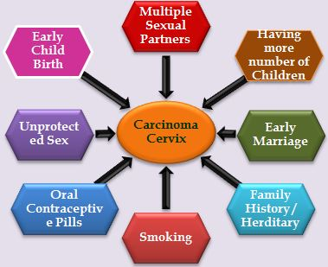    charts  ppt  ppt  ppt  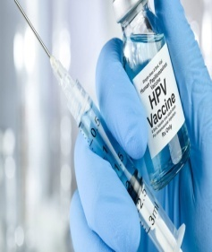     | Define cervical cancer  explained  Enlisted the risk factors of cervical cancer  Enlisted the clinical features of cervical cancer  Explained screening facilities  Explained management of cervical cancer  Explained prevention of cervical cancer
Conclusion;
Thank you for your kind co operation .I hope would understood the meaning the meaning etiology and risk factors , signs and symptoms, diagnostic evaluation, management and prevention of cervical cancer.
Bibliography;
1.lewis a text book of medical surgical nursing 2 edition
2.Brunner and suddarth a text book of medical surgical nursing 2 edition
3.Etedafe pg. cervical cancer;Advances in prevention.presentation for part one update course in obstetrics and Gynacology.2014

ಅನುಬಂಧ - XVII
ಪಾಠಯೋಜನೆ
ಗರ್ಭಕಂಠದಕ್ಯಾನ್ಸರ್ ತಡೆಗಟ್ಟುವ ಕುರಿತು ಆರೋಗ್ಯ ಶಿಕ್ಷಣ

ಮಾರ್ಗದರ್ಶನ:ಇವರಿಂದಸಿದ್ಧಪಡಿಸಲಾಗಿದೆ:

ಡಾ. ಜಿ. ವಿಜಯಲಕ್ಷ್ಮಿಮಟ್ಟುಗಲ್ಲಕವಿತಾ
ಪ್ರಿನ್ಸಿಪಾಲ್II ನೇ ವರ್ಷದಎಂಎಸ್ಸಿ ನರ್ಸಿಂಗ್
SDUCONSDUCON
ತಮಕ, ಕೋಲಾರ.ತಮಕ, ಕೋಲಾರ.

ವಿದ್ಯಾರ್ಥಿಶಿಕ್ಷಕರಹೆಸರು: ಮಟ್ಟುಗಲ್ಲಕವಿತಾ
ವಿಷಯ: ಗರ್ಭಕಂಠದಕ್ಯಾನ್ಸರ್ ತಡೆಗಟ್ಟುವ ಕುರಿತು ಆರೋಗ್ಯ ಶಿಕ್ಷಣ

ಬ್ಯಾಚ್: II ನೇವರ್ಷMsc (N)
ಸ್ಥಳ: ಮಹಿಳಾಸಭಾಂಗಣಕೋಲಾರ
ದಿನಾಂಕ:
ಸಮಯ: 60 ನಿಮಿಷ
ಗುಂಪಿನಸಂಖ್ಯೆ: 30

ಮಹಿಳೆಯರ ಹಿಂದಿನ ಜ್ಞಾನ :ಗರ್ಭಕಂಠದ ಕ್ಯಾನ್ಸರ್ ತಡೆಗಟ್ಟುವ ಬಗ್ಗೆ ಮಹಿಳೆಯರಿಗೆ ಸ್ವಲ್ಪ ಜ್ಞಾನವಿರುತ್ತದೆ

ಎ.ವಿ. ಏಡ್ಸ್: ಪಿಪಿಟಿ, ಚಾರ್ಟ್ಸ್ಮ ,ಕರಪತ್ರಗಳು
.
ಸಾಮಾನ್ಯಉದ್ದೇಶಗಳು:
ಆರೋಗ್ಯ ಶಿಕ್ಷಣವನ್ನು ಪೂರ್ಣಗೊಳಿಸಿದ ನಂತರ, ಮಹಿಳೆಯರು ಗರ್ಭಕಂಠದ ಕ್ಯಾನ್ಸರ್ ತಡೆಗಟ್ಟುವ ಬಗ್ಗೆ ಜ್ಞಾನವನ್ನು ಪಡೆದುಕೊಳ್ಳಲು ಮತ್ತು ಗರ್ಭಕಂಠದ ಕ್ಯಾನ್ಸರ್ ಅಪಾಯಕಾರಿ ಅಂಶಗಳನ್ನು ಗುರುತಿಸಲು ಮತ್ತು ಆರೋಗ್ಯಕರ ಜೀವನಶೈಲಿ ಅಭ್ಯಾಸಗಳನ್ನು ಅಳವಡಿಸಿಕೊಳ್ಳಲು ಸಾಧ್ಯವಾಗುತ್ತದೆ.
.

ನಿರ್ದಿಷ್ಟ ಉದ್ದೇಶಗಳು:
ತರಗತಿಯ ಅಂತ್ಯದ ವೇಳೆಗೆ, ವಿದ್ಯಾರ್ಥಿಗಳಿಗೆ ಸಾಧ್ಯವಾಗುತ್ತದೆ,
1. ಗರ್ಭಕಂಠದ ಕ್ಯಾನ್ಸರ್ ಅನ್ನು ವಿವರಿಸಿ
2. ಗರ್ಭಕಂಠದ ಕ್ಯಾನ್ಸರ್ ಲಕ್ಷಣಗಳು ಮತ್ತು ಅಪಾಯಕಾರಿ ಅಂಶಗಳನ್ನು ಪಟ್ಟಿ ಮಾಡಿ
3. ಗರ್ಭಕಂಠದ ಕ್ಯಾನ್ಸರ್ ಚಿಹ್ನೆಗಳು ಮತ್ತು ರೋಗಲಕ್ಷಣಗಳನ್ನು ಪಟ್ಟಿ ಮಾಡಿ
4. ಗರ್ಭಕಂಠದ ಕ್ಯಾನ್ಸರ್ ರೋಗನಿರ್ಣಯದ ಸಂಶೋಧನೆಗಳನ್ನು ಪಟ್ಟಿ ಮಾಡಿ
5. ಗರ್ಭಕಂಠದ ಕ್ಯಾನ್ಸರ್ ನಿರ್ವಹಣೆಯನ್ನು ವಿವರಿಸಿ
6. ಗರ್ಭಕಂಠದ ಕ್ಯಾನ್ಸರ್ ತಡೆಗಟ್ಟುವ ಕುರಿತು ಚರ್ಚಿಸಿ

ಸಮಯ | ವಿಶೇಷಉದ್ದೇಶಗಳು | ವಿಷಯ | ಶಿಕ್ಷಕರಚಟುವಟಿಕೆ | ವಿದ್ಯಾರ್ಥಿಚಟುವಟಿಕೆ | AV ಏಡ್ಸ್ | ಮೌಲ್ಯಮಾಪನ
2 ನಿಮಿಷ  2ನಿಮಿಷ  2ನಿಮಿಷ  10  ನಿಮಿಷ  5 ನಿಮಿಷ  5 ನಿಮಿಷ  10 ನಿಮಿಷ  5 ನಿಮಿಷ  5 ನಿಮಿಷ | ವಿಷಯವನ್ನುಪರಿಚಯಿಸುವುದು  ಗರ್ಭಕಂಠದಕ್ಯಾನ್ಸರ್ಅನ್ನುವ್ಯಾಖ್ಯಾನಿಸುತ್ತದೆ  ಗರ್ಭಕಂಠದಕ್ಯಾನ್ಸರ್ಸಂಭವವನ್ನುವಿವರಿಸಿ  ಗರ್ಭಕಂಠದಕ್ಯಾನ್ಸರ್ನ  ಅಪಾಯಕಾರಿಅಂಶಗಳನ್ನುವಿವರಿಸಿ  ಗರ್ಭಕಂಠದಕ್ಯಾನ್ಸರ್‌ನಲಕ್ಷಣಗಳನ್ನುಪಟ್ಟಿಮಾಡಿ  ರೋಗನಿರ್ಣಯಪರೀಕ್ಷೆಗಳು  ವಿವರಿಸುತ್ತದೆ  ಗರ್ಭಕಂಠದಕ್ಯಾನ್ಸರ್‌ನವೈದ್ಯಕೀಯನಿರ್ವಹಣೆಯನ್ನುವಿವರಿಸಿ  ಗರ್ಭಕಂಠದಕ್ಯಾನ್ಸರ್ತಡೆಗಟ್ಟುವಿಕೆಯನ್ನುವಿವರಿಸಿ | ವ್ಯಾಖ್ಯಾನ  ಕ್ಯಾನ್ಸರ್ಸೇರಿದಂತೆಸಾಂಕ್ರಾಮಿಕವಲ್ಲದರೋಗಗಳುಭಾರತದಲ್ಲಿಪ್ರಮುಖಸಾರ್ವಜನಿಕಆರೋಗ್ಯಸಮಸ್ಯೆಗಳಾಗಿಹೊರಹೊಮ್ಮುತ್ತಿವೆ.ಈರೋಗಗಳುಜೀವನಶೈಲಿಗೆಸಂಬಂಧಿಸಿವೆ, ದೀರ್ಘಸುಪ್ತಅವಧಿಯನ್ನುಹೊಂದಿರುತ್ತವೆಮತ್ತುಅದರಚಿಕಿತ್ಸೆಗಾಗಿವಿಶೇಷಮೂಲಸೌಕರ್ಯಮತ್ತುಮಾನವಸಂಪನ್ಮೂಲದಅಗತ್ಯವಿದೆ.  ಕ್ಯಾನ್ಸರ್  ಕ್ಯಾನ್ಸರ್ಒಂದೇರೀತಿಯಗುಣಲಕ್ಷಣಗಳನ್ನುಹೊಂದಿರುವರೋಗಗಳಗುಂಪುಗೆಸೇರುತ್ತದೆ.ಕ್ಯಾನ್ಸರ್‌ನಲ್ಲಿದೇಹದಜೀವಕೋಶಗಳುನಿಯಂತ್ರಣಮೀರಿಬೆಳೆಯುತ್ತವೆ. ದೇಹದಲ್ಲಿನಎಲ್ಲಾಜೀವಕೋಶಗಳಲ್ಲಿಕ್ಯಾನ್ಸರ್ಸಂಭವಿಸಬಹುದುಮತ್ತುವಿವಿಧಕ್ಯಾನ್ಸರ್ಪ್ರಕಾರಗಳುವಿಭಿನ್ನನೈಸರ್ಗಿಕಇತಿಹಾಸವನ್ನುಹೊಂದಿವೆ  ಈಗನಾವುಗರ್ಭಕಂಠದಕ್ಯಾನ್ಸರ್ಮತ್ತುಅದರತಡೆಗಟ್ಟುವಿಕೆಯಬಗ್ಗೆಇನ್ನಷ್ಟುತಿಳಿದುಕೊಳ್ಳುತ್ತೇವೆ.  ಗರ್ಭಕಂಠದಕ್ಯಾನ್ಸರ್  ಗರ್ಭಕಂಠದಕ್ಯಾನ್ಸರ್ಎಂದರೆಗರ್ಭಕಂಠದಆಂತರಿಕಪದರದಲ್ಲಿಅಸಹಜಜೀವಕೋಶಗಳಅನಿಯಂತ್ರಿತಬೆಳವಣಿಗೆಯಾಗಿದೆ.  ಗರ್ಭಕಂಠಸ್ತ್ರೀಸಂತಾನೋತ್ಪತ್ತಿವ್ಯವಸ್ಥೆಯಒಂದುಭಾಗವಾಗಿದೆಮತ್ತುಇದುಗರ್ಭಾಶಯದಕೆಳಗಿನಭಾಗದಲ್ಲಿದೆ.ಇದುಗರ್ಭಾಶಯದಿಂದಯೋನಿಯವರೆಗೆತೆರೆಯುತ್ತದೆ.  ಘಟನೆ  ಗರ್ಭಕಂಠದಕ್ಯಾನ್ಸರ್ಭಾರತೀಯಮಹಿಳೆಯರಲ್ಲಿಒಟ್ಟುಕ್ಯಾನ್ಸರ್ಪ್ರಕರಣಗಳಲ್ಲಿ 16.5% ರಷ್ಟಿದೆಮತ್ತುಇದುದೇಶದಮಹಿಳೆಯರಲ್ಲಿಎರಡನೇಅತ್ಯಂತಸಾಮಾನ್ಯರೀತಿಯಕ್ಯಾನ್ಸರ್ಆಗಿದೆ.  ಪ್ರತಿನಿಮಿಷಕ್ಕೆಒಬ್ಬಮಹಿಳೆಗರ್ಭಕಂಠದಕ್ಯಾನ್ಸರ್‌ನಿಂದಬಳಲುತ್ತಿದ್ದಾರೆ  ಪ್ರಸ್ತುತದತ್ತಾಂಶವುಎಲ್ಲಾಪ್ರಕರಣಗಳಲ್ಲಿ 90% ಮಹಿಳೆಯರುಸ್ಕ್ರೀನಿಂಗ್ಮತ್ತುಆರಂಭಿಕಪತ್ತೆಗಾಗಿಆಸ್ಪತ್ರೆಗೆತಲುಪದಕಾರಣದಿಂದಸಂಭವಿಸುತ್ತವೆಎಂದುಸೂಚಿಸುತ್ತದೆ  ಭಾರತದಲ್ಲಿ 30 ರಿಂದ 59 ವರ್ಷವಯಸ್ಸಿನಸುಮಾರು 160 ಮಿಲಿಯನ್ಮಹಿಳೆಯರುಗರ್ಭಕಂಠದಕ್ಯಾನ್ಸರ್ಬರುವಅಪಾಯದಲ್ಲಿದ್ದಾರೆಎಂದುಅಂದಾಜಿಸಲಾಗಿದೆ  ಕರ್ನಾಟಕದಲ್ಲಿಯೇಪ್ರತಿವರ್ಷ 5,000 ಹೊಸಪ್ರಕರಣಗಳನ್ನುಗುರುತಿಸಲಾಗುತ್ತದೆ. ಬೆಂಗಳೂರಿನಲ್ಲಿ, ಗರ್ಭಕಂಠದಕ್ಯಾನ್ಸರ್ಮಹಿಳೆಯರಲ್ಲಿಎರಡನೇಅತ್ಯಂತಸಾಮಾನ್ಯವಾದಕ್ಯಾನ್ಸರ್ಆಗಿದೆ, ಪ್ರತಿವರ್ಷ 850 ಪ್ರಕರಣಗಳನ್ನುಗುರುತಿಸಲಾಗುತ್ತದೆ.  ಗರ್ಭಕಂಠದಕ್ಯಾನ್ಸರ್ನಅಪಾಯಕಾರಿಅಂಶಗಳು  ಬಹುತೇಕಎಲ್ಲಾಗರ್ಭಕಂಠದಕ್ಯಾನ್ಸರ್ಪ್ರಕರಣಗಳು (99%) ಹೈ-ರಿಸ್ಕ್ಹ್ಯೂಮನ್ಪ್ಯಾಪಿಲೋಮವೈರಸ್ (HPV) ಸೋಂಕಿನೊಂದಿಗೆಸಂಬಂಧಹೊಂದಿವೆ, ಇದುಲೈಂಗಿಕಸಂಪರ್ಕದಮೂಲಕಹರಡುವಅತ್ಯಂತಸಾಮಾನ್ಯವೈರಸ್.  ಅನೇಕಲೈಂಗಿಕಪಾಲುದಾರರನ್ನುಹೊಂದಿರುವಮಹಿಳೆಯರುಸುಲಭವಾಗಿಗರ್ಭಕಂಠದಕ್ಯಾನ್ಸರ್ಪಡೆಯಬಹುದು  ಚಿಕ್ಕವಯಸ್ಸಿನಲ್ಲೇಸಂಭೋಗ/ಮದುವೆಯಾಗುವುದು  ಗೊನೊರಿಯಾ, ಸಿಫಿಲಿಸ್ಮತ್ತುHIV/AIDS ನಂತಹಲೈಂಗಿಕವಾಗಿಹರಡುವಸೋಂಕುಗಳು (STI ಗಳು) ಹೊಂದಿರುವಮಹಿಳೆಯರು  ಕುಟುಂಬದಇತಿಹಾಸ / ಅನುವಂಶಿಕತೆ / ಕ್ಯಾನ್ಸರ್ನೊಂದಿಗೆಜೆನೆಟಿಕ್ಸ್  ಸಿಗರೇಟ್ಸೇದುವುದು  ದುರ್ಬಲಗೊಂಡಪ್ರತಿರಕ್ಷಣಾವ್ಯವಸ್ಥೆ / ದೇಹದನೈಸರ್ಗಿಕರಕ್ಷಣಾವ್ಯವಸ್ಥೆಯಲ್ಲಿವೈಫಲ್ಯ / ಸೋಂಕುಅಥವಾಪ್ರತಿರಕ್ಷಣಾವ್ಯವಸ್ಥೆಯನ್ನುನಿಗ್ರಹಿಸುವಔಷಧಿಗಳನ್ನುತೆಗೆದುಕೊಳ್ಳುವುದು  ದೀರ್ಘಕಾಲಗರ್ಭನಿರೋಧಕಮಾತ್ರೆಗಳನ್ನುಬಳಸುವುದು  ಗರ್ಭಧಾರಣೆಗಳನಡುವೆಯಾವುದೇಜನ್ಮಅಂತರವಿಲ್ಲಮತ್ತುಅನೇಕಮಕ್ಕಳಿಗೆಜನ್ಮನೀಡುವುದು[5 ಅಥವಾಹೆಚ್ಚು]  ಪೌಷ್ಟಿಕಾಂಶಸೇವನೆಯಅಸಮರ್ಪಕತೆ  ವಿಟಮಿನ್ಎಮತ್ತುಸಿಕೊರತೆಯಂತಹಪೌಷ್ಟಿಕಾಂಶದಕೊರತೆ  ಜನನಾಂಗದಸ್ವಚ್ಛತೆಯಕೊರತೆ  ಗರ್ಭಕಂಠದಕ್ಯಾನ್ಸರ್ರೋಗದಲಕ್ಷಣಗಳು  ಗರ್ಭಕಂಠದಕ್ಯಾನ್ಸರ್ಹಲವಾರುವರ್ಷಗಳಿಂದನಿಧಾನವಾಗಿಬೆಳವಣಿಗೆಯಾಗುತ್ತದೆ  ಕೆಲವುಮಹಿಳೆಯರಲ್ಲಿ, ಕ್ಯಾನ್ಸರ್ಯಾವುದೇರೋಗಲಕ್ಷಣಗಳನ್ನುಉಂಟುಮಾಡುವುದಿಲ್ಲ, ಇತರರಲ್ಲಿಇದುಅಸಹಜಯೋನಿರಕ್ತಸ್ರಾವಅಥವಾಸ್ರವಿಸುವಿಕೆಯನ್ನುಉಂಟುಮಾಡುತ್ತದೆ.  ಇದುಮುಟ್ಟಿನಅವಧಿಗಳನಡುವಿನರಕ್ತಸ್ರಾವವನ್ನುಒಳಗೊಂಡಿರುತ್ತದೆ  ಲೈಂಗಿಕತೆಯನಂತರರಕ್ತಸ್ರಾವ, ಅಥವಾಋತುಬಂಧದನಂತರರಕ್ತಸ್ರಾವ  ಈರಕ್ತಸ್ರಾವವುಚುಕ್ಕೆಅಥವಾಭಾರೀರಕ್ತಸ್ರಾವವಾಗಿರಬಹುದು  12 ತಿಂಗಳುಗಳಲ್ಲಿ 5 ಪ್ರತಿಶತಕ್ಕಿಂತಹೆಚ್ಚುದೇಹದತೂಕವನ್ನುಕಳೆದುಕೊಳ್ಳುವುದು. ರೋಗಿಯಚರ್ಮವುಸಡಿಲಮತ್ತುಸುಕ್ಕುಗಟ್ಟಿದಮತ್ತುಗುಳಿಬಿದ್ದಕಣ್ಣುಗಳು, ರಕ್ತಹೀನತೆ, ಹಸಿವುಕಡಿಮೆಯಾಗುವುದು  ತೆಳುವಾದನೀರಿನಂಶದಯೋನಿಡಿಸ್ಚಾರ್ಜ್ಮತ್ತುಕೋಳಿವಾಸನೆವಿಸರ್ಜನೆ  ನೋವು: ಇದುತಡವಾದಲಕ್ಷಣವಾಗಿದೆ; ವ್ಯಕ್ತಿಗೆಬೆನ್ನುನೋವು, ಕಾಲುನೋವು, ಶ್ರೋಣಿಕುಹರದನೋವುಮತ್ತುಮೊಣಕಾಲುನೋವುಇರುತ್ತದೆ  ನೋವಿನಮತ್ತುಆಗಾಗ್ಗೆಮೈಕ್ಯುರೇಷನ್, ಮೂತ್ರದಅಸಂಯಮ, ಪ್ರುರಿಟಿಸ್, ಯೋನಿಡಿಸ್ಚಾರ್ಜ್ಮುಂತಾದಕೊನೆಯಹಂತದಲ್ಲಿಇತರರೋಗಲಕ್ಷಣಗಳುಕಂಡುಬರುತ್ತವೆ.  ರೋಗನಿರ್ಣಯಪರೀಕ್ಷೆಗಳು  ರೋಗನಿರ್ಣಯಪರೀಕ್ಷೆಗಳುಗರ್ಭಕಂಠದಕ್ಯಾನ್ಸರ್ಅನ್ನುಆರಂಭಿಕಹಂತಗಳಲ್ಲಿಗುರುತಿಸಿದರೆಗರ್ಭಕಂಠದಕ್ಯಾನ್ಸರ್ಪಡೆಯುವವರಸಂಖ್ಯೆಯನ್ನುಕಡಿಮೆಮಾಡಬಹುದುಮತ್ತುಕಾಯಿಲೆಯಿಂದಸಾಯುವವರಸಂಖ್ಯೆಯನ್ನುಕಡಿಮೆಮಾಡಬಹುದು.ಸಾಮಾನ್ಯಗರ್ಭಕಂಠದಕ್ಯಾನ್ಸರ್ಪರೀಕ್ಷೆಗಳು  .  1.ಪ್ಯಾಪ್ಪರೀಕ್ಷೆ: ಗರ್ಭಕಂಠದಕ್ಯಾನ್ಸರ್ಅನ್ನುಪರೀಕ್ಷಿಸಲುಪ್ಯಾಪ್ಪರೀಕ್ಷೆಯನ್ನುಸಾಮಾನ್ಯವಾಗಿಬಳಸಲಾಗುತ್ತದೆ.  ಪ್ಯಾಪ್ಪರೀಕ್ಷೆಯುಗರ್ಭಕಂಠಮತ್ತುಯೋನಿಯಮೇಲ್ಮೈಯಿಂದಅಂಗಾಂಶದತುಂಡು  ಸಂಗ್ರಹಿಸುವಒಂದುವಿಧಾನವಾಗಿದೆ. ನಂತರಅದನ್ನೂ  ಸೂಕ್ಷ್ಮದರ್ಶಕದಅಡಿಯಲ್ಲಿವೀಕ್ಷಿಸಲಾಗುತ್ತದೆ. ಈವಿಧಾನವನ್ನುಪ್ಯಾಪ್ಸ್ಮೀಯರ್ಎಂದೂಕರೆಯುತ್ತಾರೆ.  2. HPV ಪರೀಕ್ಷೆ: ಈಪರೀಕ್ಷೆಯುಗರ್ಭಕಂಠದಕ್ಯಾನ್ಸರ್‌ಗೆಸಂಬಂಧಿಸಿರುವಹ್ಯೂಮನ್ಪ್ಯಾಪಿಲೋಮವೈರಸ್‌ನಿಂದಉಂಟಾದಸೋಂಕುಇದೆಯೇಎಂದುಕಂಡುಹಿಡಿಯಲುಸಹಾಯಮಾಡುತ್ತದೆ.  ಚಿಕಿತ್ಸೆ  ಯಾವುದೇಕ್ಯಾನ್ಸರ್ಅನ್ನುಕೆಳಗಿನಮೂರುಕ್ರಮಗಳೊಂದಿಗೆಚಿಕಿತ್ಸೆನೀಡಲಾಗುತ್ತದೆ  ಶಸ್ತ್ರಚಿಕಿತ್ಸೆ  ಗರ್ಭಕಂಠಶಸ್ತ್ರಚಿಕಿತ್ಸೆಎಂದರೆ  ಗರ್ಭಕಂಠವನ್ನುಒಳಗೊಂಡಂತೆಗರ್ಭಾಶಯತೆಗೆದುಹಾಕುವಿಕೆಯಾಗಿದೆ. ಗರ್ಭಕಂಠದಕ್ಯಾನ್ಸರ್ಅಥವಾಪ್ರಿಕ್ಯಾನ್ಸರ್("ಡಿಸ್ಪ್ಲಾಸಿಯಾ") ಅಥವಾಅಸಹಜಪ್ಯಾಪ್ಅಥವಾHPV ಪರೀಕ್ಷೆಯಇತಿಹಾಸದಲ್ಲಿಇದನ್ನುಮಾಡಲಾಗುತ್ತದೆ.  ಕೀಮೋಥೆರಪಿ  ಕೀಮೋಥೆರಪಿಎಂದರೆಕ್ಯಾನ್ಸರ್ಅನ್ನುನಾಶಮಾಡಲುಬಳಸುವಔಷಧಿಗಳು.  .  ರೇಡಿಯೊಥೆರಪಿ  ರೇಡಿಯೊಥೆರಪಿ/ರೇಡಿಯೇಶನ್ಥೆರಪಿಯುಟ್ಯೂಮರ್ಕೋಶಗಳೊಳಗಿನಡಿಎನ್‌ಎಗೆಹಾನಿಮಾಡುವಮೂಲಕಮತ್ತುಅವುಗಳಸಂತಾನೋತ್ಪತ್ತಿಸಾಮರ್ಥ್ಯವನ್ನುನಾಶಪಡಿಸುವಮೂಲಕಕಾರ್ಯನಿರ್ವಹಿಸುತ್ತದೆ.  ಗರ್ಭಕಂಠದಕ್ಯಾನ್ಸರ್ತಡೆಗಟ್ಟುವಿಕೆ  ಗರ್ಭಕಂಠದಕ್ಯಾನ್ಸರ್ಅನ್ನುಆರಂಭಿಕಹಂತಗಳಲ್ಲಿಗುರುತಿಸಿದರೆ100% ಗುಣಪಡಿಸಬಲ್ಲವುಆದ್ದರಿಂದಈಕೆಳಗಿನಕ್ರಮಗಳನ್ನುತೆಗೆದುಕೊಳ್ಳಬೇಕು  21-29 ವರ್ಷದೊಳಗಿನಮಹಿಳೆಯರು, ಪ್ರತಿ 3 ವರ್ಷಗಳಿಗೊಮ್ಮೆಪ್ಯಾಪ್ಸ್ಮೀಯರ್ಅನ್ನುನಡೆಸಬೇಕು.  30-65 ವರ್ಷವಯಸ್ಸಿನಮಹಿಳೆಯರು, ಗರ್ಭಕಂಠದಕ್ಯಾನ್ಸರ್ಸ್ಕ್ರೀನಿಂಗ್ಪ್ರತಿ 5 ವರ್ಷಗಳಿಗೊಮ್ಮೆಪ್ಯಾಪ್ಸ್ಮೀಯರ್ಮತ್ತುHPV ಪರೀಕ್ಷೆಯನ್ನುಒಳಗೊಂಡಿರಬೇಕು.  ವಯಸ್ಸಾದಮಹಿಳೆಯರಿಗೆ, ಕಳೆದ 5 ಅಥವಾ 10 ವರ್ಷಗಳಲ್ಲಿಎರಡುಅಥವಾಮೂರುಅಸಹಜಪರೀಕ್ಷಾಫಲಿತಾಂಶಗಳಇತಿಹಾಸವಿದ್ದರೆಮಾತ್ರಪ್ಯಾಪ್ಮತ್ತುHPV ಪರೀಕ್ಷೆಯನ್ನುನಡೆಸಬೇಕು.  HPV ಲಸಿಕೆ  ಗರ್ಭಕಂಠದಕ್ಯಾನ್ಸರ್ನಹೆಚ್ಚಿನಪ್ರಕರಣಗಳಿಗೆಕಾರಣವಾಗುವಎರಡುರೀತಿಯHPV ಸೋಂಕನ್ನುತಡೆಗಟ್ಟಲು, ಲಸಿಕೆಲಭ್ಯವಿದೆ  ಈಲಸಿಕೆಯನ್ನು 9-26 ವರ್ಷವಯಸ್ಸಿನಮಹಿಳೆಯರಿಗೆಅನುಮೋದಿಸಲಾಗಿದೆ.  HPV ಅಥವಾಜನನಾಂಗದಸೋಂಕನ್ನುಹೊಂದಿರುವಜನರೊಂದಿಗೆಲೈಂಗಿಕಕ್ರಿಯೆಗಳಲ್ಲಿತೊಡಗಿಸಿಕೊಳ್ಳದಿರುವಮೂಲಕಗರ್ಭಕಂಠದಕ್ಯಾನ್ಸರ್ಅನ್ನುತಡೆಯಬಹುದು.  ಕಾಂಡೋಮ್‌ಗಳುHPV ಯಿಂದರಕ್ಷಿಸುವುದಿಲ್ಲ, ಆದರೆಇತರರೀತಿಯಲೈಂಗಿಕವಾಗಿಹರಡುವರೋಗಗಳನ್ನುತಡೆಗಟ್ಟಲುಬಳಸಬೇಕು  ನಿಮ್ಮಲೈಂಗಿಕಪಾಲುದಾರರಸಂಖ್ಯೆಯನ್ನುಮಿತಿಗೊಳಿಸಿಮತ್ತುಹೆಚ್ಚಿನಅಪಾಯದಲೈಂಗಿಕಚಟುವಟಿಕೆಗಳಲ್ಲಿಭಾಗವಹಿಸುವಪಾಲುದಾರರನ್ನುತಪ್ಪಿಸಿ  ಧೂಮಪಾನವನ್ನುತ್ಯಜಿಸುವುದರಿಂದಗರ್ಭಕಂಠದಕ್ಯಾನ್ಸರ್ಬರುವಅಪಾಯವನ್ನುಕಡಿಮೆಮಾಡಬಹುದು.  18 ವರ್ಷಗಳಮೊದಲುಮದುವೆಮತ್ತು 18 ವರ್ಷಗಳಮೊದಲುಲೈಂಗಿಕಸಂಭೋಗವನ್ನುತಪ್ಪಿಸಬೇಕು  ಪ್ರತಿದಿನವಿಟಮಿನ್ಎಯನ್ನುತೆಗೆದುಕೊಳ್ಳಿ, ಉದಾಹರಣೆಗೆಹಸಿರುಎಲೆಗಳತರಕಾರಿಗಳುವಿಶೇಷವಾಗಿಡ್ರೊಮಾಸ್ಟಿಕ್ಎಲೆಗಳುಎಲ್ಲಾಹಳದಿಬಣ್ಣದಹಣ್ಣುಗಳಾದಮಾವು, ಪಪ್ಪಾಯಿಇತ್ಯಾದಿಮತ್ತುವಿಟಮಿನ್ಸಿಸಮೃದ್ಧಹಣ್ಣುಗಳಾದಕಿತ್ತಳೆ, ನಿಂಬೆ, ಪೈನ್ಸೇಬುಇತ್ಯಾದಿ.  ಉತ್ತಮನೈರ್ಮಲ್ಯಅಭ್ಯಾಸಗಳಾದಜನನಾಂಗದನೈರ್ಮಲ್ಯ, ಮುಟ್ಟಿನನೈರ್ಮಲ್ಯ, ಪ್ರತಿಖಾಲಿಯಾದನಂತರಪೆರಿನಿಯಲ್ಪ್ರದೇಶವನ್ನುತೊಳೆಯುವುದು, ಬಟ್ಟೆಯಕೆಳಗೆಹತ್ತಿಯನ್ನುಧರಿಸುವುದು, ಬಟ್ಟೆಯಕೆಳಗೆಪ್ರತಿದಿನತೊಳೆಯುವುದು  ಗರ್ಭನಿರೋಧಕಗಳತಡೆವಿಧಾನಗಳು  . | ವಿಷಯವನ್ನುಪರಿಚಯಿಸುವುದು  ಗರ್ಭಕಂಠದಕ್ಯಾನ್ಸರ್ಸಂಭವವನ್ನುಸಂಶೋಧಕರುವಿವರಿಸುತ್ತಾರೆ  ಗರ್ಭಕಂಠದಕ್ಯಾನ್ಸರ್‌ನಲಕ್ಷಣಗಳನ್ನುಪಟ್ಟಿಮಾಡಿ  ಲಭ್ಯವಿರುವರೋಗನಿರ್ಣಯಪರೀಕ್ಷೆಗಳು  ಸಂಶೋಧಕರುವಿವರಿಸುತ್ತಾರೆ  ಗರ್ಭಕಂಠದಕ್ಯಾನ್ಸರ್‌ನವೈದ್ಯಕೀಯನಿರ್ವಹಣೆಯನ್ನುಸಂಶೋಧಕರುವಿವರಿಸುತ್ತಾರೆ  ಸಂಶೋಧಕರುಗರ್ಭಕಂಠದಕ್ಯಾನ್ಸರ್ತಡೆಗಟ್ಟುವಿಕೆಯನ್ನುವಿವರಿಸುತ್ತಾರೆ | ಮಹಿಳೆಯರುಎಚ್ಚರಿಕೆಯಿಂದಆಲಿಸುತ್ತಾರೆ  ಮಹಿಳೆಯರುಎಚ್ಚರಿಕೆಯಿಂದಆಲಿಸುತ್ತಾರೆ  ಮಹಿಳೆಯರುಎಚ್ಚರಿಕೆಯಿಂದಆಲಿಸುತ್ತಾರೆ  ಮಹಿಳೆಯರುಎಚ್ಚರಿಕೆಯಿಂದಆಲಿಸುತ್ತಾರೆ  ಮಹಿಳೆಯರುಎಚ್ಚರಿಕೆಯಿಂದಆಲಿಸುತ್ತಾರೆ  ಮಹಿಳೆಯರುಎಚ್ಚರಿಕೆಯಿಂದಆಲಿಸುತ್ತಾರೆ  ಮಹಿಳೆಯರುಎಚ್ಚರಿಕೆಯಿಂದಆಲಿಸುತ್ತಾರೆ  ಮಹಿಳೆಯರುಎಚ್ಚರಿಕೆಯಿಂದಆಲಿಸುತ್ತಾರೆ | ಕಪ್ಪುಹಲಗೆ  ಕಪ್ಪುಹಲಗೆ  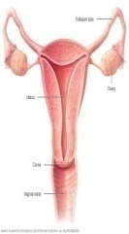  ಪವರ್ಪಾಯಿಂಟ್ಪ್ರಸ್ತುತಿ  ಪಟ್ಟಿಯಲ್ಲಿ  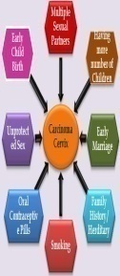  ಪಟ್ಟಿಯಲ್ಲಿ  ppt  ppt | ವಿಷಯವನ್ನುವಿವರಿಸಿ  ಗರ್ಭಕಂಠದಕ್ಯಾನ್ಸರ್  ರ್ಅನ್ನುವಿವರಿಸಿ  ಗರ್ಭಕಂಠದಕ್ಯಾನ್ಸರ್ಸಂಭವವನ್ನುವಿವರಿಸಿ  ಗರ್ಭಕಂಠದಕ್ಯಾನ್ಸರ್ನ  ಅಪಾಯಕಾರಿಅಂಶಗಳನ್ನುಪಟ್ಟಿಮಾಡಲಾಗಿದೆ  ರೋಗಲಕ್ಷಣಗಳನ್ನುವಿವರಿಸಲಾಗಿದೆ  ರೋಗನಿರ್ಣಯಪರೀಕ್ಷೆಗಳು  ವಿವರಿಸಿದರು  ಗರ್ಭಕಂಠದಕ್ಯಾನ್ಸರ್‌ನ ¡¡ನಿರ್ವಹಣೆಯನ್ನುವಿವರಿಸಿ  ಗರ್ಭಕಂಠದಕ್ಯಾನ್ಸರ್ತಡೆಗಟ್ಟುವಿಕೆಯನ್ನುವಿವರಿಸಿ

ತೀರ್ಮಾನ;
ಧನ್ಯವಾದಗಳುಗ್ರಂಥಸೂಚಿ;

1.ಇದುವೈದ್ಯಕೀಯಶಸ್ತ್ರಚಿಕಿತ್ಸಾಶುಶ್ರೂಷೆಯಪಠ್ಯಪುಸ್ತಕ 2 ಆವೃತ್ತಿ
2. ಬ್ರನ್ನರ್ಮತ್ತುಸುದರ್ಥ್ವೈದ್ಯಕೀಯಶಸ್ತ್ರಚಿಕಿತ್ಸಾಶುಶ್ರೂಷೆಯಪಠ್ಯಪುಸ್ತಕ 2 ಆವೃತ್ತಿ
3.Etedafe pg. UÀ¨sÀðPÉÆÃ±Àಕ್ಯಾನ್ಸರ್; ತಡೆಗಟ್ಟುವಿಕೆಯಲ್ಲಿಪ್ರಗತಿ

ANNEXURE-XVIII
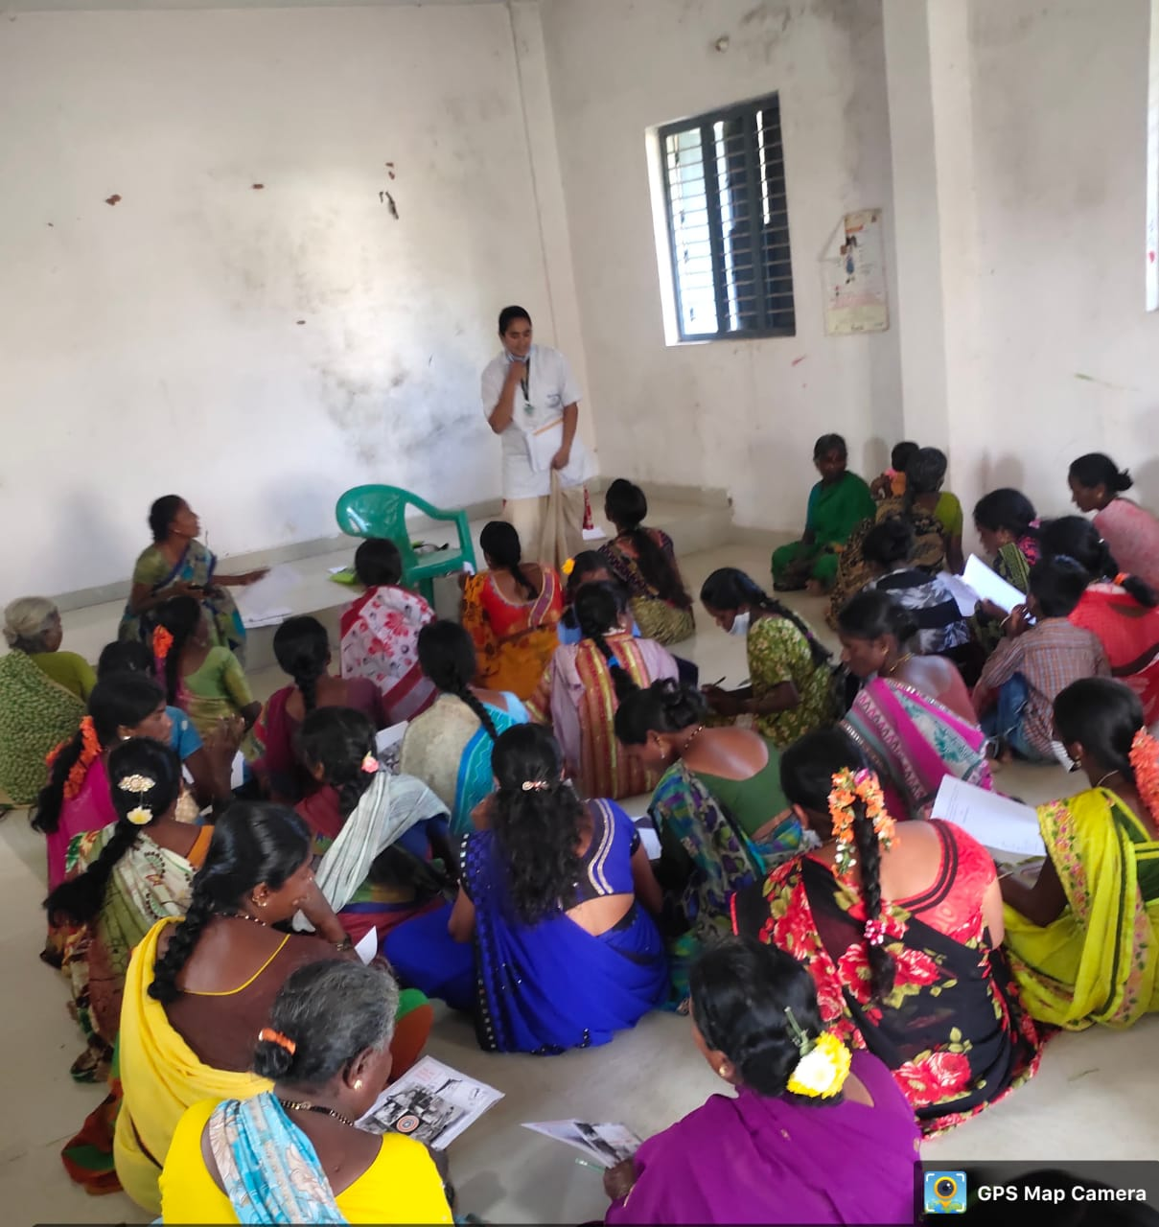
Data collection photos

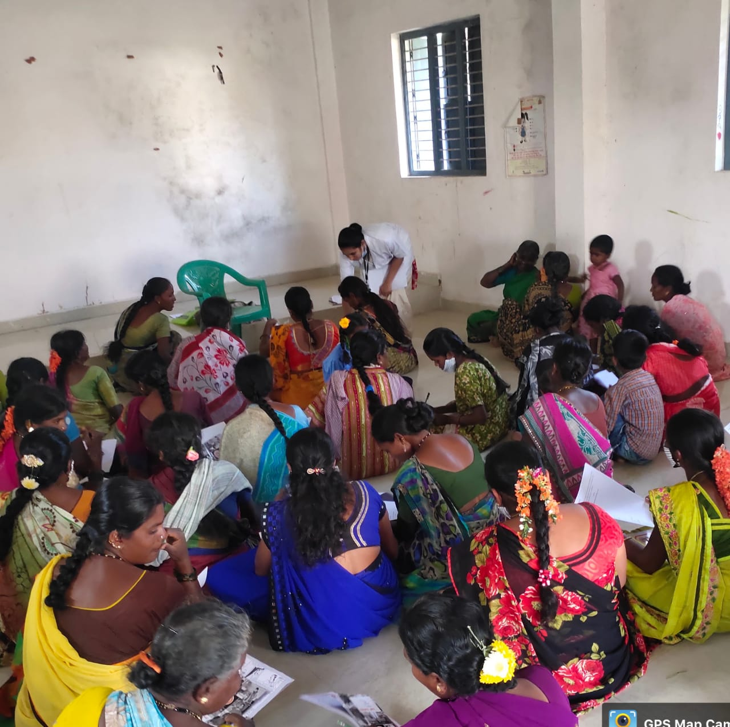

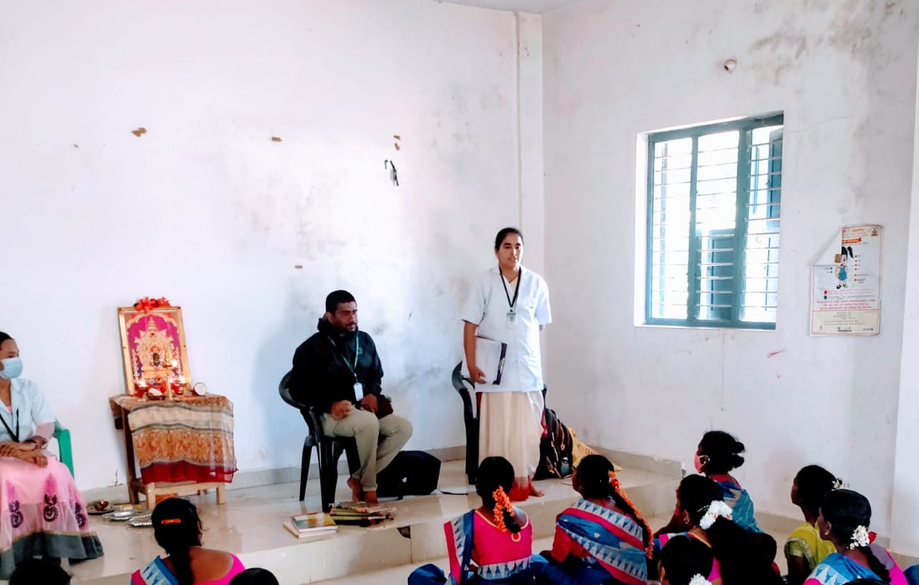

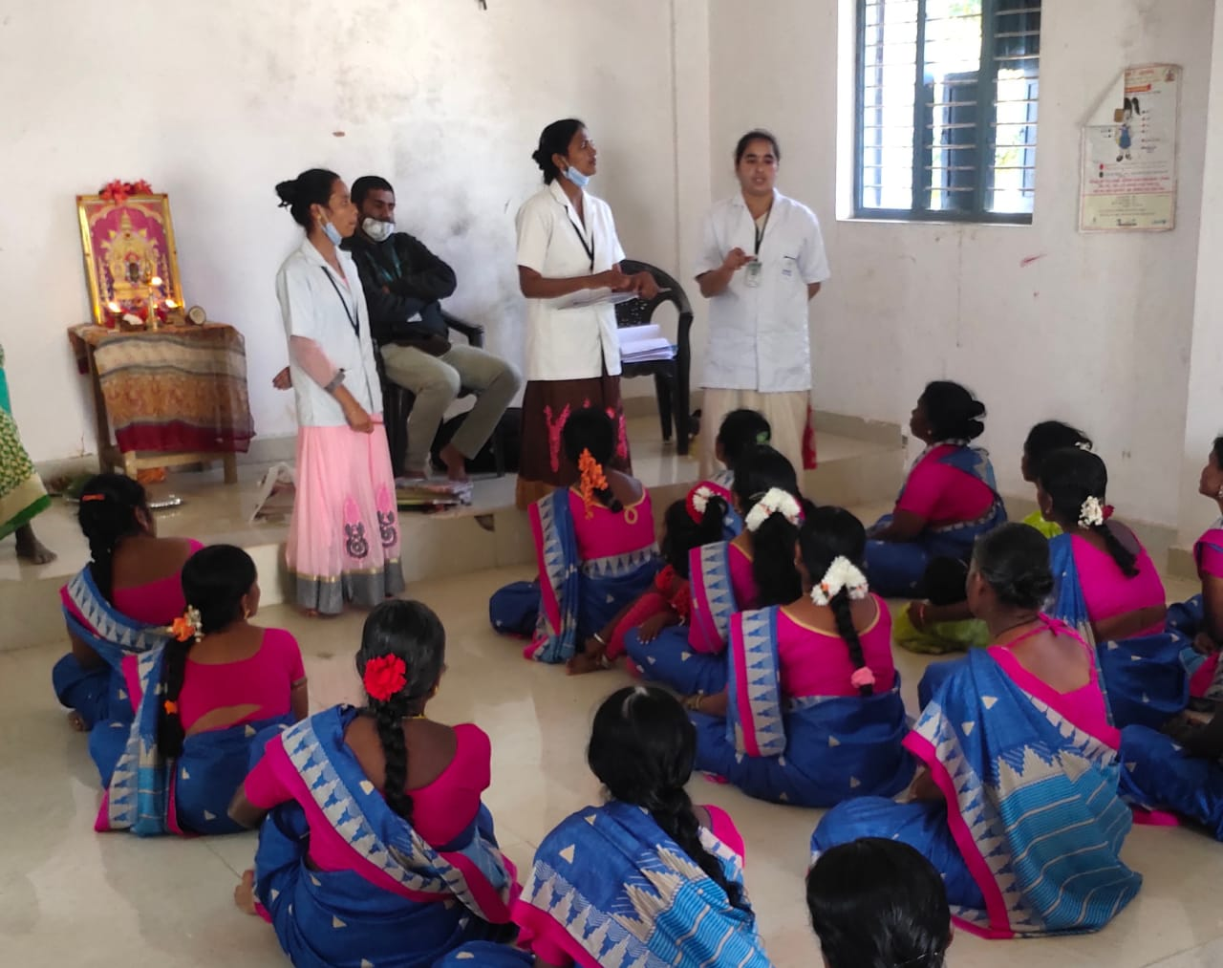

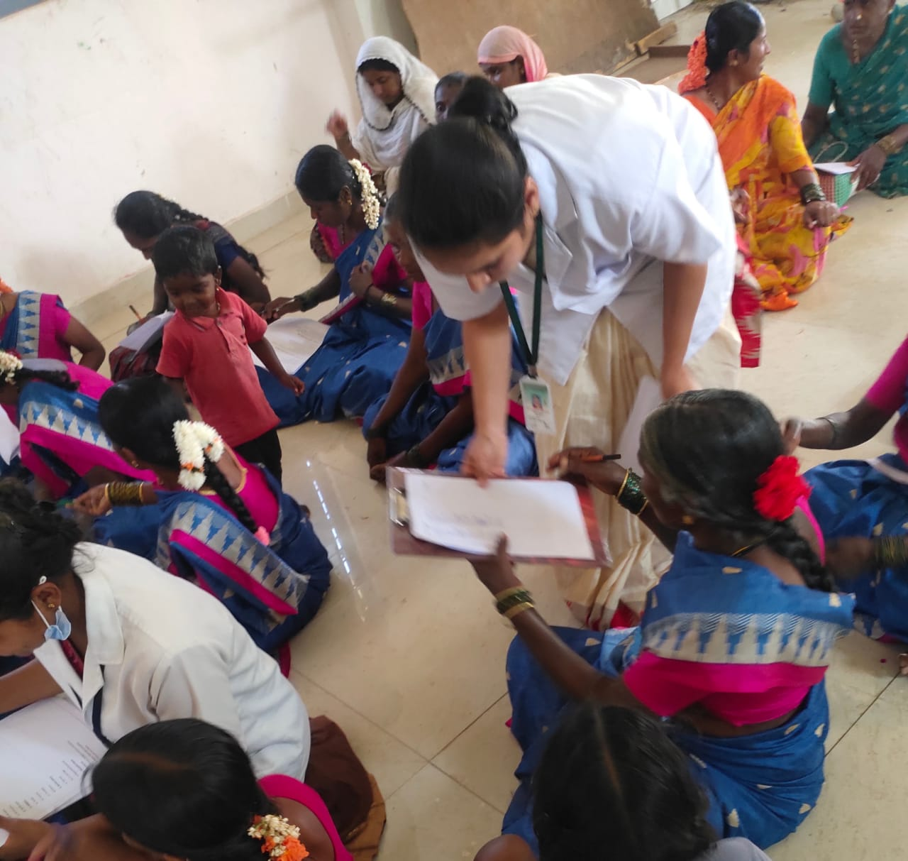

ANNEXURE-XIX
Gannt Chart
RESEARCH ACTIVITY | M  a y  2  0  2  0 | J  u n e  2  0  2  0 | J  U  l  y  2  0  2  0 | A  u g  2  0  2  0 | S  e p t  2  0  2  0 | O  C  t  2  0  2 o | N  o v  2  0  2  0 | D  e c  2  0  2  0 | J  a n  2  0  2  1 | F  e b  2  0  2  1 | M  a r  2  0  2  1 | A  p r  i  l  2  0  2  1 | M  a y  2  0  2  1 | J  u n e  2  0  2  1 | J  u l  Y  2  0  2  1 | A  u g  2  0  2  1 | S  e p  2  0  2  1 | O  C  t  2  0  2  1
SUBMISSION OFSYNOPSIS
SYNOPSIS APPROVEL
PREPARATION FORDATA COLLECTION
IMPLEMENTA TIONOFDATA COLLECTION PLAN
DATA ANALYSIS
PREPARATION OFCHAPTERS
REPORT WRITINGAND SUBMISSION OFREPORT
REPORT PRESENTATIO N

Note: Due to non appearing of main exam, the dissertation work extended up to 26-03-2022.

ANNEXURE-XX
MASTER CODING SHEET
SOCIO-DEMOGRAPHIC DATA OF WOMEN
Sl. no | Age | Marital status | Education | Occupation | Age of menarche
1 | b | B | d | a | a
2 | a | B | b | a | c
3 | b | B | b | a | b
4 | b | B | b | a | a
5 | a | B | d | a | b
6 | d | B | a | a | b
7 | b | B | b | a | b
8 | c | A | a | a | a
9 | b | B | b | a | a
10 | c | A | a | a | a
11 | b | B | b | a | a
12 | b | B | c | a | b
13 | a | A | b | a | b
14 | a | A | b | a | b
15 | a | A | a | a | b
16 | a | B | d | b | b
17 | d | B | a | a | b
18 | d | C | a | a | b
19 | c | A | a | a | a
20 | b | A | b | b | a
21 | a | A | d | c | b
22 | b | B | d | a | a
23 | b | B | d | a | b
24 | c | B | a | a | b
25 | c | B | a | a | a
26 | d | A | a | a | b
27 | c | A | b | b | a
28 | b | A | a | a | a
29 | b | A | b | a | a
30 | a | B | d | a | a
PRE-TEST KNOWLEDGE ON PREVENTION OF CERVICAL CANCER
Sl. No. | I |  |  |  | II |  |  |  |  |  |  |  | III |  |  |  |  |  | IV |  | V |  |  | VI |  | VII
Sl. No. | 1 | 2 | 3 | 4 | 5 | 6 | 7 | 8 | 9 | 10 | 11 | 12 | 13 | 14 | 15 | 16 | 17 | 18 | 19 | 20 | 21 | 22 | 23 | 24 | 25 | 26 | 27 | 28
1 | 1 | 0 | 0 | 0 | 1 | 0 | 1 | 0 | 0 | 0 | 1 | 0 | 0 | 0 | 0 | 0 | 0 | 0 | 0 | 0 | 0 | 1 | 1 | 1 | 0 | 1 | 1 | 0
2 | 0 | 1 | 0 | 1 | 0 | 1 | 1 | 0 | 0 | 0 | 0 | 1 | 0 | 0 | 0 | 0 | 0 | 1 | 1 | 0 | 0 | 0 | 0 | 1 | 0 | 1 | 1 | 0
3 | 0 | 1 | 0 | 1 | 0 | 1 | 1 | 0 | 1 | 0 | 0 | 1 | 0 | 0 | 0 | 0 | 0 | 1 | 1 | 0 | 0 | 0 | 0 | 1 | 0 | 1 | 1 | 0
4 | 0 | 1 | 1 | 1 | 0 | 0 | 1 | 0 | 0 | 0 | 0 | 1 | 1 | 1 | 1 | 1 | 0 | 0 | 0 | 0 | 1 | 1 | 1 | 0 | 1 | 1 | 1 | 0
5 | 0 | 1 | 0 | 0 | 0 | 0 | 1 | 0 | 0 | 0 | 0 | 1 | 0 | 0 | 0 | 0 | 0 | 1 | 0 | 0 | 0 | 0 | 0 | 1 | 0 | 0 | 1 | 1
6 | 0 | 0 | 0 | 1 | 1 | 1 | 1 | 0 | 0 | 0 | 1 | 0 | 1 | 0 | 0 | 0 | 1 | 0 | 0 | 1 | 1 | 1 | 0 | 1 | 1 | 1 | 0 | 1
7 | 1 | 1 | 1 | 1 | 0 | 0 | 0 | 0 | 0 | 0 | 0 | 1 | 0 | 1 | 0 | 0 | 0 | 0 | 0 | 0 | 0 | 1 | 1 | 1 | 0 | 1 | 1 | 0
8 | 1 | 0 | 0 | 1 | 0 | 0 | 0 | 1 | 0 | 0 | 1 | 0 | 0 | 0 | 0 | 0 | 0 | 1 | 0 | 0 | 0 | 1 | 1 | 0 | 1 | 0 | 0 | 0
9 | 0 | 1 | 1 | 0 | 0 | 0 | 0 | 0 | 0 | 1 | 0 | 1 | 0 | 1 | 0 | 0 | 0 | 0 | 0 | 0 | 0 | 1 | 1 | 1 | 0 | 1 | 1 | 1
10 | 0 | 1 | 0 | 1 | 0 | 0 | 1 | 1 | 0 | 0 | 0 | 1 | 0 | 0 | 0 | 0 | 1 | 0 | 0 | 0 | 0 | 0 | 1 | 0 | 0 | 1 | 1 | 1
11 | 0 | 0 | 0 | 1 | 0 | 1 | 0 | 0 | 0 | 0 | 0 | 1 | 0 | 1 | 0 | 1 | 0 | 0 | 1 | 0 | 0 | 0 | 1 | 0 | 1 | 1 | 1 | 1
12 | 0 | 0 | 0 | 0 | 0 | 0 | 0 | 1 | 0 | 0 | 0 | 1 | 0 | 0 | 0 | 0 | 0 | 0 | 1 | 0 | 0 | 1 | 1 | 0 | 0 | 1 | 0 | 1
13 | 1 | 0 | 0 | 1 | 1 | 0 | 0 | 1 | 0 | 1 | 1 | 0 | 1 | 0 | 0 | 1 | 1 | 0 | 1 | 0 | 1 | 1 | 1 | 1 | 1 | 1 | 0 | 0
14 | 1 | 0 | 0 | 0 | 1 | 1 | 1 | 0 | 0 | 0 | 0 | 0 | 0 | 0 | 0 | 0 | 0 | 0 | 0 | 0 | 0 | 0 | 1 | 0 | 0 | 1 | 1 | 0
15 | 1 | 1 | 0 | 1 | 0 | 1 | 0 | 0 | 1 | 0 | 0 | 0 | 1 | 0 | 1 | 0 | 0 | 0 | 0 | 0 | 0 | 1 | 1 | 0 | 0 | 1 | 0 | 0
16 | 1 | 0 | 0 | 1 | 0 | 0 | 0 | 1 | 0 | 0 | 1 | 0 | 0 | 0 | 0 | 0 | 0 | 1 | 0 | 0 | 0 | 1 | 1 | 1 | 1 | 0 | 0 | 0
17 | 0 | 1 | 0 | 0 | 0 | 0 | 1 | 0 | 0 | 1 | 0 | 1 | 0 | 0 | 0 | 0 | 0 | 0 | 0 | 1 | 0 | 1 | 1 | 1 | 0 | 1 | 0 | 0
18 | 0 | 1 | 0 | 1 | 0 | 0 | 0 | 0 | 1 | 0 | 0 | 0 | 0 | 0 | 0 | 0 | 0 | 0 | 0 | 1 | 0 | 1 | 1 | 1 | 1 | 0 | 0 | 0
19 | 0 | 0 | 1 | 1 | 1 | 0 | 0 | 0 | 1 | 0 | 0 | 1 | 0 | 1 | 1 | 0 | 0 | 0 | 0 | 0 | 1 | 0 | 1 | 1 | 0 | 1 | 0 | 0
20 | 0 | 1 | 0 | 0 | 0 | 0 | 0 | 0 | 1 | 0 | 0 | 0 | 0 | 1 | 0 | 1 | 0 | 0 | 0 | 0 | 0 | 0 | 1 | 1 | 1 | 0 | 1 | 0
21 | 0 | 0 | 0 | 1 | 0 | 0 | 0 | 0 | 0 | 1 | 0 | 0 | 0 | 0 | 0 | 0 | 0 | 0 | 0 | 1 | 1 | 0 | 1 | 1 | 0 | 1 | 0 | 0
22 | 1 | 0 | 1 | 0 | 0 | 0 | 0 | 0 | 0 | 0 | 1 | 0 | 0 | 0 | 0 | 0 | 0 | 0 | 0 | 0 | 1 | 1 | 1 | 0 | 1 | 0 | 1 | 0
23 | 1 | 0 | 0 | 1 | 0 | 0 | 0 | 0 | 0 | 1 | 1 | 0 | 0 | 0 | 1 | 1 | 0 | 0 | 0 | 0 | 0 | 0 | 0 | 1 | 0 | 1 | 0 | 0
24 | 0 | 0 | 0 | 1 | 0 | 0 | 1 | 0 | 0 | 0 | 0 | 1 | 0 | 0 | 1 | 1 | 0 | 0 | 1 | 0 | 0 | 1 | 0 | 1 | 0 | 1 | 1 | 1
25 | 1 | 0 | 1 | 0 | 0 | 0 | 0 | 0 | 0 | 0 | 0 | 1 | 0 | 1 | 0 | 0 | 0 | 0 | 0 | 1 | 1 | 0 | 1 | 0 | 0 | 0 | 1 | 0
26 | 1 | 0 | 0 | 1 | 0 | 0 | 0 | 0 | 0 | 0 | 0 | 0 | 0 | 0 | 0 | 1 | 1 | 0 | 1 | 1 | 0 | 0 | 1 | 1 | 1 | 1 | 1 | 0
27 | 0 | 0 | 0 | 0 | 0 | 0 | 0 | 0 | 0 | 0 | 1 | 0 | 0 | 1 | 0 | 0 | 0 | 0 | 0 | 0 | 0 | 1 | 0 | 1 | 0 | 0 | 1 | 1
28 | 1 | 0 | 1 | 0 | 0 | 0 | 0 | 0 | 0 | 0 | 1 | 0 | 0 | 0 | 1 | 1 | 0 | 0 | 1 | 0 | 1 | 0 | 1 | 0 | 1 | 1 | 1 | 0
29 | 1 | 1 | 1 | 0 | 0 | 0 | 0 | 0 | 0 | 0 | 0 | 0 | 0 | 1 | 1 | 0 | 1 | 0 | 0 | 0 | 0 | 0 | 1 | 1 | 0 | 1 | 0 | 0
30 | 0 | 0 | 1 | 0 | 1 | 0 | 0 | 1 | 0 | 0 | 0 | 1 | 0 | 0 | 0 | 1 | 0 | 0 | 0 | 1 | 0 | 0 | 0 | 1 | 0 | 0 | 1 | 0

POST-TEST KNOWLEDGE ON PREVENTION OF CERVICAL CANCER
Sl. No. | I |  |  |  |  | II |  |  |  |  |  |  | III |  |  |  |  |  | IV |  | V |  |  | VI |  | VII
Sl. No. | 1 | 2 | 3 | 4 | 5 | 6 | 7 | 8 | 9 | 10 | 11 | 12 | 13 | 14 | 15 | 16 | 17 | 18 | 19 | 20 | 21 | 22 | 23 | 24 | 25 | 26 | 27 | 28
1 | 1 | 1 | 1 | 0 | 1 | 0 | 0 | 0 | 1 | 0 | 0 | 1 | 0 | 1 | 0 | 0 | 1 | 0 | 1 | 0 | 0 | 1 | 1 | 1 | 0 | 0 | 1 | 1
2 | 1 | 1 | 1 | 0 | 1 | 0 | 0 | 0 | 1 | 0 | 1 | 1 | 0 | 1 | 0 | 0 | 0 | 0 | 0 | 1 | 0 | 1 | 1 | 1 | 0 | 1 | 1 | 0
3 | 0 | 0 | 1 | 0 | 1 | 1 | 0 | 0 | 1 | 0 | 1 | 1 | 0 | 1 | 0 | 1 | 0 | 0 | 0 | 1 | 0 | 1 | 0 | 0 | 0 | 0 | 1 | 1
4 | 0 | 1 | 0 | 1 | 0 | 1 | 1 | 0 | 0 | 0 | 0 | 0 | 1 | 0 | 1 | 1 | 0 | 1 | 0 | 1 | 1 | 0 | 0 | 0 | 1 | 1 | 1 | 1
5 | 1 | 1 | 0 | 1 | 1 | 0 | 0 | 0 | 1 | 0 | 1 | 0 | 0 | 0 | 0 | 0 | 0 | 0 | 0 | 1 | 0 | 1 | 1 | 1 | 0 | 0 | 1 | 0
6 | 1 | 1 | 1 | 0 | 1 | 1 | 1 | 0 | 0 | 1 | 1 | 1 | 1 | 1 | 1 | 1 | 1 | 1 | 1 | 1 | 1 | 0 | 0 | 0 | 0 | 1 | 1 | 1
7 | 1 | 1 | 1 | 0 | 1 | 1 | 1 | 0 | 0 | 1 | 1 | 1 | 1 | 1 | 1 | 1 | 1 | 1 | 1 | 1 | 1 | 0 | 1 | 1 | 0 | 1 | 1 | 1
8 | 0 | 0 | 1 | 0 | 1 | 0 | 0 | 0 | 1 | 0 | 0 | 1 | 0 | 1 | 0 | 1 | 0 | 0 | 0 | 0 | 0 | 1 | 1 | 1 | 0 | 1 | 1 | 0
9 | 1 | 1 | 1 | 0 | 1 | 0 | 0 | 1 | 0 | 1 | 0 | 0 | 0 | 0 | 0 | 0 | 0 | 0 | 0 | 0 | 0 | 1 | 1 | 1 | 1 | 1 | 1 | 1
10 | 0 | 1 | 1 | 0 | 1 | 0 | 0 | 1 | 1 | 0 | 0 | 0 | 0 | 0 | 0 | 0 | 1 | 0 | 0 | 1 | 0 | 0 | 0 | 1 | 0 | 1 | 0 | 0
11 | 1 | 1 | 1 | 1 | 1 | 0 | 0 | 0 | 0 | 0 | 1 | 1 | 1 | 1 | 1 | 1 | 1 | 1 | 1 | 1 | 1 | 1 | 0 | 1 | 0 | 1 | 1 | 1
12 | 1 | 1 | 1 | 0 | 1 | 0 | 0 | 0 | 1 | 0 | 0 | 1 | 0 | 1 | 0 | 0 | 0 | 0 | 0 | 0 | 0 | 1 | 1 | 1 | 1 | 1 | 0 | 0
13 | 0 | 0 | 1 | 0 | 0 | 0 | 0 | 1 | 0 | 0 | 1 | 0 | 1 | 0 | 0 | 0 | 0 | 0 | 1 | 1 | 1 | 1 | 0 | 0 | 1 | 1 | 0 | 1
14 | 1 | 0 | 0 | 1 | 1 | 0 | 0 | 1 | 0 | 0 | 1 | 0 | 0 | 0 | 0 | 0 | 1 | 0 | 0 | 1 | 1 | 1 | 1 | 0 | 1 | 1 | 1 | 0
15 | 0 | 0 | 0 | 0 | 1 | 1 | 1 | 0 | 1 | 0 | 1 | 1 | 1 | 1 | 1 | 1 | 1 | 1 | 0 | 1 | 1 | 0 | 1 | 1 | 1 | 1 | 1 | 0
16 | 1 | 1 | 0 | 0 | 1 | 1 | 0 | 0 | 0 | 0 | 0 | 0 | 0 | 0 | 0 | 0 | 1 | 0 | 1 | 0 | 1 | 1 | 1 | 0 | 0 | 1 | 1 | 0
17 | 1 | 1 | 0 | 0 | 0 | 0 | 1 | 0 | 1 | 1 | 0 | 0 | 0 | 0 | 0 | 0 | 1 | 0 | 1 | 0 | 1 | 1 | 1 | 0 | 0 | 1 | 1 | 0
18 | 0 | 1 | 0 | 0 | 0 | 1 | 0 | 0 | 1 | 1 | 0 | 0 | 0 | 1 | 0 | 0 | 0 | 0 | 0 | 0 | 1 | 1 | 1 | 1 | 0 | 0 | 0 | 0
19 | 0 | 1 | 1 | 0 | 1 | 0 | 0 | 0 | 1 | 0 | 0 | 1 | 0 | 1 | 0 | 1 | 1 | 1 | 0 | 0 | 0 | 1 | 1 | 1 | 0 | 0 | 1 | 1
20 | 1 | 0 | 0 | 0 | 1 | 0 | 0 | 0 | 0 | 0 | 1 | 0 | 0 | 1 | 0 | 0 | 0 | 0 | 0 | 1 | 1 | 0 | 0 | 1 | 1 | 0 | 1 | 1
21 | 1 | 0 | 0 | 1 | 1 | 0 | 0 | 0 | 1 | 1 | 0 | 1 | 1 | 1 | 0 | 1 | 1 | 0 | 0 | 0 | 1 | 1 | 0 | 1 | 0 | 0 | 1 | 1
22 | 1 | 1 | 0 | 1 | 1 | 0 | 1 | 0 | 0 | 0 | 1 | 0 | 1 | 0 | 0 | 0 | 0 | 0 | 0 | 1 | 1 | 0 | 1 | 0 | 0 | 1 | 1 | 1
23 | 1 | 0 | 0 | 0 | 1 | 0 | 0 | 1 | 0 | 0 | 1 | 0 | 1 | 0 | 0 | 0 | 0 | 0 | 1 | 0 | 1 | 0 | 1 | 0 | 1 | 0 | 1 | 0
24 | 1 | 1 | 1 | 0 | 1 | 0 | 1 | 1 | 1 | 1 | 1 | 1 | 1 | 1 | 0 | 1 | 1 | 1 | 1 | 1 | 1 | 0 | 1 | 1 | 1 | 1 | 1 | 1
25 | 1 | 1 | 1 | 1 | 1 | 0 | 1 | 1 | 0 | 1 | 0 | 1 | 0 | 1 | 1 | 1 | 0 | 1 | 1 | 1 | 1 | 0 | 1 | 1 | 1 | 1 | 1 | 1
26 | 1 | 1 | 1 | 1 | 1 | 0 | 1 | 0 | 1 | 1 | 1 | 0 | 1 | 1 | 0 | 0 | 0 | 0 | 0 | 1 | 1 | 1 | 0 | 0 | 0 | 1 | 0 | 1
27 | 1 | 1 | 1 | 1 | 1 | 0 | 1 | 0 | 0 | 0 | 1 | 1 | 1 | 1 | 1 | 1 | 1 | 0 | 1 | 0 | 1 | 1 | 1 | 1 | 1 | 1 | 1 | 1
28 | 1 | 1 | 0 | 1 | 1 | 0 | 1 | 0 | 1 | 1 | 1 | 0 | 0 | 1 | 1 | 1 | 1 | 1 | 1 | 0 | 1 | 1 | 1 | 1 | 0 | 1 | 0 | 1
29 | 1 | 1 | 0 | 1 | 0 | 0 | 0 | 1 | 1 | 0 | 0 | 1 | 1 | 1 | 1 | 0 | 1 | 0 | 0 | 1 | 0 | 1 | 0 | 1 | 1 | 1 | 1 | 0
30 | 1 | 1 | 1 | 1 | 0 | 0 | 1 | 0 | 0 | 0 | 0 | 0 | 1 | 0 | 0 | 1 | 1 | 0 | 1 | 1 | 1 | 1 | 1 | 1 | 1 | 1 | 1 | 0

