**“A STUDY TO ASSES THE KNOWLEDGE REGARDING SHAKEN BABY SYNDROME AMONG MOTHERS OF INFANTS IN A SELECTED HOSPITAL KOLAR WITH A VIEW TO DEVELOP AN INFORMATION LEAFLET”**

**BY**

**Ms.Anumol G, Ms.Evelyn Maria Abraham, Ms.Francy Jomol K.J, Ms.Jesnamol George, Ms.Josmi John, Ms.Neethu Joy, Ms.Pavitra S, Ms. Veena A, Mrs.Sandosh Kumar Singh and Mrs. Prameela**

**Research project submitted to**

**Sri Devaraj Urs College of Nursing, Tamaka, Kolar, Karnataka.**



In partial fulfillment of the degree of

**Basic B.SC (N) & Post B.SC (N)**

**IN**

**Child Health Nursing**

Under the guidance of

**PROF. RADHA M.S**

Vice Principal & HOD of Pediatric Nursing

**Sri Devaraj Urs College of Nursing**

Tamaka, Kolar

**2016**

**DECLARATION BY THE CANDIDATE**

We here by declare that this research project entitled “**A STUDY TO ASSESS THE KNOWLEDGE REGARDING SHAKEN BABY SYNDROME AMONG MOTHERS OF INFANTS IN A SELECTED HOSPITAL KOLAR WITH A VIEW TO DEVELOP AN INFORMATION LEAFLET**” is a bonafide and genuine research work carried out by us under the guidance of **Prof. Radha M.S, HOD Department of Child health Nursing**, Sri Devaraj Urs College of Nursing, Tamaka, Kolar, 563101.

**Signature of the candidates,**

**Ms. Anumol G**

**Ms. Evelyn Maria Abraham**

**Ms.Francy Jomol K.J**

**Ms.Jesna mol George**

**Ms. Josmi john**

**Ms. Neethu Joy**

**Ms. Pavithra S**

**Ms. Veena A**

**Mr.Santhosh Kumar Singh**

**Mrs.Prameela**

**Date**

**Place: Tamaka**

**CERTIFICATE BY THE GUIDE**

This is to certify that the research project entitled “**A STUDY TO ASSESS THE KNOWLEDGE REGARDING SHAKEN BABY SYNDROME AMONG MOTHERS OF INFANTS IN A SELECTED HOSPITAL KOLAR WITH A VIEW TO DEVELOP AN INFORMATION LEAFLET**” is a bonafide research work done by **Anumol G, Evelyn Maria Abraham, Francy Jomol, Jesnamol George, Josmi John, Neethu Joy, Pavitra** **S, Veena A, Sandosh Kumar Singh, Prameela** in partial fulfillment of the requirement for Basic B.SC Nursing & Post BSC programme.

**Date**

**Place: Tamaka, Kolar Signature of the Guide**

**Prof. RADHA M.S**

**HOD of pediatric nursing**

**SDUCON**

**Tamaka**

**Kolar**

**ENDORSEMENT BY THE HOD, PRINCIPAL OF THE INSTITUTION**

This is to certify that the research project entitled **“A STUDY TO ASSESS THE KNOWLEDGE REGARDING SHAKEN BABY SYNDROME AMONG MOTHERS OF INFANTS IN A SELECTED HOSPITAL KOLAR WITH A VIEW TO DEVELOP AN INFORMATION LEAFLET** **”** is a bonafied research work done by **Anumol G, Evelyn Maria Abraham, Francy Jomol, Jesnamol George, Josmi John, Neethu Joy, Pavitra** **S, Veena A, Sandosh Kumar Singh, Prameela** in partial fulfillment of the requirement for Basic B.SC Nursing & Post BSC programme.

**Signature of the HOD Signature of the Principal**

**Prof. RADHA MS Dr. G Vijayalakshmi**

**HOD Of pediatric Nursing Principal**

**SDUCON SDUCON**

**Tamaka, Kolar Tamaka, Kolar**

**Date: Date:**

**Place : Tamaka Place:Tamaka**

**COPY RIGHT**

**DECLARATION BY THE CANDIDATE**

We hereby declare that Sri Devaraj Urs College of Nursing, Tamaka, Kolar, Karnataka shall have the right to preserve, use and disseminate this research project in print or electronic format for academic and research purpose.

**Signature of the candidates,**

**Ms. Anumol G**

**Ms. Evelyn Maria Abraham**

**Ms.Francy Jomol K.J**

**Ms.Jesna mol George**

**Ms. Josmi john**

**Ms. Neethu Joy**

**Ms. Pavithra S**

**Ms. Veena A**

**Mr.Santhosh Kumar Singh**

**Mrs.Prameela**

**Place:Tamaka**

**Date:**

**ACKNOWLEDGEMENT**

First of all we thank God Almighty for showering his blessing on us by giving us the strength and wisdom for the successful completion of the study.

We express special thanks to the **Management** of the Sri Devaraj Urs College of Nursing for giving me a platform to complete my study efficiently.

We express our heartful thanks and sincere gratitude to my guide **Mrs RadhaM.S,** Proffesor, Vice Principal and HOD of Pediatric Nursing Dept. for her keen interest , guidance, valuable suggestion and cooperation, constant interaction, for boosting our spirit through all up and downs, which has made this study fruitful and enriching learning experience throughout this study.

We express our sincere thanks to **Mrs. Lavanya Subhashini** Assoct. Prof. Department of Pediatric Nursing, Sri Devaraj Urs College of Nursing for her consistent, corrective efforts and encouragement in helping us to complete the study successfully.

We express our profound respect and deep gratitude to **Dr. G Vijayalakshmi** , Principal, Sri Devaraj Urs College of nursing for her support, to carry out the study.

We would like to express our gratitude to **Mrs. Punitha**, Associate professor, OBG of Nursing Dept. and Class Coordinator of 4th year BSc nursing for giving support, encouragement and valuable ideas that helped us from the initial stages of our study.

We express my humble thanks to **Dr. Sudha Reddy** Dept of Pediatrics, R.L.J Hospital for her valuable suggestions and guidance.

We express our heartful thanks to **Ms. Baby G k** Asst. Lecturer, Department of pediatrics for her suggestions.

We express our sincere gratitude to all the **HODs** of various departments and all teaching faculty of Sri Devaraj Urs College Of Nursing for their encouragement, suggestions expert guidance in tool validation which helped us to complete the study

Our special thanks to **Librarians** of Sri Devaraj Urs College of Nursing for their constant support and help in terms of orienting us to broader range of source appropriate literature was available.

Our personal gratitude to **Participants** who have enthusiastically been a part of the study and without their cooperation the study would not have been possible.

We offer our gratitude to all our **loved ones, Parents, friends, Seniors and well**-**wishers** for their timely help and most of all for their prayers.

Thank u very much from all of us!

**Signature of the candidates,**

**Ms. Anumol G**

**Ms. Evelyn Maria Abraham**

**Ms.Francy Jomol K.J**

**Ms.Jesna mol George**

**Ms. Josmi john**

**Ms. Neethu Joy**

**Ms. Pavithra S**

**Ms. Veena A**

**Mr.Santhosh Kumar Singh**

**Place:Tamaka, Kolar Mrs.Prameela**

**ABSTRACT**

**Background**

Shaken baby syndrome is the most common cause of death or serious neurological injury resulting from child abuse. It is a form of child abuse that is characterized by brain injury.The purpose of the study was to provide information about prevention of Shaken baby syndrome among infants to mothers.

**STATEMENT OF PROBLEM**

**“*A STUDY TO ASSESS THE KNOWLEDGE REGARDING SHAKEN* *BABY SYNDROME AMONG MOTHERS OF INFANTS IN A SELECTED HOSPITAL KOLAR WITH A VIEW TO DEVELOP AN*  *INFORMATION LEAFLET”***

**OBJECTIVES OF THE STUDY**

1) To assess the knowledge of mothers regarding shaken baby syndrome.

2) To determine association between mothers knowledge score and selected socio-demographic variables.

**RESEARCH HYPOTHESIS**

H0- There will not be statistically significant association between mothers knowledge regarding shaken baby syndrome and the socio demographic variables.

**METHODOLOGY**

In the present study, quantitative approach was selected and descriptive survey research design was adopted. A structured knowledge questionnaire on Shaken baby syndrome was developed to collect the data. The main study was conducted at R.L.Jalappa Hospital and Research center. Tamaka, Kolar, with the sample size of 100 mothers, selected by using convenient sampling technique and the collected data were analyzed and interpreted by using descriptive and inferential statistics.

**RESULT & CONCLUSION**

The findings of the study have shown that majority ie 68%(68) of mothers had poor knowledge and 25%(25) had average knowledge and 7%(7) had good knowledge about shaken baby syndrome.

Findings also revealed that demographic variables like educational status of mothers and number of children has significant association between knowledge score of mothers. The demographic variables like age of the mother, occupation, type of family, area of residence, source of information, age of the child, sex of the child and religion have no significant association with the knowledge score which in turn emphasizes the importance and need of adequate knowledge regarding shaken baby syndrome.

**KEYWORDS:** Shaken baby syndrome, Knowledge, mothers, infants.

**TABLE OF CONTENTS**

|  |  |  |
| --- | --- | --- |
| **CHAPTER**  **NO** | **CONTENTS** | **PAGE NO** |
| **1** | **Introduction**   1. Introdution 2. Need for the study | 1-3  4 |
| **2** | **Objectives**   1. Statement of the problem 2. Objectives of the study 3. Null Hypothesis 4. Assumption 5. Operation definition 6. Summary | 5-7 |
| **3** | **Review of literatures related to study**   1. Literature related to traumatic physical abuse. 2. Literature related to incidence report on shaken baby syndrome. 3. Literature related to awareness on shaken baby syndrome among mothers. 4. Summary | 8-13 |
| **4** | **Research Methodology**   1. Research approach 2. Research design 3. Variables 4. Setting of the study 5. Population 6. Sample, Sample size 7. Sampling technique   Vii. Criteria for the selection of sample  Viii Selection and development of tool  IX. Content validity  X Reliability of the study  Xi. Pilot study  Xii Data collection procedures  Xiii Plan of data analysis  xiv. Summary | 14-20 |
| **5** | **Data analysis and interpretation**   1. Objective of the study 2. Null Hypothesis 3. Presentation of data 4. Summary | 21-28 |
| **6** | **Discussion** | 29-31 |
| **7** | **Conclusion** | 32-35 |
| **8** | **Summary** | 36-38 |
| **9** | **Bibliography** | 39-42 |
| **10** | **Annexures** | 43-70 |

**LIST OF TABLES**

|  |  |  |
| --- | --- | --- |
| **SL. NO** | **TABLES** | **PAGE NO** |
| 1 | Frequency distribution of demographic variables of mothers. | 22-23 |
| 2 | Overall knowledge scores of mother regarding Shaken baby syndrome. | 25 |
| 3 | Association between knowledge of mothers regarding Shaken baby syndrome and selected socio-demographic variables. | 26 |

**LIST OF FIGURES**

|  |  |  |
| --- | --- | --- |
| SL NO | FIGURES | PAGE NO |
| 1 | Schematic representation of research design | 16 |
| 2 | Percentage distribution of knowledge level of mothers | 25 |

**LIST OF ANNEXRES**

|  |  |  |
| --- | --- | --- |
| **ANNEXURE**  **NO** | **CONTENTS** | **PAGE NO** |
| 1 | Permission for conduct research study | 44 |
| 2 | Letter requesting opinions and suggestion of experts for establishing content validity of research tool | 45 |
| 3 | Criteria rating scale for validating structured knowledge questionnaire | 46-47 |
| 4 | Content validity certificate | 48 |
| 5 | List of experts | 49 |
| 6 | Self administerd knowledge questionnaire with answer key | 50-63 |
| 7 | Information leaflet | 63-66 |
| 8 | Master sheet | 68-72 |

**LIST OF ABBREVATIONS**

|  |  |
| --- | --- |
| **SL.**  **NO** | **ABBREVIATIONS** |
| 1 | SBS: Shaken baby syndrome |
| 2 | SDUMC: Sri Devaraj Urs Medical College |
| 3 | f :Frequency |
| 4 | %: Percentage |
| 5 | SD: Standard deviation |
| 6 | df: Degree of freedom |
| 7 | NS: Not significant |
| 8 | SS: Statistically Significant |

INTRODUCTION

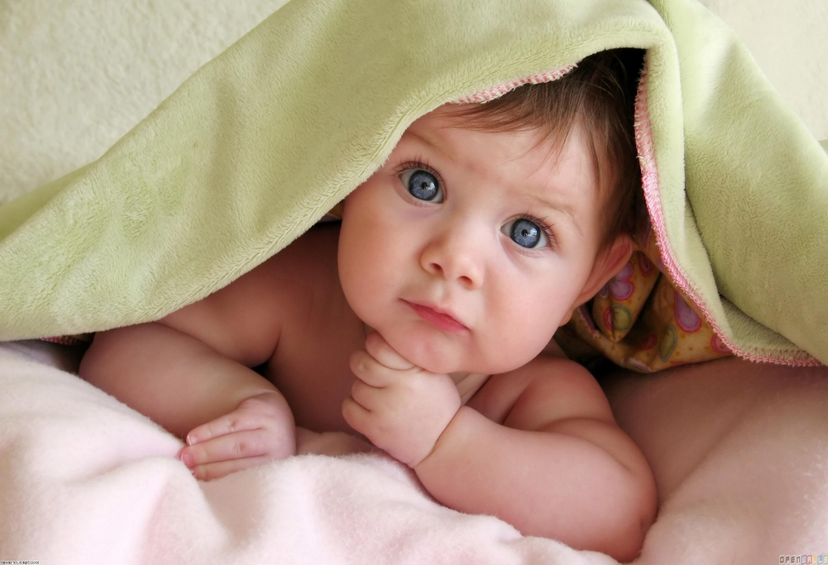  **CHAPTER -1**

**INTRODUCTION**

***“ Children are living jewels dropped unsustain from heaven, it only takes 30 seconds to change your baby’s life for ever. Never shake your baby.”***

Children are our most precious, valuable and fragile resource for the future. The children of today are the adults of tomorrow. Child abuse or maltreatment is physical, sexual, or psychological mistreatment or neglect to the children by parents or caregivers. Physical abuse is the leading cause of serious head injury in infants. Although physical abuse in the past has been diagnosis of exclusion, data regarding the nature and frequency of head trauma consistently support the need for a presumption of child abuse when a child younger than one year has suffered an intracranial injury.1

Shaken baby syndrome is a serious and clearly definable form of child abuse. It results from extreme rotational cranial acceleration induced by violent shaking or shaking impact, which would be easily recognizable by others as dangerous. At the incidence and demography of non accidental head injury in a prospective population in pediatric unit Scotland during 1998-99shaken baby syndrome occur with an annual incidence of 24.6 per 100000 children under the age of one year. 2

When someone forcefully shake the baby, the child head rotates about the neck uncontrollably because infants neck muscles aren’t well developed and provide a little support for their head. This violent movement pitches in the infant brain, and within the skull, and sometimes rupturing of blood vessel, nerves and tearing of the brain tissues occurs. The brain may strike inside the skull which causes bruising and bleeding.

The damage can be even greater when a shaking episodes end with an impact ( hitting a wall or a crib mattress) because the force of acceleration and deceleration associated are so strong. After Shaking, swelling in the brain can causes enormous pressure within the skull, compressing blood vessels and increasing overall injury to its delicate structure.3

Normal interaction with a child, like bouncing the baby on a knee will not cause there injuries although it is important to never shake a baby under any circumstances because gentle shaking can rapidly escalate. The more serious is the child neurological injuries and causes severe symptoms and shorter the period of time between the shaking and appearance of symptoms. From the time of shaking these children do not look or act as usual. They may not eat or sleep or play normally.

Babies who are shaken may be brought to medical attention by a caregiver who offers no history of injury a vague account of events or an explanation that is not consistent with the physical findings .unless the physician is aware of possibility of abuse and knowledgeable about the sign of shaken baby syndrome, the cause of this children can be missed. The outcome for infants who suffer brain damage from shaking can range from no apparent effect to permanent disability, including development delay, seizures, paralysis, blindness and even death. Survivor may have significant delayed effect of neurological injury resulting in a range of impairments seen over the course of the child’s life including cognitive, defects and behavioral problem.

The immediate and long term outcomes of head injury caused by shaken baby syndrome are worse than head injuries from other causes. At least one of every four